**DESIGN FEATURES OF HOUSE S11 AS COUNTERMEASURES TO THE CHALLENGES THAT CAME ALONG WITH DAYLIGHTING**

**Table of contents**

Abstract

1.0 Introduction

2.0 Daylight as sustainable design

3.0 General issues of daylighting and the challenges

3.1 Effects of natural light on building occupants

3.2 Challenges that came along with daylighting

4.0 Design features of House S11 in dealing with the heat gain problem of using daylight

4.1 Wind turbine ventilator

4.2 Steel frame glazed pyramids

4.3 Large canopy roof

4.4 Materials choice

4.4.1 Fair-faced red clay bricks

4.4.2 Low E laminated glass

5.0 Conclusion

6.0 References

**ABSTRACT**

The main objective of this research paper is to study how effective are the design features of House S11 in dealing with problems such as internal heat gain, damage to the furniture when using daylighting as an approach to sustainable design. In this paper, the drawback of using daylighting as sustainable design and how exactly the design features of House S11 in keeping the inside of the house comfortable will be the main focuses. In order to identify and analyse the issues stated above, a series of investigation were carried out, such as observation during the site visit, documents analysis from case studies, online sources and last but not least, books. First of all , through the investigation, the designer approaches in using daylighting to reduce the needs of artificial lighting to minimise the energy consumption in House S11 could bring a certain disadvantages. For examples, ultraviolet from sunlight bleaches and fades the finishes on our furniture especially the furniture made of wood. In addition, natural sunlight can results in undesirable heat gain in the house, this may not be favour by the occupants. So, the designers did come out with a few design features as countermeasures to the issues mentioned above. The design features are as such, the special designed wind turbine that driven without any need of mechanical means, the glazed light pyramid that diffuse direct sunlight which then illuminates the house, the large canopy roof and the materials choice to further cut down the internal heat gain. These design features not only serve to reduce the heat gain but it also contribute much in achieving thermal comfort and making the building stand out and unique.

**1.0 Introduction**

Throughout the history, daylight has been part of the source of lighting used in illuminating the building. Even though artificial lightings are necessary in some cases but daylight is still the primary lighting we favoured as it’s not only environmental friendly as it greatly reduce the carbon footprint compared to artificial lighting. In addition, daylight can provide a welcome and dynamic contribution to the human experience in buildings and, as demonstrated in recent studies on schools and retail sales environments, can impact human performance (Heshong Mahone Group, 1999a & b). As a result , we architects or designers are well aware of how important daylight is to us human, not only as system or tools that brighten our space but a medium that allow us human to experience the space. The 20th century prominent architect Le Corbusier once pointed out that daylight is a key element in architecture, “Architecture is the masterly, correct and magnificent play of volumes brought together in light ...” emphasizing that “...the history of architecture is the history of the struggle for light.” (Le Corbusier, 1989). We architects and designers are well aware of how importance of daylight is to us human, so in response to that, we do place a great effort in developing and study the daylight strategies in order to fully utilise the natural daylight. However, daylight still do bring us some disadvantages as it’s a heat source which cause extra unwanted heat gain in the building and the ultraviolet will eventually destroys and fades our furniture finishing.

So, in this paper, the relationship between the daylight and the design features of the House S11 in response to the drawbacks of using daylight will be investigate in correspond to the following questions :

**Research Question(s):**

1. What are the issues when having daylighting as a sustainable design in House S11 ?
2. How does the wind turbine contribute in solving heat gain problem ?
3. Instead of direct daylighting, what’s the benefit of having glazed light pyramid ?
4. How does the construction and features of the large canopy roof reduces heat gain beside providing shading ?
5. How does the material choice helps in reducing heat gain from sunlight ?

**2.0 Daylight as sustainable design**

On a clear and bright day, together with the reflected light from the clear sky, it’s roughly 8,000 to 10,000 footcandles of light. These light from sun and sky are more than possible to brighten up the ground for human visual tasks. The main aims in daylighting a building are to (1) get significant quantities of daylight as deep into the building as possible, (2) to maintain a uniform distribution of daylight from one area to another, and (3) to avoid visual discomfort and glare. Along with the objectives mentioned above in mind, architects will have to maximise the usage of the sunlight to reduce the energy consumption for artificial lighting, or in some cases, in cold countries, utilise the sunlight the warm the places.

Typically one third of the energy used in non-domestic buildings is for artificial lighting. Good daylight design in buildings offers huge potential savings -- as high as 70% -- for both new and refurbished buildings. There is also growing evidence that daylit buildings have fewer problems relating to health and well-being of the occupants (Baker, N., & Steemers, K. , 2002). The building energy consumption can be reduce as the reliance on the electric lighting if daylight is used appropriately in illuminating the interior spaces.

**3.0 General issues of daylighting and the challenges**

**3.1 Effects of natural light on building occupants**

According to “Discover Lighting”, a website that expertise in daylighting, they mentioned that daylight is also playing an important role in providing the potential benefits to occupants in term of health, performance or general well being. Daylight are often used not only to save energy but also to avoid hypothesized adverse health effects of over-illumination by artificial light. A successful practice of daylighting can enhance the general aesthetic value of the space and provide higher levels of lighting than that obtained from electric lighting solely. The result can contribute to a higher level of satisfaction from the occupants. In addition, most people enjoy to work in a daylighted space rather than in a non-daylighted space as they can experience the ‘exterior world’ by interacting with the all natural sunlight. An exterior view may play a role in helping workers to relax their eyes by permitting them to occasionally focus their vision on objects that are at large distances.

Artificial lighting include cool white fluorescent, incandescent, energy-efficient fluorescent, and full-spectrum fluorescent lighting. Each type has a different level of energy consumption. However, the most important factor affecting building occupants is the different spectrums of light that each source produces.

Light source with different wavelengths or spectral distributions will results in different effects on the human body. The spectral distribution of artificial light source needed for complete biological functions are always absent as compared to natural sun light. (Hathaway, et al. 1992).

Compared to electrical light sources, daylight provides a better lighting environment because “daylight…most closely matches the visual response that, through evolution, humans have come to compare with all other light” (Franta and Anstead 1994). The reason why most of the humans prefer a natural day light environment because sunlight consists of a balanced spectrum of color, with its energy peaking slightly in the blue-green area of the visible spectrum (Liberman 1991).

Humans are affected both psychologically and physiologically by the different spectrums provided by the various types of light. These effects are the less quantifiable and easily overlooked benefits of daylighting. Daylighting has been associated with improved mood, enhanced morale, lower fatigue, and reduced eyestrain. One of the important psychological aspects from daylighting is meeting a need for contact with the outside living environment (Robbins 1986).

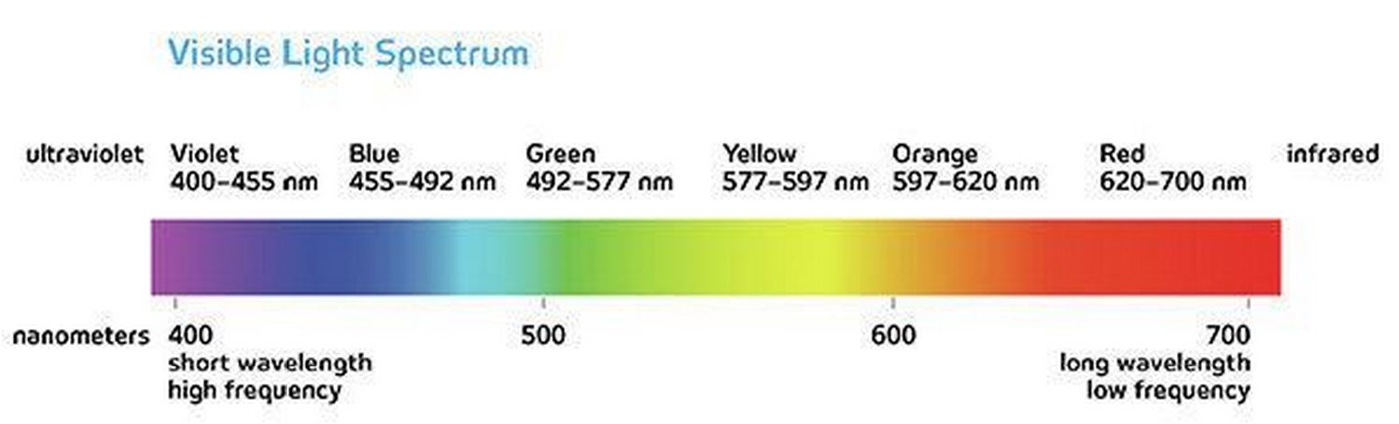

**3.2 Challenges that came along with daylighting**

**Internal heat gain**

Daylight is the combination of direct and indirect sunlight during the daytime. Daylight includes direct sunlight , diffuse sky radiation and both of these reflected from sunlight. These daylight results in solar heat gains in buildings through openings , windows and roof. The increase in the heat gain of a space affects by the daylight intensity. Objects struck by sun light absorb the short wave sunlight radiation and reradiate it in longer wavelength form – infrared. When talking about using daylight, glass or openings are always come to mind before nothing. Not to mention the openings allowed direct sunlight, the glass , which is more transparent to the shorter wavelength to the longer one, causing a net result of solar heat gain. The solar heat gain through a glazed area can be calculated by using the formula :

Qsolar = Area of window x Solar intensity x Transmissivity

An inappropriate planning of openings and windows can lead to overheating in building, especially in Malaysia, a hot and humid climate zone.

**Difficulty in designing process**

Special precautions and effort need to be taken by the architects and designers in order to ensure that the daylighting serve its purposes while not compromising the disadvantages that came along together. It’s not an easy task to have the day light penetrate into deep building spaces even during the day. Another problem we could probably face is to control the glare. It could bring uncomfortable to the occupants when there are too much glare, regardless or direct or indirect, when these light enter the building.

**Sunlight damage to the furniture**

Overexposure of furniture to sunlight can cause damage to the furniture. Leather furniture is particularly sensitive to the sunlight, as there is not only the problem of fading in colour, but also cracking and drying which completely destroy the texture of the leather furniture. This could be worst in House S11 where the owner owns the beautiful leather finish Barcelona chairs more than anyone. Wood furniture cab be damaged by the direct sunlight as well. The over expose of sunlight not only decolourise the wood but cause cracking as well. The organic wood furniture experience expansion or shrinking easily when the difference is too great, this result in the cracking of the wood furniture.

**4.0 Design features of House S11 in dealing with the heat gain problem of using daylight**

House S11, designed by ArchiCentre is truly a successful design toward sustainability. The architect in charge, Tan Loke Mun magnificently transformed the dilapidated old house that was built in 1960’s into the current House S11, which was awarded Malaysia’s first GBI Platinum rated residential house. The house is always kept comfortable for the occupants by means of passive and active cooling. In order to minimise the energy consumption, the architect had put a vast amount of effort in planning daylighting. However, daylight may bring along some major problems to the occupants, primarily unwanted internal heat gain. In respond to this issue, the architect had come out with a few design features as a countermeasure to the problem mentioned.

**4.1 Wind turbine ventilator**

Wind turbine ventilators extract hot, polluted, stale air from enclosed spaces, replacing it with fresh air from outside. These ventilators transform hot, stuffy environments within hours which result an improvement in occupants comfort levels.

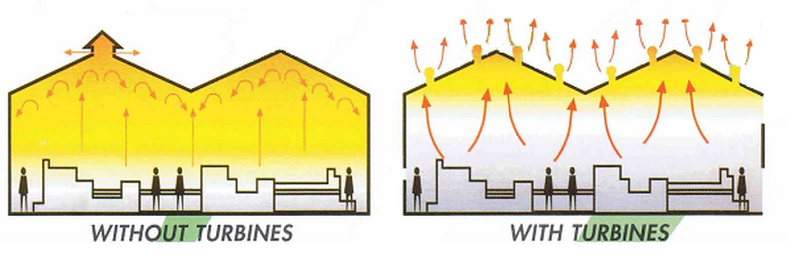

Figure 4.1.1 This figure shows the internal condition of a building when there is ventilators and without. ( Source : <http://www.bautec.co.za/Turbines.html> )

As the figure shown, the reddish orange zone indicate where the heat is accumulated. It can be clearly seen that with the help of turbines, the internal of a building is way more colder and comfortable as the heat is channel to the outside environment. This ensure the overall comfortability of the occupants which then affect the occupants condition physiological and psychologically.

**Working principle of wind turbine ventilator**

Wind turbine ventilator is powered by the wind itself to create an effective ventilation for different industries. The mechanics involve in the air movement is very simple. The hot air inside the building tends to rise up. When the turbine rotates, it expel the hot air through the vent, thereby resulting the drop in temperature at the attic areas. The drop in temperatures created a difference in air pressure which in turn drive the fresh air from openings and windows to flow in this direction. This cycle repeats and thus resulting a continuous ventilation inside of the building. However, these wind turbine ventilators are lacking in reliability due to their dependence on favourable environmental conditions.

In House S11, the wind turbine ventilators is redesigned and modified to increase the efficiency. According to the ArchiCetre, the wind turbine is specially designed which combined with the glass box, or to be more specific the steel framed glazed pyramid that provide the house with stack effect ventilation and light pipes. The wind turbines are 15 in numbers and are driven both by wind as well as convection when the air within the glass pyramids heat up as a result of the greenhouse effect. A 3 degree differential is enough to spin the turbines by convection.

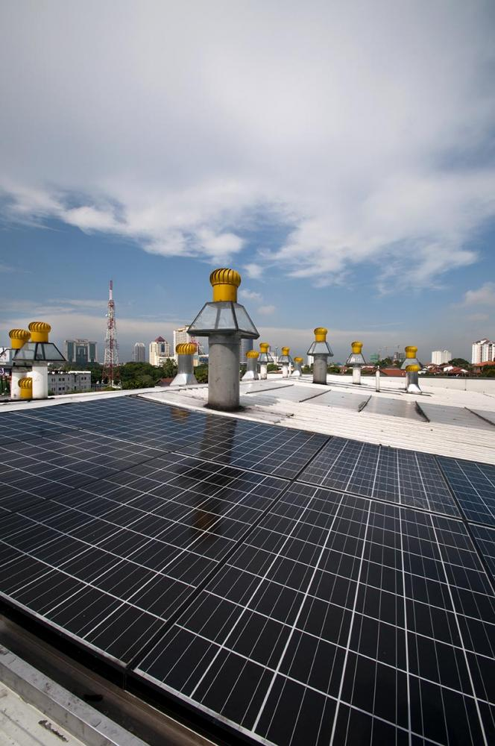

Figure 4.1.2 Wind turbine ventilators of House S11. ( Source : <http://www.s11house.com/#gallery> )

The wind turbines ventilators of House S11 work like typical ventilators, but it’s further enhanced with the aid of the steel framed glazed pyramid. In windy condition, when the wind approaches the ventilators, it pushes the blades and the rotation starts. These rotation sucks out the internal hot air as hot air rises. This event created the difference of air pressure which then cause the air to flow from higher air pressure zone to lower air pressure zone, causing a continuous extraction of air from the building.

When in case of unfavourable condition, in here referring to non windy day, the wind turbine ventilators of House S11 still working well compared to the typical ventilators. When the hot sun strikes at the glass box(highlighted in red box in the figure above), the glass pyramid heated up as a results of greenhouse effect. The increase in temperature of the glass box created a higher air pressure than outside air. This lead to the air movement between the glass box and the external environment. The air start to flow , pushing the blade of the ventilators and the wind turbine starts to operate. As the turbine rotates, replacement air is drawn into the throat of the ventilator from the building causing continuous ventilation.

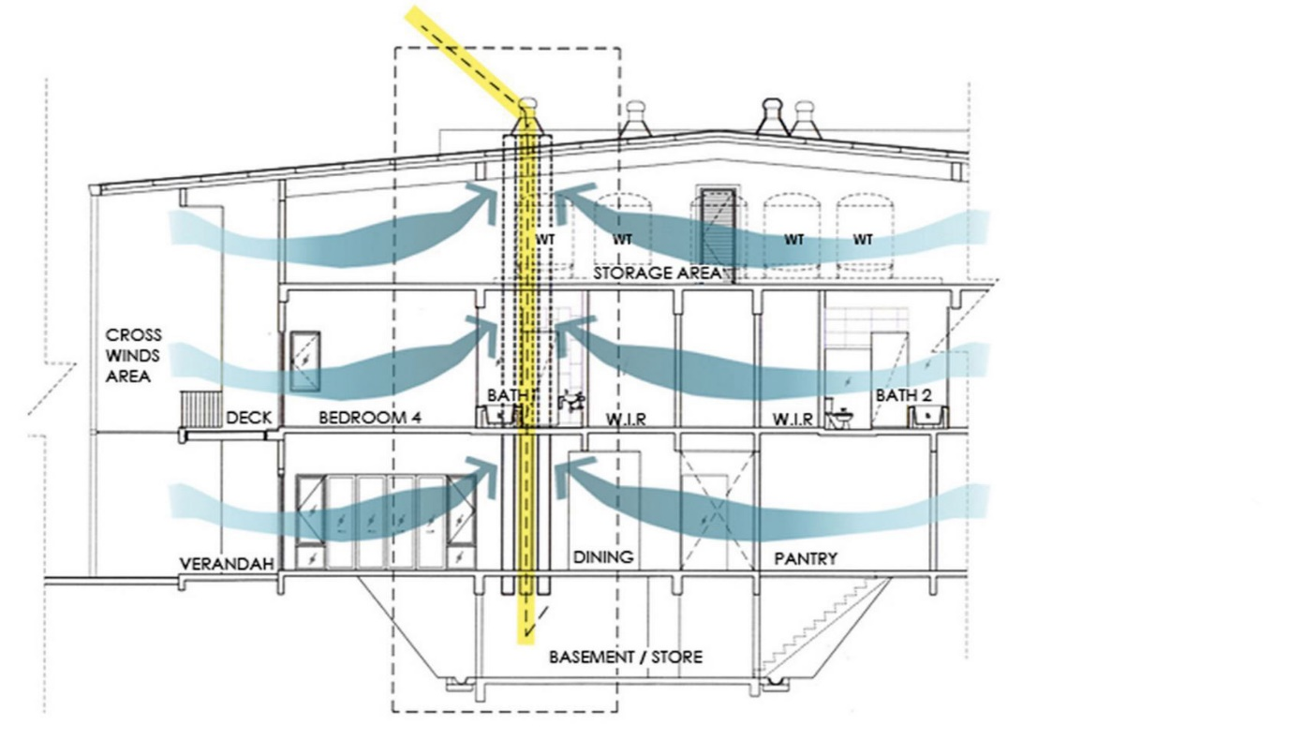Figure 4.1.3 Section of House S11 showing how the internal ventilation goes. ( Source : <http://www.s11house.com/#gallery> )

The wind turbine ventilators of House S11 draw out the hot air accumulated at attic areas and the fresh air from windows and openings take its place. These continuous movement of airflow forming stack ventilation within the house to ensure the house is kept cold. When these ventilations happened, as the wind passes through the occupants’ body surface or any furniture inside of the building, the heat transfer from the hotter mediums to the colder wind through convection. The accumulated heat stored inside of the building can be removed by such a way and thus thermal comfort could be achieved. So by this reaction, I can conclude that the wind turbine ventilators of House S11 do a pretty good job as a method to reduce or minimise extra unwanted heat gain that came along with daylighting.

**4.2 Steel frame glazed pyramids**

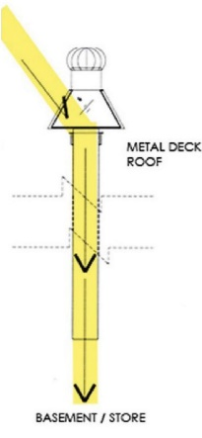During day time, most of the buildings are dependent on the daylight for illuminating purpose. However, daylight can’t penetrate deep enough into some spaces of the building. In case of House S11, the basement. The architect brilliantly make use of the light pipes to ‘transport’ the light to the basement where natural sunlight couldn’t reach. The reasons of doing so are not only to reduce the needs of artificial lighting in basement area but it’s also as a tool to protect the furniture. This is because by channelling the light to basement through this way, the sun light wouldn’t strike at the furniture directly and thus no damage to the finishes. The light captured bounces several times along the light tubes and inside here, the harmful UV rays that endanger occupants’ health and fade furniture are filtered out. In addition, the diffused sunlight from light tubes give a comfortable ambient to the occupants, not as strong at the irritating glare from direct sunlight. The daylighting consistency of using light tubes and the energy efficiency are very convincing towards sustainable designs. By using the light tube, it can deliver a more consistent light source and brighten the interior spaces deep within the building more effectively and evenly compared to natural skylight. Most importantly, by using the specially designed steel frame glazed pyramids, the heat gain can be kept to a minimum as this tube incorporates with thin and clear polycarbonate lenses that improve the U-factor and solar heat gain coefficient.

Figure 4.2.1This figure shows how skylight is channelled to the basement. ( Source : <http://www.s11house.com/#gallery> )

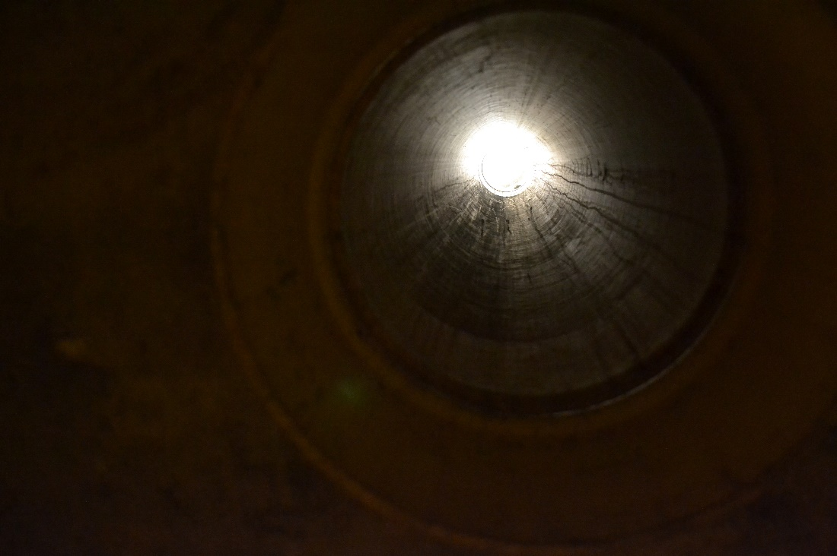

Figure 4.2.2 This figure shows the sunlight captured at the glazed pyramids being channel down to the basement by using light pipes. (Source : Yeow Yi Chuan, 2015)

Comparative study of light tubes in other architecture

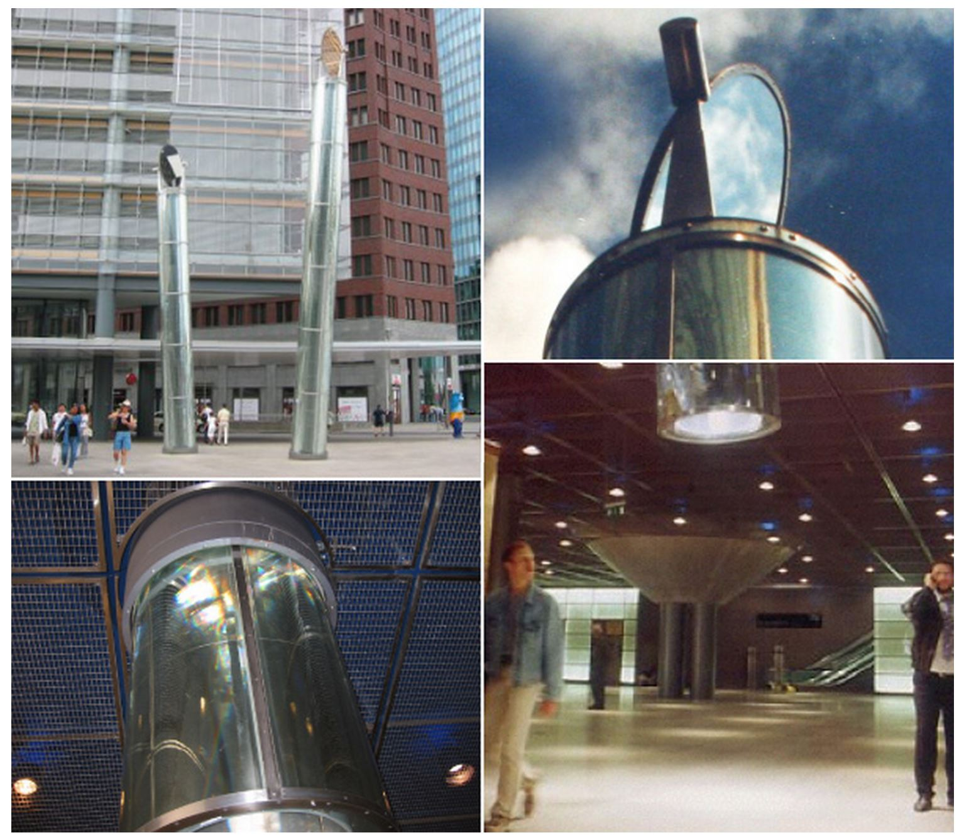

Figure 4.2.3 The image shows that the usage of light pipes in Berlin Subway Station successfully reduce the needs of artificial lighting.

**4.3 Large canopy roof**

As stated in the ArchiCentre, the large tree-like canopy roof is constructed out of lightweight recyclable profiled steel metal sheets coated in a light off-white color to minimize heat absorption. The roof insulation comprises 200-mm-thick, 50kg/m3 rockwool and two layers of heat reflective foil. A 200-mm-thick ventilated air space is left between the m ceiling lining and the rockwool to further improve heat insulation. The overall roof U value is 0.14. The low U-value of the roof guarantee the smooth rate of transfer of the heat which then ensure the comfortability of the users. This roof provides not only shade to the building but as well as a insulator that reduce the heat gain from sunlight. Furthermore, the most interesting part of the roof is that while providing shade to the building, there is an opening resembles the oculus allows appropriate amount of sunlight to brighten the interior which gives extra poetic experience to the occupants.

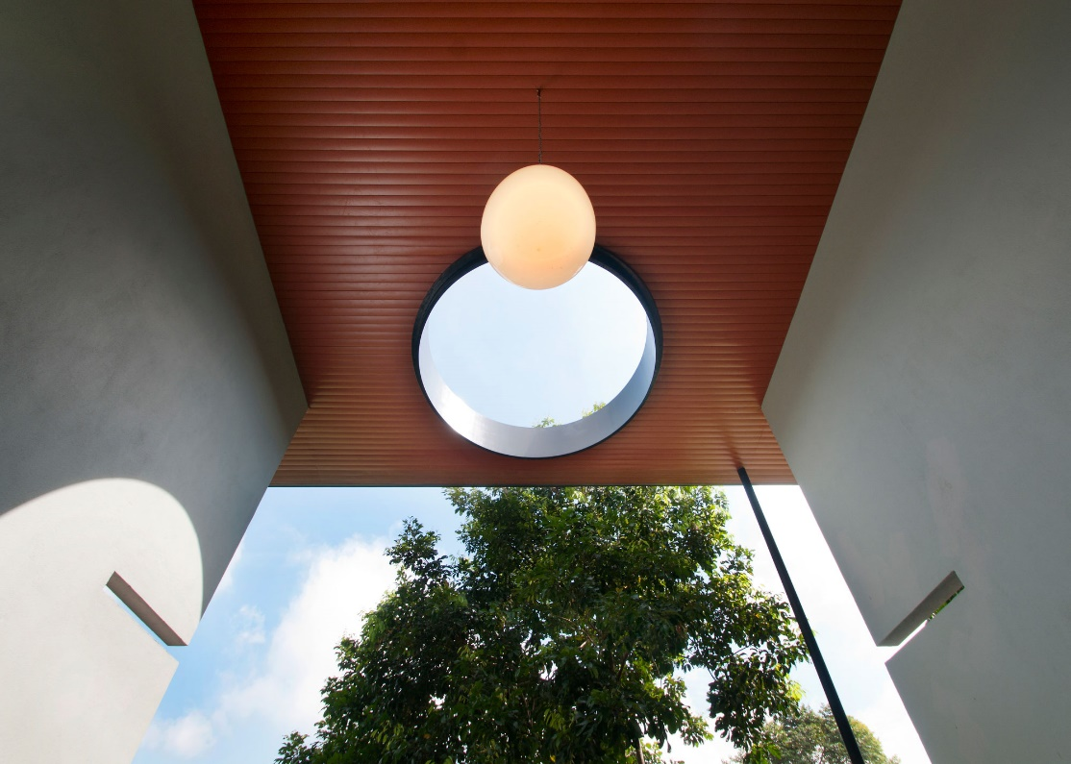

Figure 3.3.1 The opening at roof of House S11 that resembles the oculus. ( Source : <http://www.s11house.com/#gallery> )

The opening makes the building unique and standout, by casting a interesting shadows on the wall and floor. The plays of light and shadow makes the building becoming more fluid. As shown in the figure, there are trees surrounding the building as natural shading devices. The architect balance the amount of light entering the building with the aid of this opening in response to the site context.

**4.4 Materials choice**

**4.4.1 Fair-faced red clay bricks**

In S11 house, clay bricks is one of the foremost materials used both in interior as well as exterior. Towards sustainable design, clay bricks are the one material that can’t be overlooked as it’s the most sustainable green building material made. Brick is the first masonry material that can attain a “Certificate of Environmental Claims” from a third party source. It’s only because of its countless recycling options, environmentally friendly manufacturing process and also low embodied energy to manufacture bricks. According to Australian Greenhouse Office; Sustainability Victoria; Industry & Investment (NSW), heating and cooling make up 39% of the average home's energy use. By combining bricks and insulation in our home, we can decrease energy bills by up to 25%. A study done by The University of New Castle also shows that insulated brick home was almost 18 degrees Celsius cooler than the outside temperature, without any artificial cooling.

Bricks with great thermal insulation perform pretty well in providing comfortability to occupants when compared to other building materials. Bricks maintain constant interior temperatures of a structure due to their ability to absorb and slowly release heat. During daytime in Malaysia, where most of heat from sunlight will enter the building through walls, bricks is the one material that keep the unwanted heat away. In daytime, the clay bricks used in S11 house absorb a huge amount of heat due to its thermal mass property. This minimise the heat entering the building, keeping the house cold. A research done by The university of New Castle noted that considerable amount of heat radiated back into the environment by the exterior face of brick walls. This effect is then enhanced through use of light-coloured brick to reduce heat absorption and shading external walls to limit the amount of direct sun.

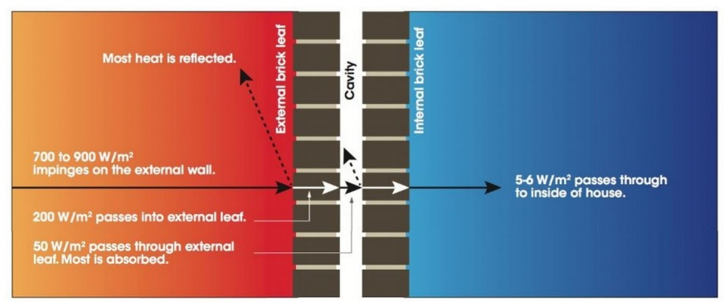Figure 4.4.1 Heat flux through a brick wall. This shows that only a little bit amount of heat passes into the internal spaces, thus keeping the house cold.

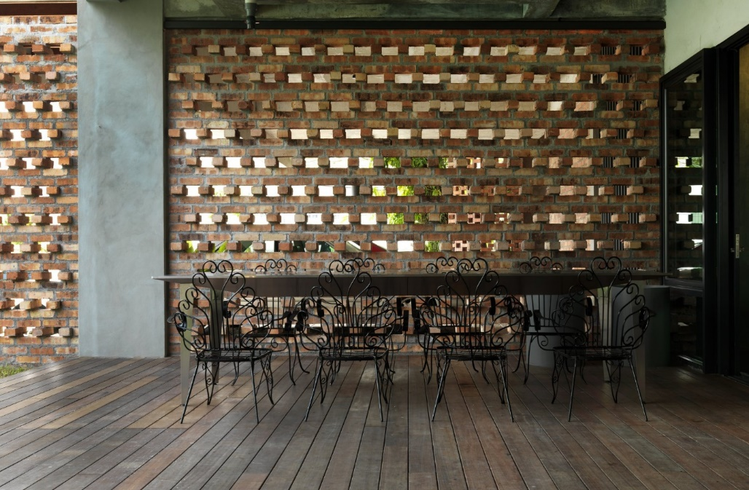

Figure 4.4.2 The use of fair faced red clay bricks in S11 house. The arrangement of bricks allowed natural light to pass through for illuminating purpose. ( Source : <http://www.s11house.com/#gallery> )

**4.4.2 Low E laminated glass**

Low E laminated glass is a type of glass is a type of coated glass that reflects long-wave infrared energy(heat). Solar infrared is commonly referred to as short-wave infrared energy, which means heat. Infrared light or heat energy, is transmitted as heat into a building, and begins at wavelengths of 780 nanometers. In S11 house, this glass type is used to minimize the amount of UV rays and infrared light that pass through glass without compromising the amount of visible light that is transmitted. By installing these low e laminated glass, the architect is allowed to utilise the natural daylight to lit the interior spaces of the house in a controlled manner, while keeping the heat gain to the interior spaces to minimum, as low e glasses reflect significant amounts of short-wave solar infrared energy.

**5.0 Conclusion**

Daylighting has been favour by architects more than artificial lighting for its many aesthetic values, energy efficiency and health benefits to the occupants. Scientists at the Lighting Research Center (LRC), in Troy, N.Y., for example, have proven that daylit environments increase not only the occupant overall productivity, as well as their well being, and provide the mental and visual stimulation necessary to regulate human circadian rhythms. In this world where we are facing the natural resources depletion crisis, daylight is one of the important tool that is being used to preserve our precious natural resources. However, nothing in this world come perfect, same goes to daylight. As an architect, we are to deal with the challenges in order to accomplish the ultimate balance in utilising daylight while not bringing more issues to the people. By doing so, we are not only saving more natural resources but more importantly raising the awareness among people of the environmental issues we are facing right now.

In conclusion, daylighting system should be highly encouraged and support by the people so that sustainability in construction field can be achieve more easily.

**6.0 References**

*Approved method: IES spatial daylight autonomy (sDA) and annual sunlight exposure (ASE*). (2012).

New York, N.Y.: Illuminating Engineering Society of North America.

Edwards, L., & Torcellini, P. (2002). Literature Review of the Effects of Natural Light on Building

Occupants.

Hart, K. (n.d.). Green Home Building: Article about Principles of Sustainable Architecture.

Retrieved June 6, 2015, from http://www.greenhomebuilding.com/articles/susarch.htm

Hunter, C. (2003). *The benefits of daylight through windows*.

Troy, NY: Lighting Research Center, Rensselaer Polytechnic Institute

Ismail, M., & Rahman, A. (2012). Rooftop Turbine Ventilator: A Review and Update. *Journal of*

*Sustainable Development JSD*.

Light pipe architecture. (n.d.). Retrieved June 6, 2015, from

<http://www.oobject.com/category/light-> pipe-architecture/

S11 House - Malaysia's first GBI Platinum (CVA) rated house. (n.d.). Retrieved June 6, 2015, from

<http://www.s11house.com/>

S11 House / ArchiCentre. (2013, January 2). Retrieved June 6, 2015, from

<http://www.archdaily.com/313041/s11-house-archicentre/>

Serrats, M. (2012). *1000 tips by 100 eco architects*. Richmond Hill, Ont.: Firefly Books.

Strongman, C. (2008). *The sustainable home: The essential guide to eco building, renovation and*

*decoration.* London: Merrell.