

THEORIES OF ARCHITECTURE & URBANISM [ARC61303] [ARC2224]

Project The Image of the City Part 2 – Cognitive Mapping

Tutor : Mr. Lam Shen Fei

Yeow Yi Chuan 0317576

**Introduction to the site**

The site I have chosen for this project is the area around the junction of Jalan T.A.R(Tunku Abdul Rahman) and Jalan Dang Wangi. The reasons why I chose this site over the other is because this area is quite interesting in term of the multi-cultural background of the people around, as well as the architecture. The busy shopping districts and local delicacies managed to attract people of different background and beliefs, from different countries to gather here, making this place even more captivating. The workers and business men from foreign countries, the locals that have been lived here for decades, and some students from neighbouring areas came across, where they have their own impressions on this place respectively, allowed me to study and look at this site at a bigger picture. Throughout the study, I circulate and look around this area, pass through all the main pathways and back alleys I could possibly find, to understand how people get here, why they are here, where do they eat and so on. I recorded down my feelings about this place for the very first time I visited here, and after I’m truly familiar with it. This is to ease my study and of course, help me when I analyse the data collected.

**Introduction to cognitive mapping**

Cognitive maps are map-like mental constructs that can be represent a person’s mental picture or image of the layout of a physical environment. This is a mental map used to study the way human find their way when there are in a place totally strange to them. This map reveal the paths or routes human take to a specific place in a particular area.

The overall project expect a few mental maps from people with different background. The main idea is also to investigate how human mental reacts to the change in proximity or size of a place, or maybe taking in the historical and cultural factors as well.

Throughout the project, I approached a few of the people with different background, conducted an interview verbally then asked to them draw their cognitive maps about this area for the analysis that have to be done later on. The difference in points of interest, the thing they have overlooked are the important facts that affect the studies.

Introduction of Cognitive Map 1

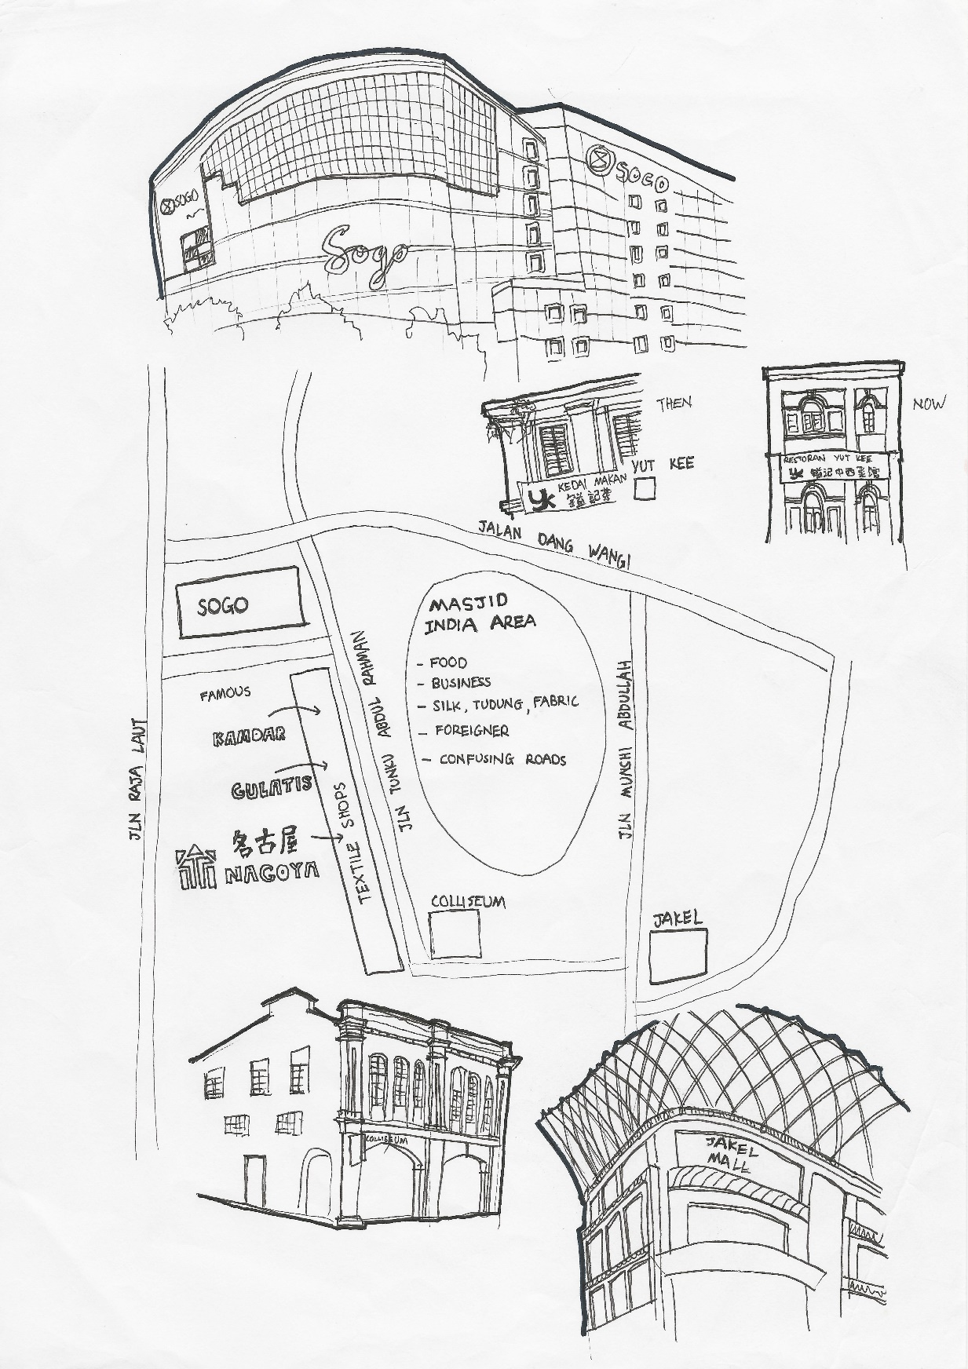The first cognitive map is my own mental map, and was drawn right after the first time I visited the place. I can only imagine the urban area by roughly pointing the position of a few key buildings that can be easily recognised. Then, from there I started to identify the main roads. Along the process of looking of walking around, I memorised the brands I can recognised then from there I started to slot in the places which have not much vision impact. However, I couldn’t identify the small alleys around this area. The area is not following the grid system and a bit unorganised.

Introduction of Cognitive Map 2

The second mental map is by a picture frame maker, Ms Lilian who has been working there for decades. Even so, the mental map is more or less the same comparing to the first one. The major elements like landmarks and key roads are positioned accurately in the map. This subject manages to visualise the map more detailed than I am due to her familiarity to the place. From the map, I can assume that she is more familiar with the area along Jalan T.A.R as you can see the density of elements are way higher than the Masjid India area. In the cognitive map, there are a few keywords which is based on her memory. It’s to represent the incidents that happened long ago in this area.

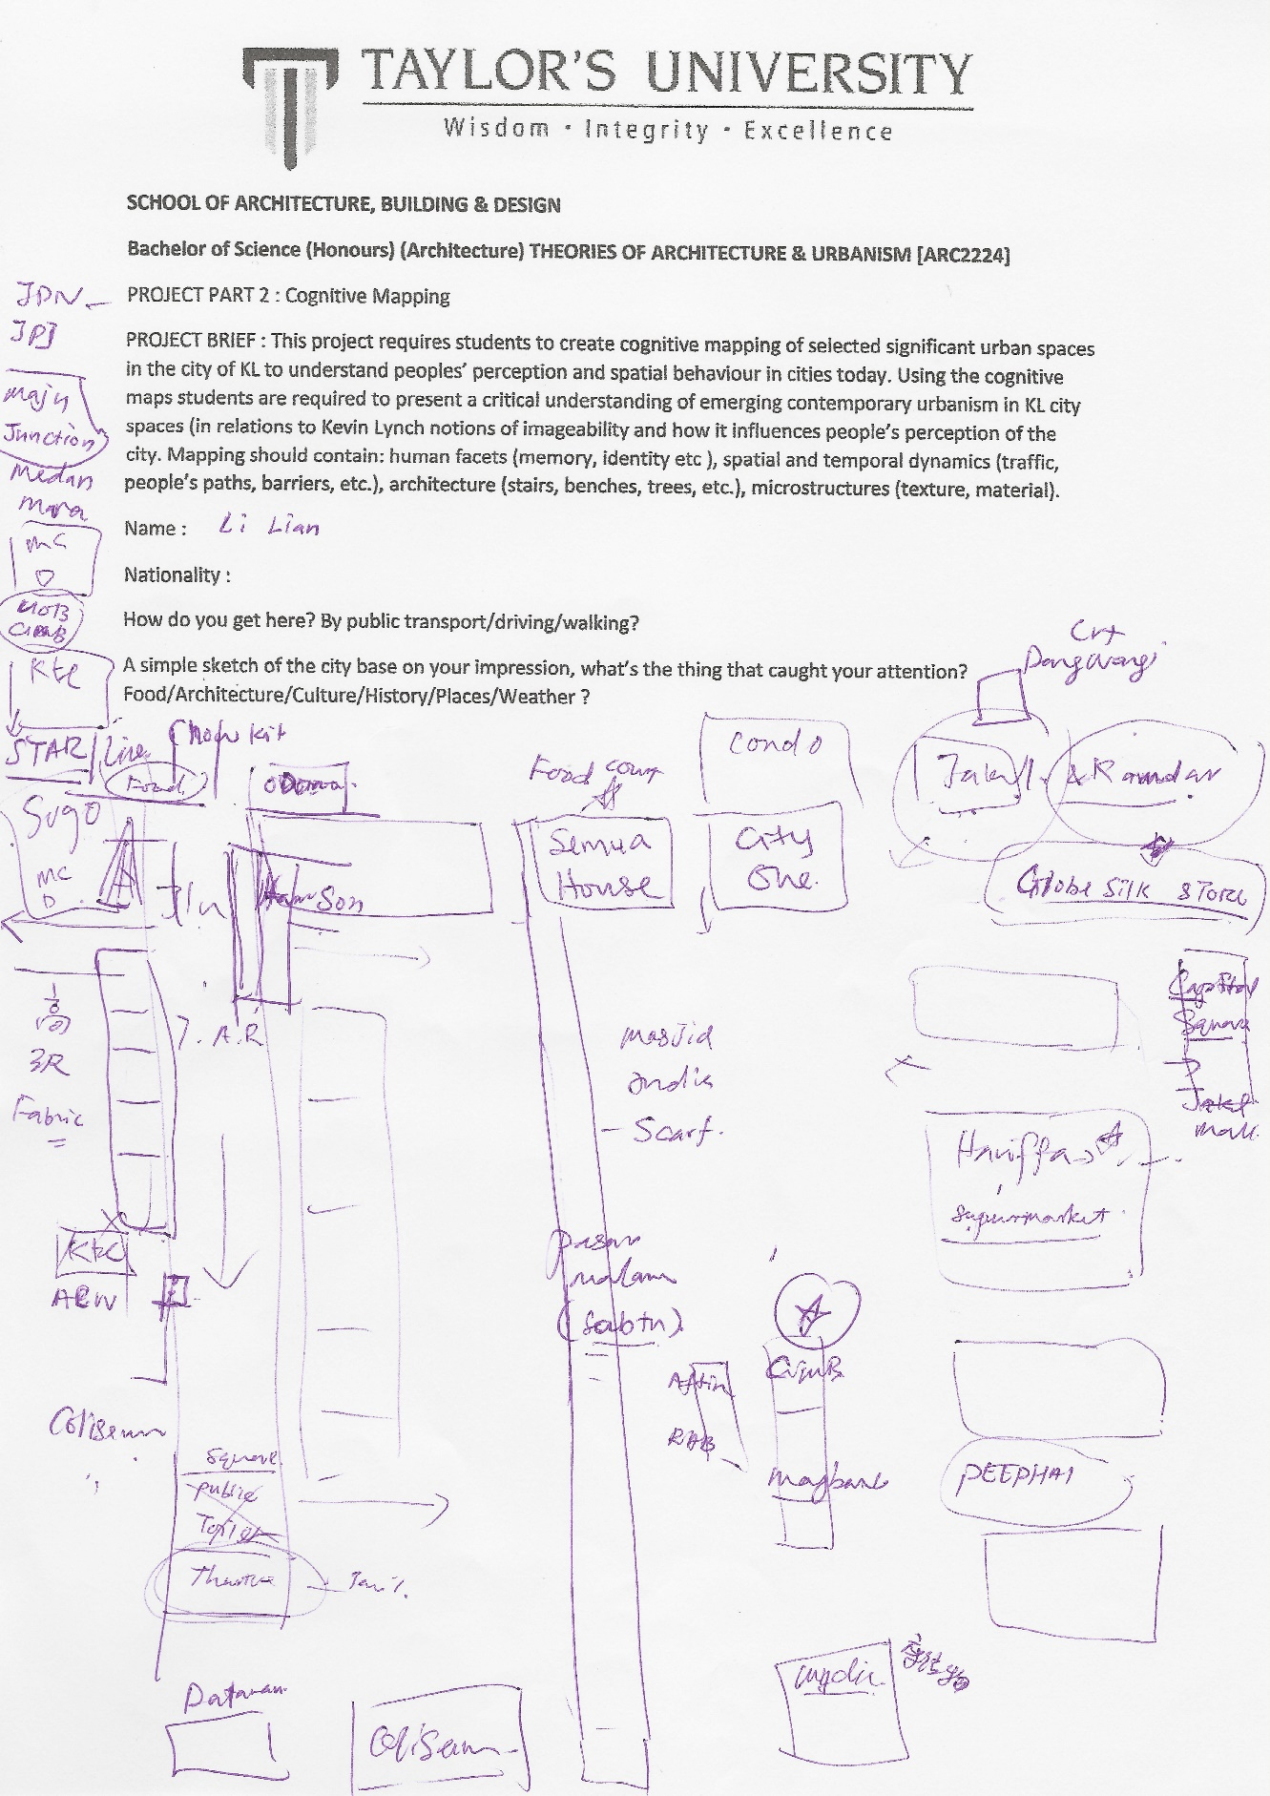

Introduction of Cognitive Map 2

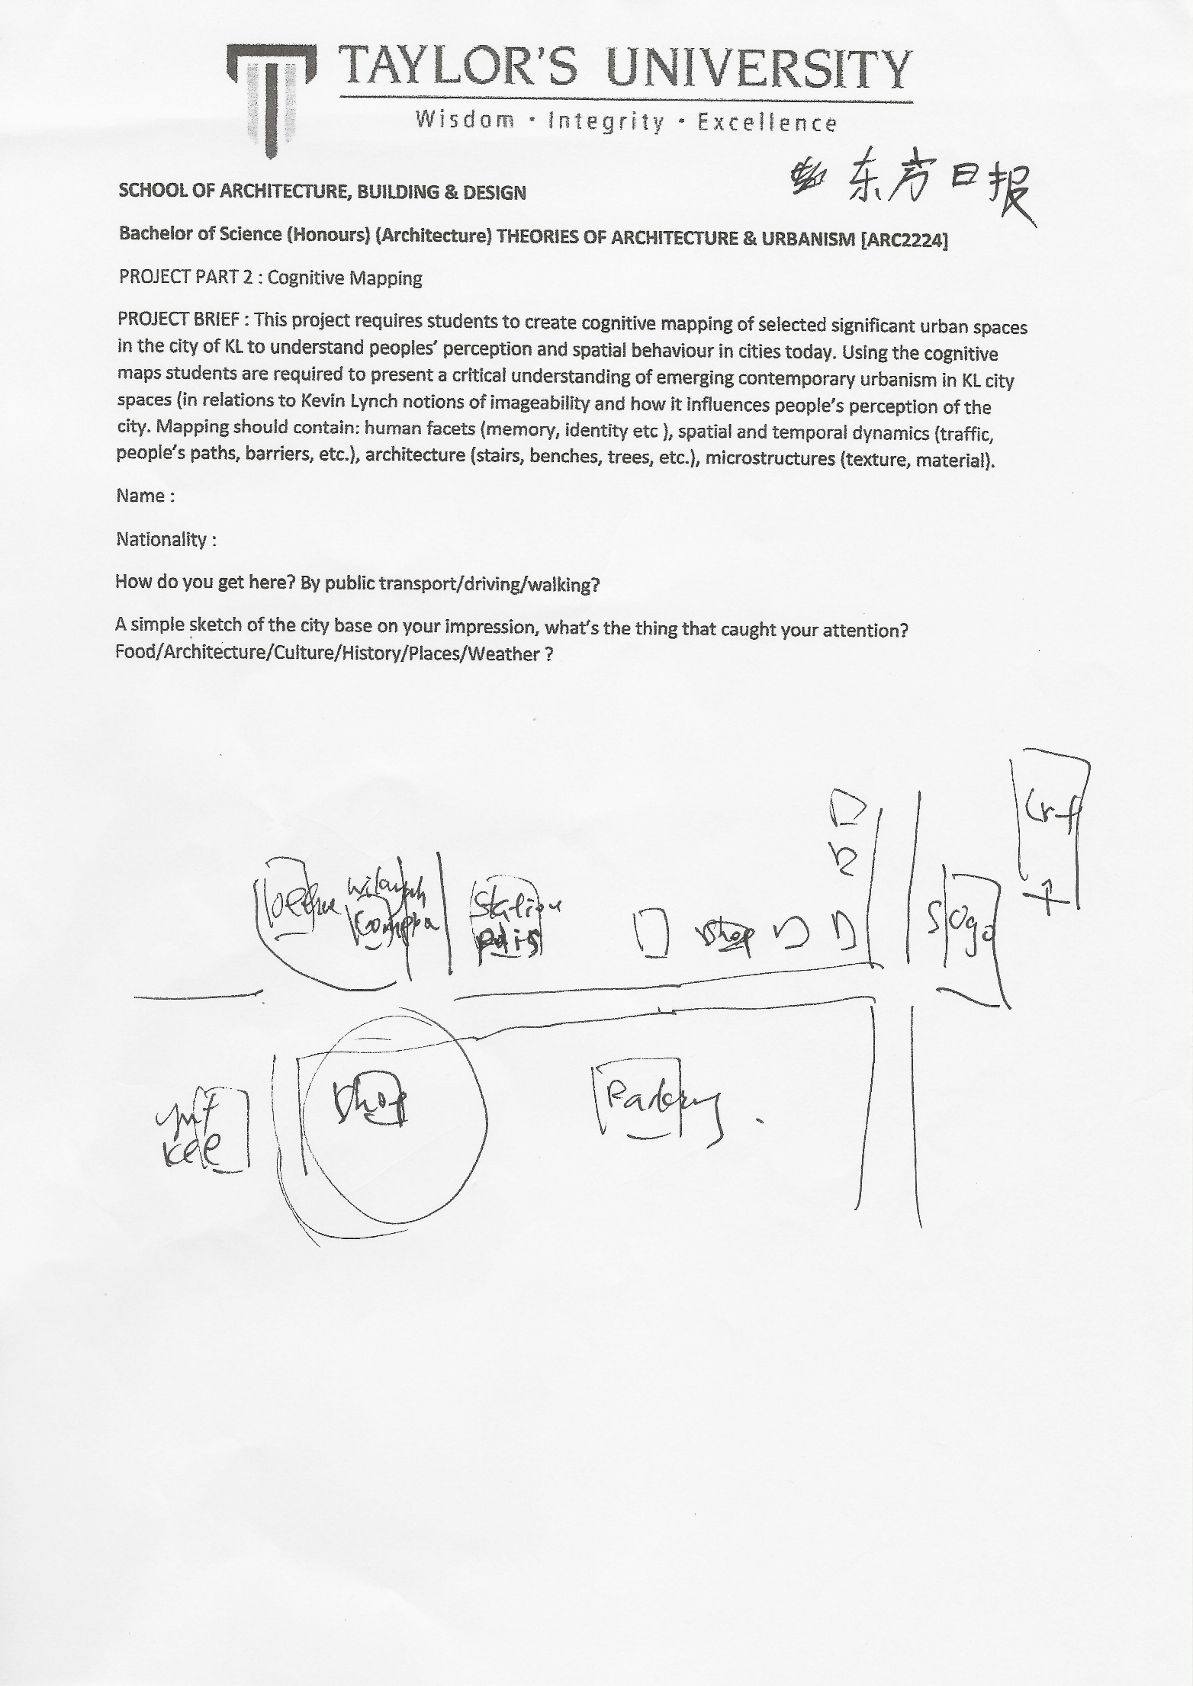The third mental map is by a female worker from oriental daily press. She don’t live here and get to work by taking LRT. By analysing her map, I concluded that she is totally new to this place. She can only identify the most important element here, which is the Sogo. In the map, she drew only a few old buildings around her offices. The only familiar element other than Sogo from her map is Yut Kee’s restaurant. The interesting part if her map is she highlighted the police station which can be used to identify a few corners and roads.

**SIMILARLITIES**

Sogo shopping complex and the key pathways around(Jalan T.A.R is the most frequent mentioned)

In Dang Wangi, when you mentioned about the word ‘impression’ or ‘iconic’, you will realise the first thing you hear is Sogo. Sogo shopping complex is Dang Wangi’s absolute landmark, to the extent that some people do not know where Dang Wangi is but they are clearly aware of the presence of Sogo in this area. Basically all the people we interviewed stated clearly the exact location of Sogo shopping complex. Using Sogo shopping mall as the centre point to generate the cognitive map, followed by the rest of the elements. I analysed the data collected and of course there are reasons why Sogo is so popular here.

First of all, the location of Sogo. It’s located at the place where people will definitely pass through, no matter by driving, public transport or walking. It’s surrounded by a few key vehicular pathways, which is Jalan Laut , Jalan T.A.R and Jalan Dang Wangi. These are the roads that people will have to pass through if they are driving in this area. The presence of Sogo is further intensified as its location is just right beside the intersection point of Jalan T.A.R. and Jalan Dang Wangi. This is the point where all the car gathered, while leaving or entering this place, so the massive Sogo should be noticed at all time. It’s not exaggerate to say that 10 out of 10 people who visit here will know Sogo.

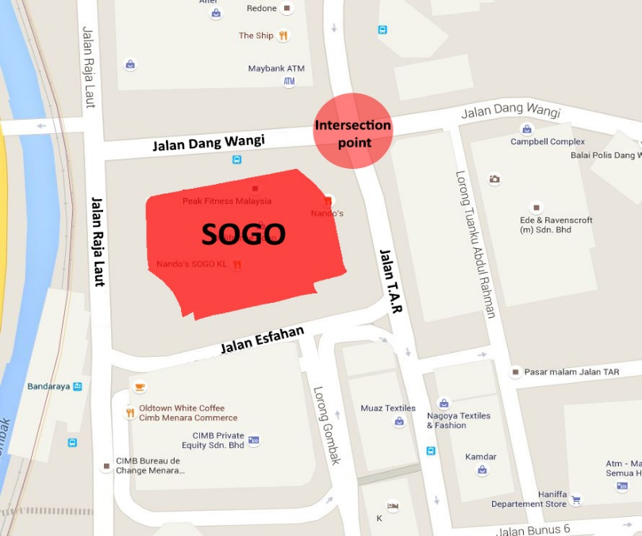

Diagram shoes Sogo is surrounded by the important roads.

Then, there are a few public transport that will lead you to Sogo as well. By taking LRT, visitors just have to get off at Bandaraya stop, there is a bridge connecting the station to Sogo. As for Monorail, get down at Medan Tuanku, walk along the Jalan Sultan Ismail, then make a left turn at the junction, walk a little further down then Sogo is just right infront. There is even a bus stop located in front of one of the Sogo’s main entrance. No matter how you look at it, the people who want to visit this area will definitely realise the presence of Sogo, not only by its massive built form, but its strategic location as well.

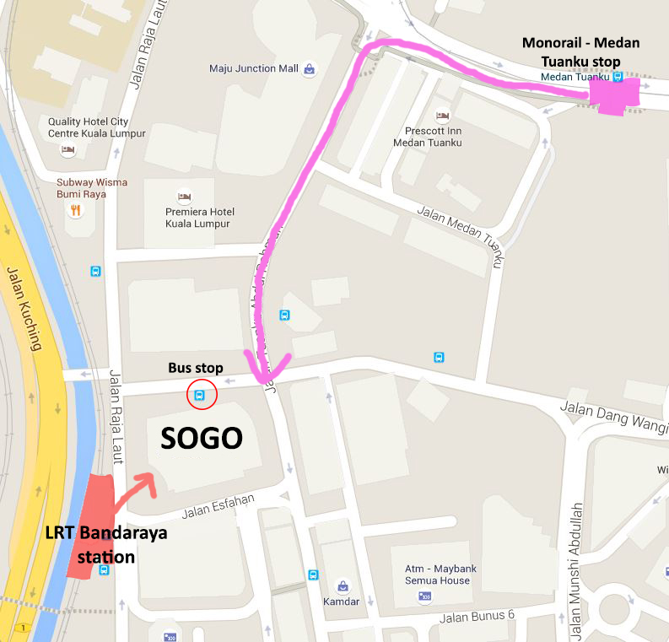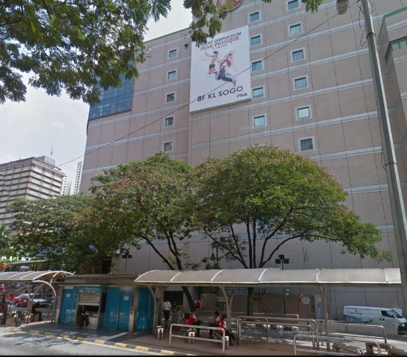

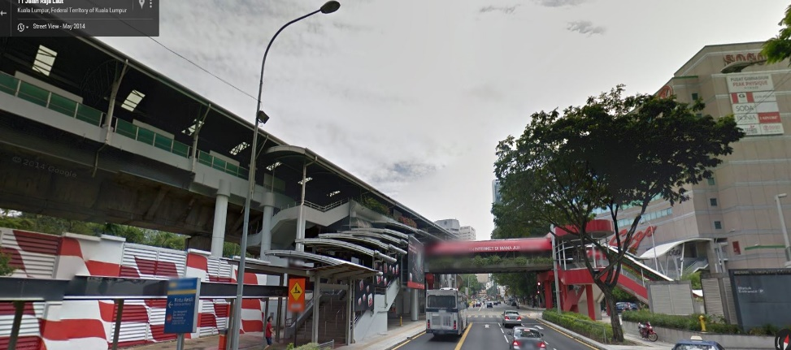

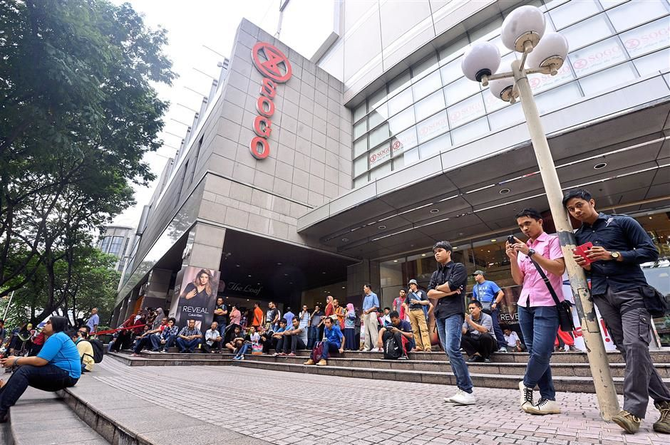In facts, the Sogo could be one of the most frequent mention in this finding, not only by its strategic location, but the plaza in front. The plaza has been a nodal point for the street performers. People living or working around starting to gather here, maybe as a tradition, whether to kill time, to chill with their family or to enjoy the show. Thus, more people get to know Sogo as a result.

People gathering in front of Sogo for the street performances.

Textiles paradise

The next thing interviewed subjects will definitely mention about this study area are Masjid India, Scarf, Fabric, Jakel, Fashion. All the thing stated above have a deep relationship with this area.

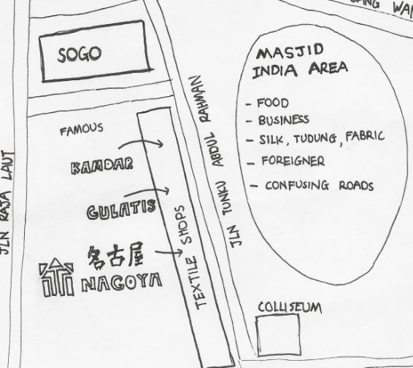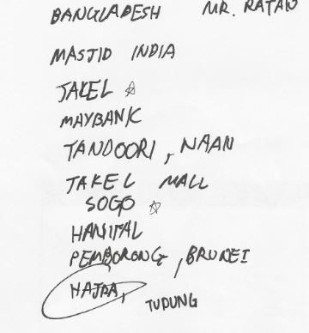

(Source : Mr. Ratan from Bangladesh) From cognitive map 1

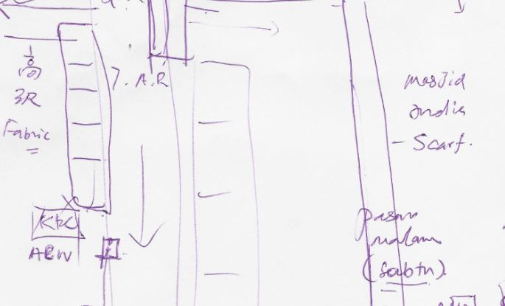

From cognitive map 2

Dang Wangi is always a famous shopping place for fabric, from affordable textiles which is relatively cheaper than any other place, up to top quality fabric ready to be export.

First, are the shop lots along Jalan T.A.R. This street is easy to be remembered because of its main function : textiles suppliers. The majority of shops here are textiles shop. The pattern of their way in displaying their products, together with the colourful signboards, the sound of loud speakers when the shop owners promoting their products, helps in creating the identity of this place. When we first steps into this place, we know it’s Jalan T.A.R immediately, as this is just as it is, a textiles place. The interesting part of this place is that the façade of the shops along this road is different. The façade is not the conventional repetitive pattern, but heavily decorated in different architecture languages. Some of the shops are fully covered with banner, some are painted in different colour, while some shops are very ‘European’ styled. This is why people will leave a deep impression on this road as compared to other places.

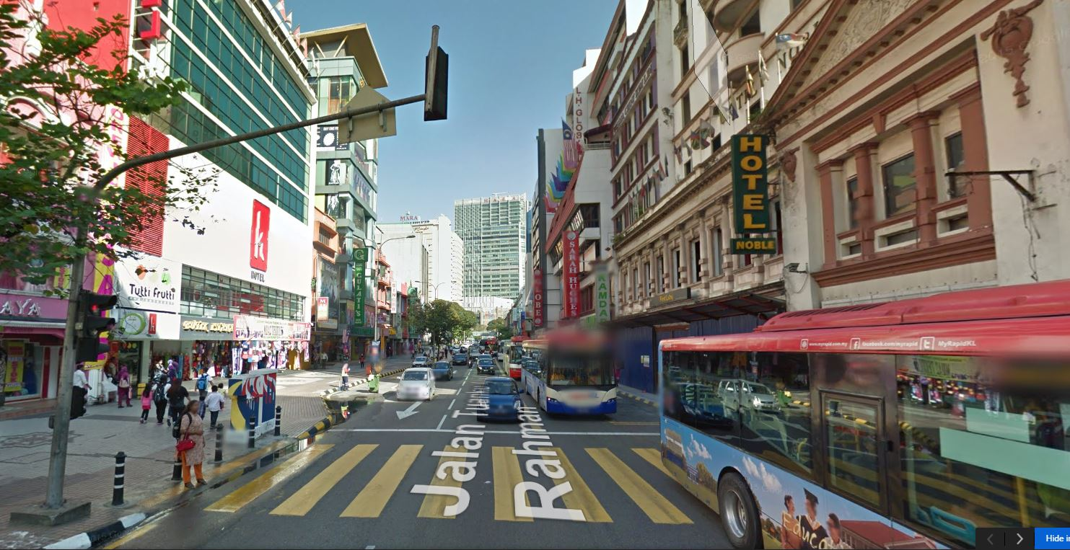

Textile shops along Jalan T.A.R

Then, the Masjid India, same as Jalan T.A.R, a textiles shopping place, however, mostly on wholesale and exporting, in a more larger scale compared to Jalan T.A.R. This place is well known even internationally. The business man from Brunei, Eastern Malaysia and many other places were drawn here due to the textiles business, making this place truly multi-cultural and thus making this place quite iconic. Another reason why most of the people know this place is that here is where you can find all kind of food. The majority of workers, visitors, tourists or students will be having their meals here because there are food courts around, together with the stalls, providing wide variety of food, not to mention there are tons of restaurants as well.

The old memories – Coliseum Cafe

Next, the Coliseum Hotel & Café is also a frequent mentioned named in the subjects’ map. The Coliseum Cafe is known even after so long is because the name itself is important in Malaysia’s history. The coliseum was founded in 1921, before World War 2 and still operating until now, almost a century. It’s the first, and the longest operating western colonial themed restaurant in Malaysia. Malaysia’s former prime ministers, from the first to the fifth, had visited this place, so no way the ordinary like us could not know this place. Then, as in architectural point of view, this shop is just 5 minutes away from Sogo, and is beside the busiest Jalan T.A.R, which can be identified easily due to the interesting decoration of the shop. On the exterior wall of this Coliseum café is the painting of our prime ministers, a wonderful piece of artwork in this area, making it even more eye catching. Their signature dishes, unique western hainese fusion cuisine did a good job in spreading the name as well.

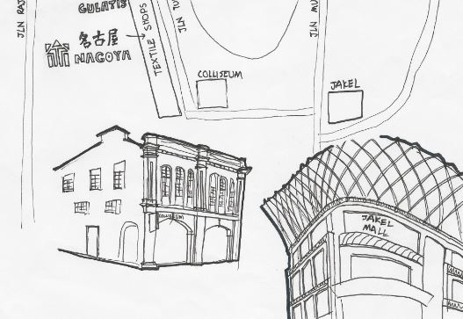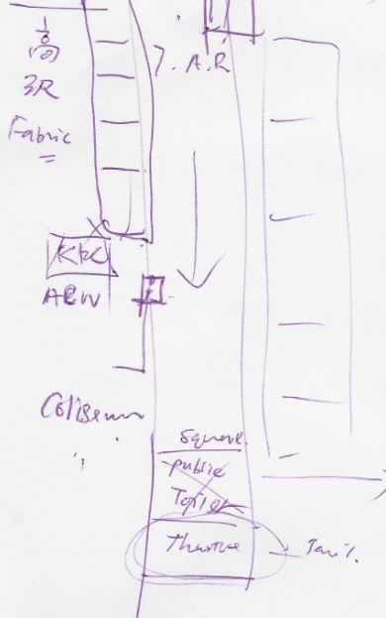

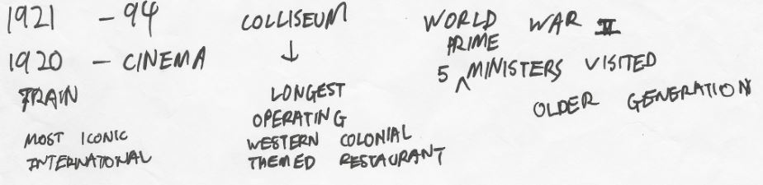

From Cognitive map 1

From cognitive map 2

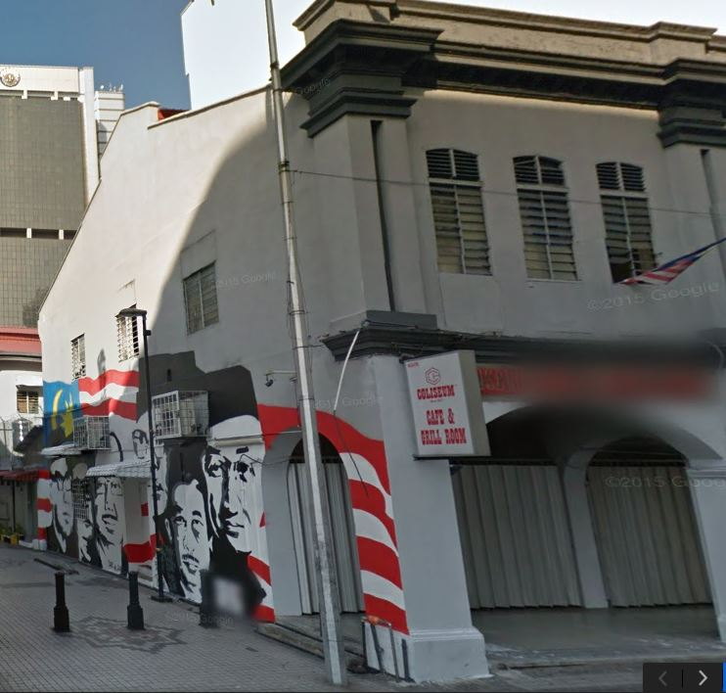(Source : Mr Lam)

The painted wall of Coliseum Café

**Dissimilarities**

Area where they have their meals

The most significant differences I can find in the cognitive maps is the area where the subjects normally have their meals. According to findings, white collar workers around CIMB banks building will be having their meals in Sogo’s food court while the rest will be having their meal in Semua house’s food court or just get some simple food from the food stalls. The reason behind this could be the pricing. The expenses in Sogo’s food court will be slightly higher compared to the restaurants outside. This make sense when white collars with higher income will be having their meals in Sogo(which they emphasized on the hygienic issues) rather than outside.

Then, from the cognitive maps produced by Non-Muslims friends, the “Yut Kee” restaurant is often mentioned but not in Muslim friends’ map. This could be because of this famous Chinese-Western restaurant serve the very famous, however non halal roasted pork and “roti babi”. This restaurant located in North East direction of Dang Wangi, it’s a place where mostly Non-Muslims hanging around. The people around will surely answer “Yut Kee” restaurant when talking about food. This restaurant is so famous only within Non-muslims because they serve non halal food. So, a simple conclusion can be made that the difference in identify or locating a place for food will somehow be affected by eating habits and religion as well.

Banks in Masjid India

Normally, banks wouldn’t really be mentioned as it’s too common. Majority of the interviewed people focuses on food, buildings, the roads and an area which serve a specific function. Despite that, out of some many subjects with different background, there are still 2 people spoke about banks.

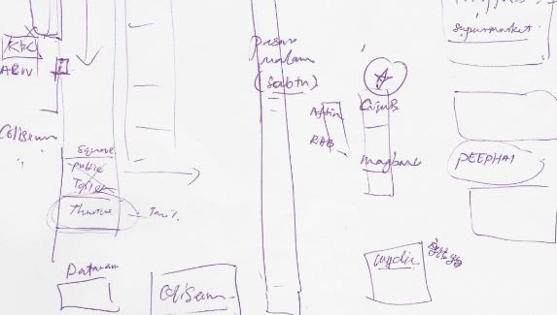

From cognitive map 2 (Source : Mr. Ratan from Bangladesh)

These people do business in Masjid India. The sales, purchasing and trading are done in cash so we can expect a huge cash flow within that area. Thus crime cases like robbery and thievery are happening quite often. In order to secure their money and property, they have to go to banks frequently. For example, according to one of the source, Mr Ratan from Bangladesh who is running a company in this area, doing textile wholesale, must go to the nearest bank he could find in Masjid India every few hours to bank in their money. The same reason goes for the first person.

Buildings beside Sogo shopping complex

By comparing the cognitive maps, beside Sogo, the respective landmarks are Jakel mall, CIMB building and police station. The most interesting example is the police station. The subject drew police station as her second landmark. This can be explained by her familiarity with the police station. In Malaysia, the police station are designed to be very defensive and always finish painted in Blue and White. No matter what area in Malaysia, as long as It’s blue and white, the percentage of it being police station is high. So the same principle is applied to the subjects. She is familiar with the conventional police station. For a subject like herself who is fresh with this place will immediately attach to the buildings/signage she is familiar with.

**Discussion on findings & Conclusion**

Throughout the studies, I found that majority of the subjects managed to imagine the city of Dang Wangi based on Kevin Lynch’s theory on “Image of the city”. They will first memorise the landmarks, for this case, the Sogo, then slowly generate other elements such as edges, paths, nodal points and districts. As the Sogo is surrounded by all the key driveways, so they can easily identify the pathways, and where the roads lead to. Then along the roads, they placed the buildings/places according, forming edges and districts. Then, from there add in the details and information. The subjects, whether familiar or not with the place, successfully generate the cognitive maps using the theory.

As conclusion, people with different background will have a totally different image of city. The people who have been living or working there for long enough will organize their mental map based on their memory, the past experience and the visibility of the city. As for the new comers, they arrange their maps the same way as the other did, relying on vision. Throughout the projects, not even one subjects think that by touching or smelling could help in looking for a way in a city make sense.