Week 1

Construction activity : Site excavation

Duration : 6days

Materials : -

Equipments : backhoe loader, bulldozer, excavator

Skilled workers : heavy vehicle drivers (3), general worker (3)

Technical information : These vehicles will responsible in removing all the obstacles and the hoarding will be set up to prevent outsiders from coming in.

Week 2

Construction activity 1 : Construction surveying

Duration : 2 days

Materials : -

Equipments : theodolites

Technical information : The angular deviation, horizontal, vertical and slope distances are accurately measured by using equipment stated above.

Construction activity 2 : Compacting/ Level the earth

Duration : 1 day

Material : -

Equipment : Compactor

Week 3

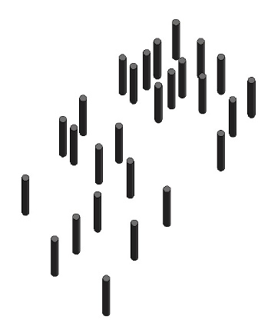 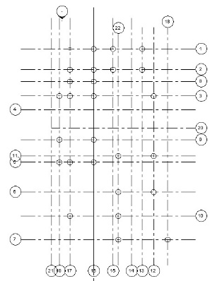

Construction activity : Piling

Duration : 6 days

Material : precast piles

Equipment : hydraulic hammer

Skilled worker : Piling machine driver , 1 recorder , 2 general workers

Technical information : The piles are hammered down according to the foundation plan prepared by engineer. The worker will make sure the piles to stay vertical using a leveling instrument during piling process as the obstruction during piling can cause the piles to deflect from true vertical line. The pile is said to be stable only when it goes no more than 2mm when hammered for 10 times.

Week 4

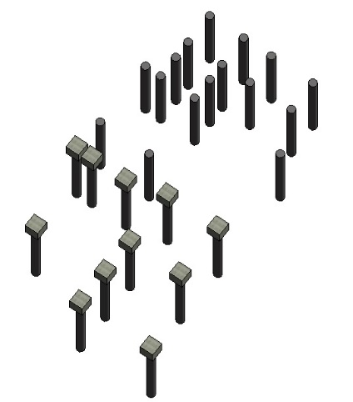

Week 5

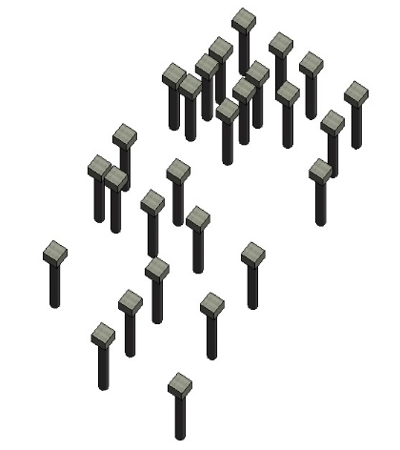

Construction activity : Piles cap

Duration : 6 day

Materials : Concrete grade 30 , laminated plywood( for formwork), reinforcement

Equipment : concrete mixer

Skilled worker : Carpenter (2) , General worker (4)

Technical information : The formwork will be construct right after the piling is done. Then , concrete is pour into the formwork. Then, the concrete is stirred to make sure that there is no air bubbles that might weaken the structure when set .Once the pile caps hardened, it’s ready for the next move.

Week 6

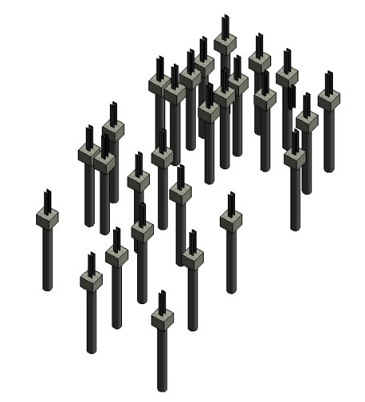

Construction activity : stumps from pile caps

Duration : 6 days

Materials : Concrete grade 30 , reinforcement , timber formwork

Equipment : concrete mixer , bar bending machine , heavy duty circular saw

Skilled worker : carpenter 2, bar bender 2, general worker 2

Week 7

Construction activity : Construct formwork for ground beams

Duration : 3 days

Materials : Laminated plywood, nails

Equipment : Hammer, clamps, measuring tape

Skilled worker : Carpenter (2)

Technical information : -

Week 7

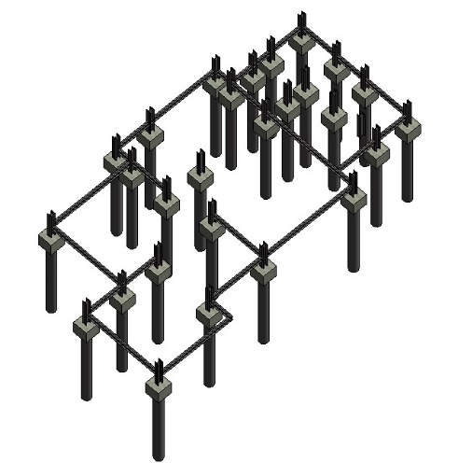 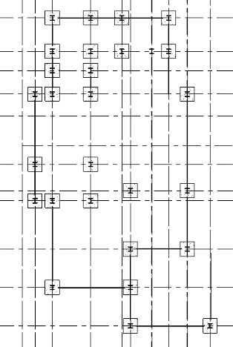

Week 8

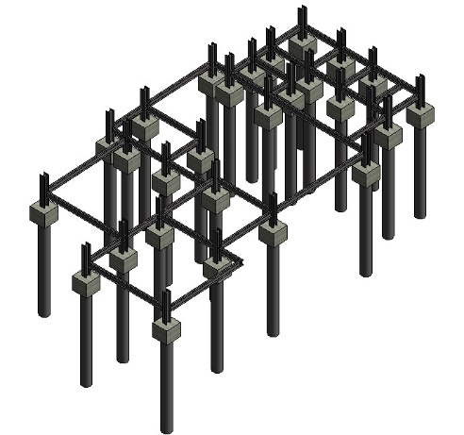 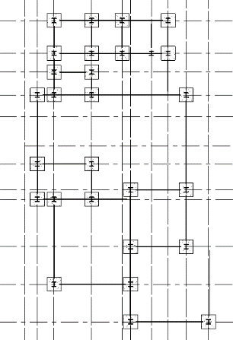

Construction activity : ground beam

Duration : 6 days

Materials : concrete grade 30 , reinforcement , laminated plywoodformwork

Equipment : concrete mixer

Skilled workers : general workers (3)

Week 9

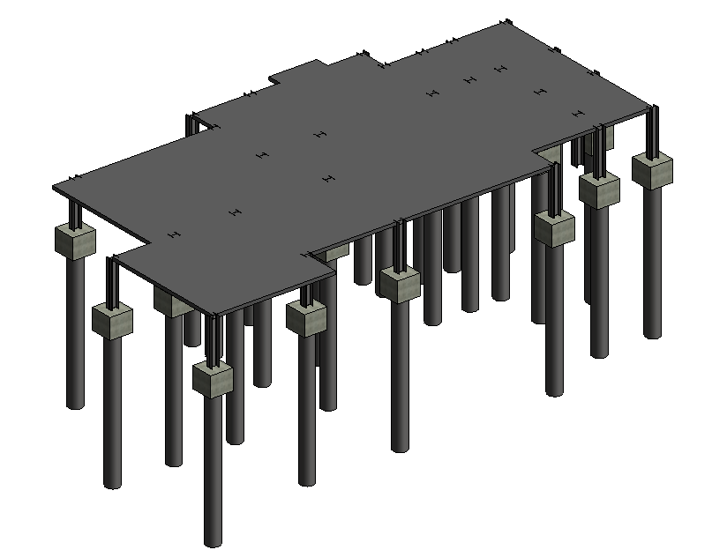

Construction activity : ground floor slab

Duration : 6 days

Materials : Concrete grade 30, coated plywood formwork, reinforcement

Equipments : concrete mixer, leveling instrument

Skilled worker: general worker (3)

Technical information : Formwork will be set up and the reinforcement will be place before the concrete cast into the formwork. Once the concrete is cured, the ground floor slab is done.

Week 10 & 11

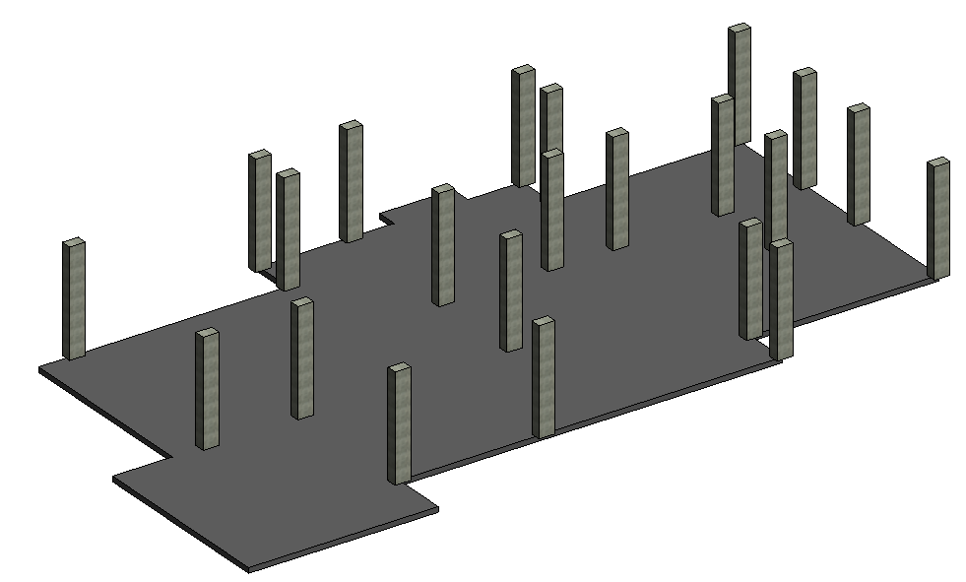

Construction activity 1 : Formwork for columns

Duration : 3 days

Materials : Coated plywood

Equipment : Concrete vibrator

Skilled worker : general workers (2)

Construction activity 2 : Casting the columns

Duration : 7 days

Materials : Concrete grade 30

Equipment : concrete mixer

Technical Information : The workers will make sure the concrete went all the way down in the formwork by using concrete vibrator.

Week 12

Construction activity 1 : Set up the scaffolds

Skilled worker : General worker (2)

Duration : 1 day

Materials & equipment : -

Technical information : -

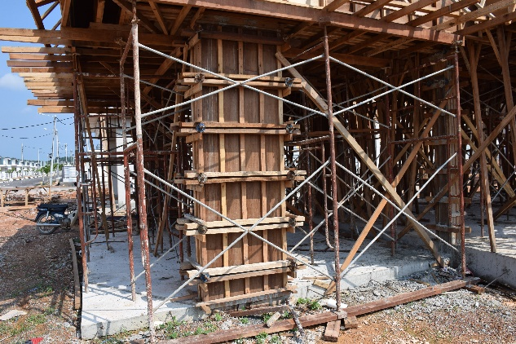

Construction activity 2 : Formwork for first floor beams and floor slab

Duration : 5 days

Materials : Coated plywood

Equipments : Table saw, Measuring tape

Skilled worker : Carpenter(2) , general worker (2)

Technical information : The formwork will be support by the scaffold and also timber beam support cross

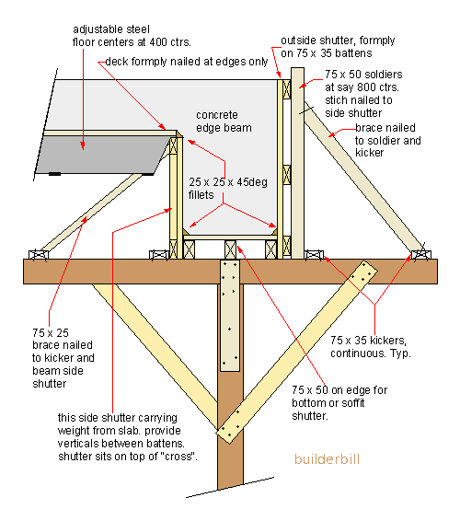

Formwork supporting system for floor slab and beams

Week 13

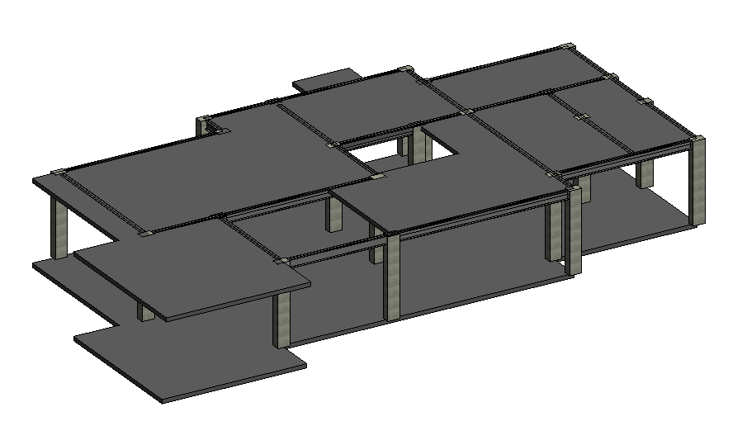

Construction activity : Pouring concrete into the 1st floor slab and beams formwork

Duration : 7 days

Materials : BRC , reinforcement bar, concrete grade 30

Equipment : concrete vibrator, concrete mixer, mobile crane

Skilled worker : General worker(4) , crane driver (1)

Technical information : Before pouring the concrete, the BRCs and reinforcement bars will be inserted into the formwork, with atleast 1 inch lifted up from the bottom using stools.

Week 14 & 15

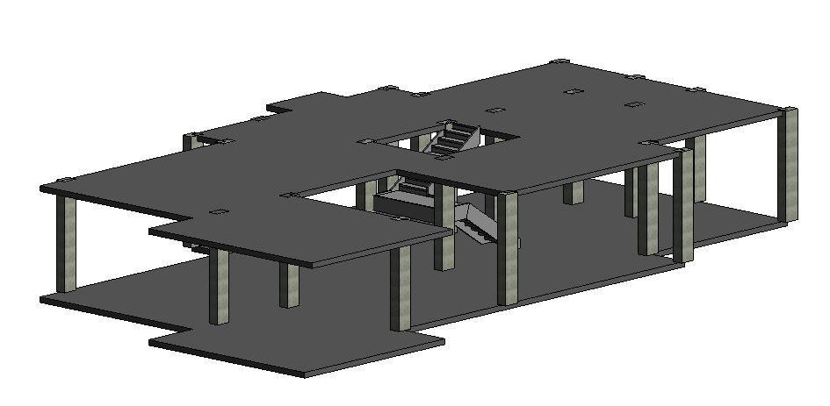

Construction activity 1 : Ground floor stair case formwork

Duration : 3 days

Materials : Plywood

Equipments : Table saw , Measuring tape, Leveling instrument

Skilled worker : Carpenter (1), General worker (1)

Technical information : The supporting system for formwork will be construct first. Then, the carpenter will mark the height and width of staircases on these plywood panels and start to construct the formwork for staircases.

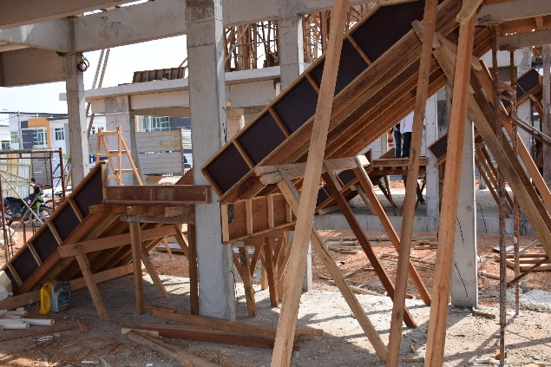 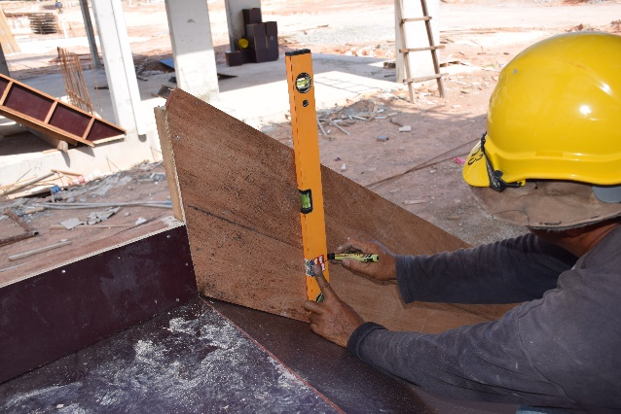

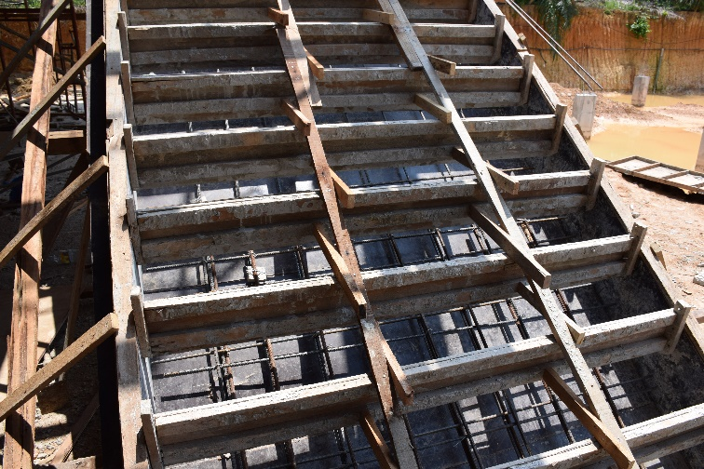

Construction activity 2 : Casting the concrete

Duration : 7 days

Materials : concrete grade 30

Equipment : concrete mixer and crane mobile

Skilled worker : General worker (2), crane driver (1)

Technical information : The carpenter will first construct the formwork for staircase. After complete the formwork, the reinforcement bar will be inserted and join with the starter bar. Then, the concrete will pour from top to bottom using a mobile crane to carry the concrete mixer.

Week 16 & 17

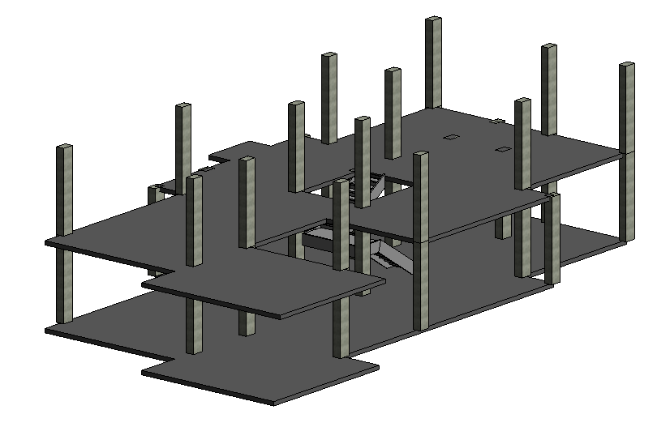

Construction activity 1 : Formwork for 1st floor columns

Duration : 4 days

Materials : Coated plywood

Equipment : Table saw, measuring tape,

Skilled worker : general worker (2)

Construction activity 2 : Columns for level 1

Duration : 7 days

Materials : Concrete grade 30

Equipment : concrete vibrator, concrete mixer, mobile crane

Skilled worker : general worker (3) , crane driver (1)

Technical information : After pouring the concrete into the formwork, the workers will be vibrating the concrete to make sure it goes all the way down to the bottom of formwork.

Week 18

Construction activity 1 : Set up the scaffolds

Skilled worker : General worker (2)

Duration : 1 day

Materials & equipment : -

Technical information : -

Construction activity 2 : Formwork for second floor beams and floor slab

Duration : 5 days

Materials : Coated plywood

Equipments : Table saw, Measuring tape

Skilled worker : Carpenter(2) , general worker (2)

Technical information : -

Week 19

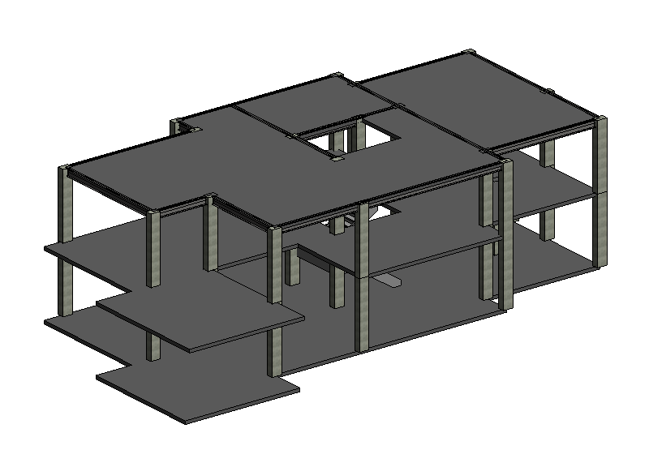

Construction activity : Pouring concrete into the 2nd floor slab and beams formwork

Duration : 7 days

Materials : BRC , reinforcement bar, concrete grade 30

Equipment : concrete vibrator, concrete mixer, mobile crane

Skilled worker : General worker(4) , crane driver (1)

Technical information : Before pouring the concrete, the BRCs and reinforcement bars will be inserted into the formwork(with atleast 1 inch lifted up from the bottom using stools).

Week 20

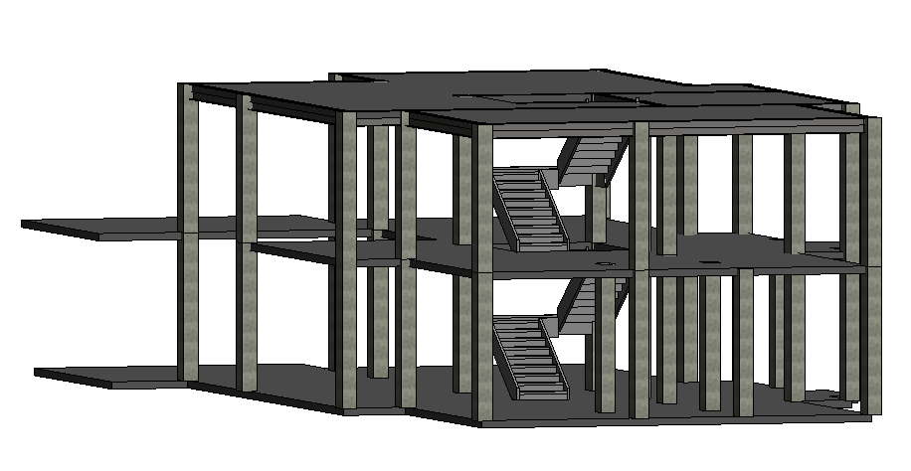

Construction activity 1 : First floor stair case formwork

Duration : 3 days

Materials : Plywood

Equipments : Table saw , Measuring tape, Leveling instrument

Skilled worker : Carpenter (1), General worker (1)

Construction activity 2 : Casting the concrete

Duration : 7 days

Materials : concrete grade 30

Equipment : concrete mixer and crane mobile

Skilled worker : General worker (2), crane driver (1)

Technical information : The carpenter will first construct the formwork for staircase. After complete the formwork, the reinforcement bar will be inserted and join with the starter bar. Then, the concrete will pour from top to bottom using a mobile crane to carry the concrete mixer.

Week 21

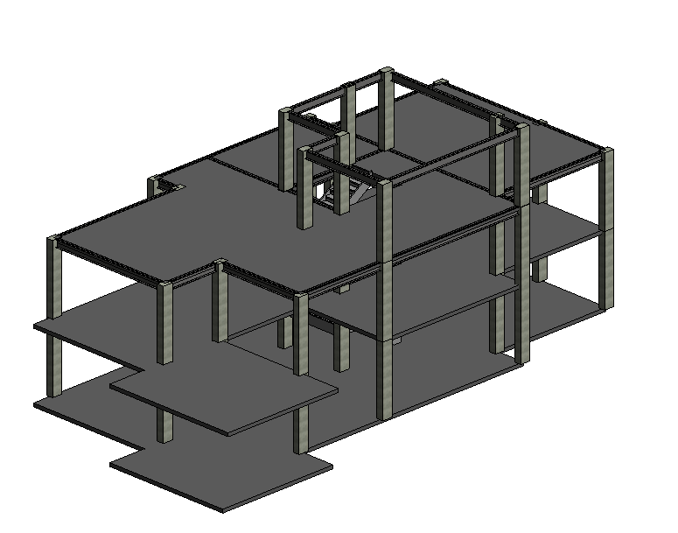

Construction activity 1 : Formwork for 2nd floor columns and beams

Duration : 1 days

Materials : Coated plywood

Equipment : Table saw, measuring tape,

Skilled worker : general worker (2)

Construction activity 2 : Columns and beams for level 2

Duration : 6 days

Materials : Concrete grade 30

Equipment : concrete vibrator, concrete mixer, mobile crane

Skilled worker : general worker (3) , crane driver (1)

Technical information : After pouring the concrete into the formwork, the workers will be vibrating the concrete to make sure it goes all the way down to the bottom of formwork.

Week 22

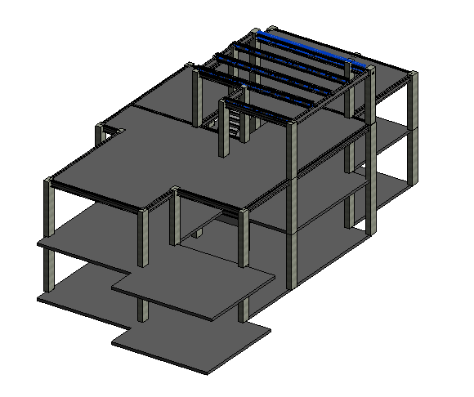

Construction activity : Metal roof truss installation

Duration : 4 days

Materials : Metal Roof truss

Equipment : Screw Driver

Skilled worker : General worker (2)

Technical information : -

Week 23 & 24

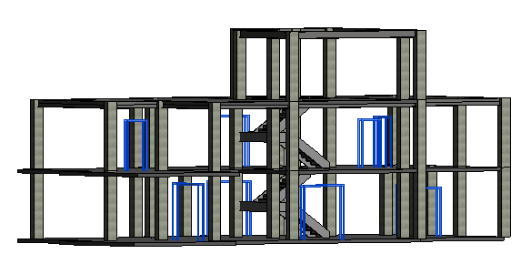

Construction activity 1 : Door frames installation

Duration : 5 days

Material : Solid wood door frame, stainless steel door frame

Equipment : Screw driver

Skilled worker : Door frame installer (2)

Technical Information :

Construction activity 2 : Sliding door frame installation

Duration : 3 days

Material : Sliding door frame

Equipment : screw driver

Skilled worker : door frame installer (2)

Technical information : The upper and lower track will be install after the door casing. Then, the stopper/threshold will be install as well to reduce the damage to the glass door panels.

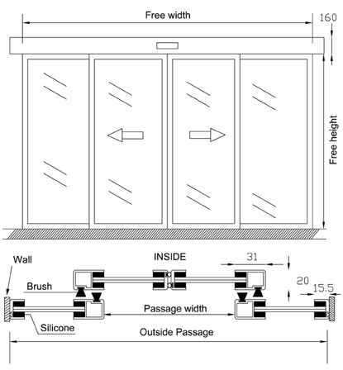

Week 25

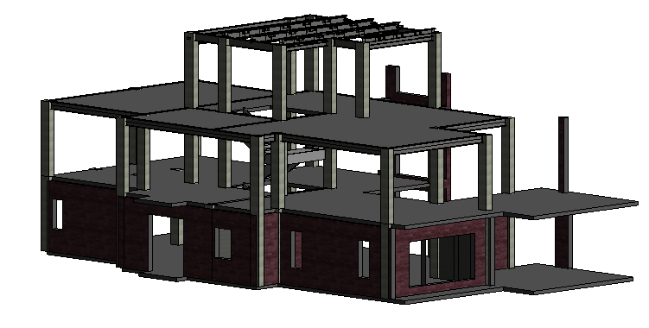

Construction Activity 1: Brickwork for ground floor

Duration: 6 Days

Materials: raw clay bricks, cement, sand and water(for mortar), brickwork reinforcement mesh(Ex-Mesh)

Equipment: brick trowels, leveling instrument,

Skilled worker: general worker (3)

Technical information: The bricks will be stack together until the level of windows, and continue right after the installation of windows frame. Lintel will be added on top of the window frame to act as a supporting system. The ex-mesh will normally be lay on every third brickwork joint to strengthen its resistant to vibration, temperature change and tensional stresses.

Week 26

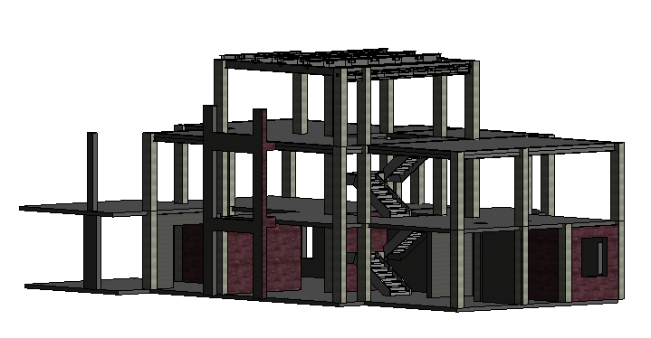

Construction Activity 1: Brickwork for ground floor (Internal)

Duration: 6 Days

Materials: raw clay bricks, cement, sand and water(for mortar), brickwork reinforcement mesh(Ex-Mesh)

Equipment: brick trowels, leveling instrument,

Skilled worker: general worker (3)

Technical information: The bricks will be stack together until the level of windows, and continue right after the installation of windows frame. Lintel will be added on top of the window frame to act as a supporting system. The ex-mesh will normally be lay on every third brickwork joint to strengthen its resistant to vibration, temperature change and tensional stresses.

Week 27

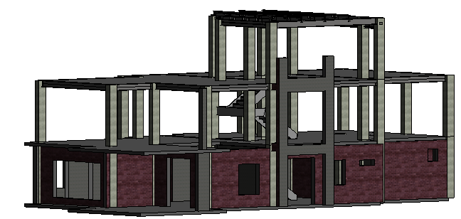

Construction Activity 1: Brickwork for ground floor (remaining exterior )

Duration: 6 Days

Materials: raw clay bricks, cement, sand and water(for mortar), brickwork reinforcement mesh(Ex-Mesh)

Equipment: brick trowels, leveling instrument,

Skilled worker: general worker (3)

Technical information: The bricks will be stack together until the level of windows, and continue right after the installation of windows frame. Lintel will be added on top of the window frame to act as a supporting system. The ex-mesh will normally be lay on every third brickwork joint to strengthen its resistant to vibration, temperature change and tensional stresses.

Week 28

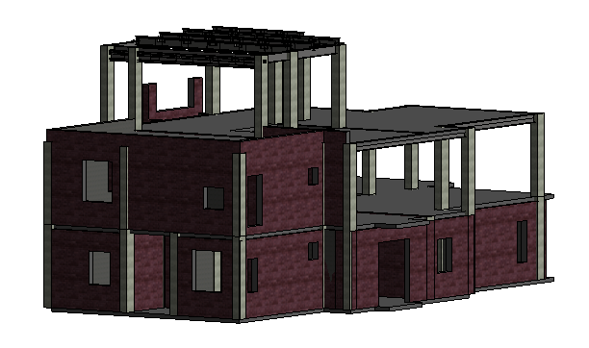

Construction Activity 1: Brickwork for first floor

Duration: 6 Days

Materials: raw clay bricks, cement, sand and water(for mortar), brickwork reinforcement mesh(Ex-Mesh)

Equipment: brick trowels, leveling instrument,

Skilled worker: general worker (3)

Technical information: The bricks will be stack together until the level of windows, and continue right after the installation of windows frame. Lintel will be added on top of the window frame to act as a supporting system. The ex-mesh will normally be lay on every third brickwork joint to strengthen its resistant to vibration, temperature change and tensional stresses.

Week 29

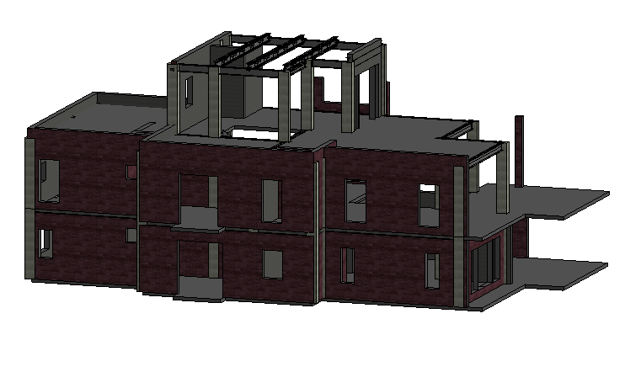

Construction Activity 1: Brickwork for first floor

Duration: 6 Days

Materials: raw clay bricks, cement, sand and water(for mortar), brickwork reinforcement mesh(Ex-Mesh)

Equipment: brick trowels, leveling instrument,

Skilled worker: general worker (3)

Technical information: The bricks will be stack together until the level of windows, and continue right after the installation of windows frame. Lintel will be added on top of the window frame to act as a supporting system. The ex-mesh will normally be lay on every third brickwork joint to strengthen its resistant to vibration, temperature change and tensional stresses.

Week 30

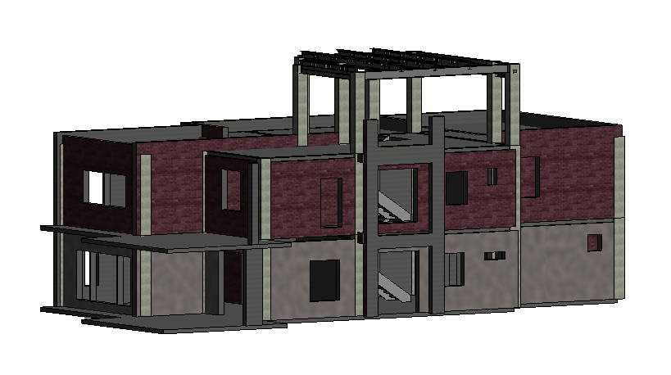

Construction Activity 1: Brickwork for first floor

Duration: 6 Days

Materials: raw clay bricks, cement, sand and water(for mortar), brickwork reinforcement mesh(Ex-Mesh)

Equipment: brick trowels, leveling instrument,

Skilled worker: general worker (3)

Technical information: The bricks will be stack together until the level of windows, and continue right after the installation of windows frame. Lintel will be added on top of the window frame to act as a supporting system. The ex-mesh will normally be lay on every third brickwork joint to strengthen its resistant to vibration, temperature change and tensional stresses.

Construction activity 2 : Cement render for ground floor(one site)

Duration : 6 days

Materials : plaster

Equipment : trowel , sponge

Skilled worker : general worker (2)

Technical information : Cement render will be done only once in rough surface to provide protection to the external wall that always exposed to extreme weather.

Week 31

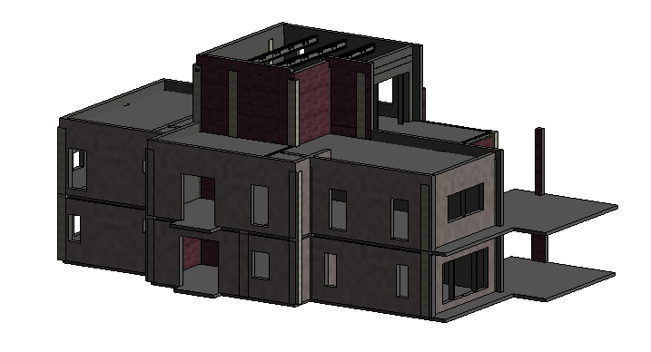

Construction Activity 1: Brickwork for second floor

Duration: 6 Days

Materials: raw clay bricks, cement, sand and water(for mortar), brickwork reinforcement mesh(Ex-Mesh)

Equipment: brick trowels, leveling instrument,

Skilled worker: general worker (3)

Technical information: The bricks will be stack together until the level of windows, and continue right after the installation of windows frame. Lintel will be added on top of the window frame to act as a supporting system. The ex-mesh will normally be lay on every third brickwork joint to strengthen its resistant to vibration, temperature change and tensional stresses.

Construction activity 2 : Cement render for ground floor(the rest) and first floor (one site)

Duration : 6 days

Materials : plaster

Equipment : trowel , sponge

Skilled worker : general worker (2)

Technical information : Cement render will be done only once in rough surface to provide protection to the external wall that always exposed to extreme weather.

Week 32

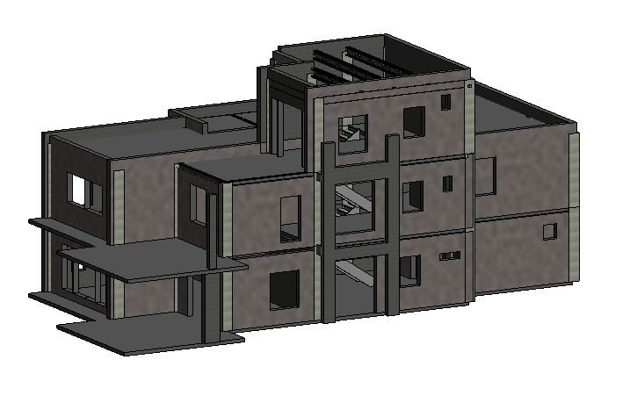

Construction activity 1 : Cement render for first floor(the rest) and second floor

Duration : 6 days

Materials : plaster

Equipment : trowel , sponge

Skilled worker : general worker (2)

Technical information : Cement render will be done only once in rough surface to provide protection to the external wall that always exposed to extreme weather.

Week 33

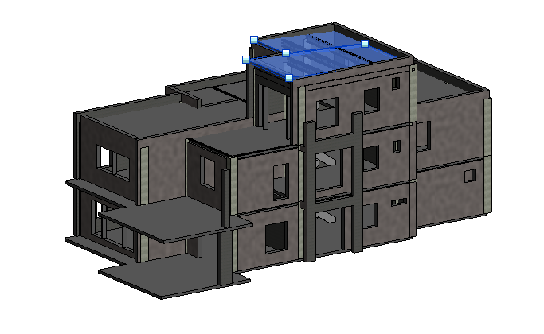

Construction activity 1 : Metal roof deck installation for second floor

Duration : 3 days

Material : Metal deck roof, safety mesh , insulator

Equipment : screw driver

Skilled worker : Metal deck roof installer(2)

Technical information : The installation will be follow the sequence which is metal deck roof, insulation, safety wire mesh and lastly ceiling.

Construction activity 2 : Plastering for second floor

Duration : 6 days

Materials : undercoat plaster

Equipment : trowel , sponge

Skilled worker : general worker (2)

Technical information : Plastering will be done 2 times , which is the rougher surface, undercoat for first layer and a smoother surface, skim coat as a base ready for paint.

Week 34

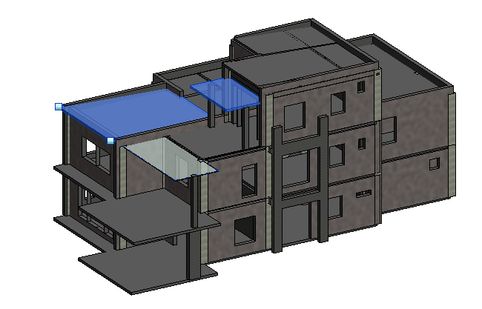

Construction activity 1 : Metal deck roof and glazing roof installation

Duration : 4 days

Material : metal deck roof , glass panel

Equipment : Electrical screw driver

Skilled worker : Metal deck roof installer (2)

Technical information : -

Construction activity 2 : Plastering for first floor, first part(undercoat)

Duration : 6 days

Materials : undercoat plaster

Equipment : trowel , sponge

Skilled worker : general worker (2)

Technical information : Plastering will be done 2 times , which is the rougher surface, undercoat for first layer and a smoother surface, skim coat as a base ready for paint.

Week 35

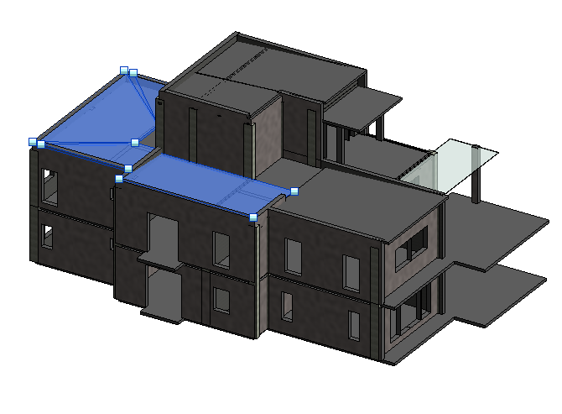

Construction activity 1 : Metal roof deck installation for first floor

Duration : 4 days

Material : Metal deck roof, safety mesh , insulator

Equipment : screw driver

Skilled worker : Metal deck roof installer(2)

Technical information : The installation will be follow the sequence which is metal deck roof, insulation, safety wire mesh and lastly ceiling.

Construction activity 2 : Plastering for first floor, second part(undercoat)

Duration : 6 days

Materials : undercoat plaster

Equipment : trowel , sponge

Skilled worker : general worker (2)

Technical information : Plastering will be done 2 times , which is the rougher surface, undercoat for first layer and a smoother surface, skim coat as a base ready for paint.

Week 36

Construction activity 1 : Skim coat for second floor

Material : skimming plaster

Equipment : tapping knife

Skilled worker : 1 general worker

Technical information : Skim coat will be apply on the undercoat uniformly using tapping knife to make sure a better base for painting.

Construction activity 2 : Undercoat for ground floor (first part)

Materials : undercoat plaster

Equipment : trowel , sponge

Skilled worker : general worker (2)

Technical information : Plastering will be done 2 times , which is the rougher surface, undercoat for first layer and a smoother surface, skim coat as a base ready for paint.

Week 37

Construction activity 1 : Skim coat for first floor (first part)

Material : skimming plaster

Equipment : tapping knife

Skilled worker : 1 general worker

Technical information : Skim coat will be apply on the undercoat uniformly using tapping knife to make sure a better base for painting.

Construction activity 2 : Undercoat for ground floor (second part)

Materials : undercoat plaster

Equipment : trowel , sponge

Skilled worker : general worker (2)

Technical information : Plastering will be done 2 times , which is the rougher surface, undercoat for first layer and a smoother surface, skim coat as a base ready for paint.

Week 38

Construction activity 1 : Skim coat for first floor (second part)

Material : skimming plaster

Equipment : tapping knife

Skilled worker : 1 general worker

Technical information : Skim coat will be apply on the undercoat uniformly using tapping knife to make sure a better base for painting.

Construction activity 2 : Sand screed for second floor and first floor(first part)

Material : -

Equipment : screeding tools

Skilled worker : 1 general worker

Technical information : The sand screed will be apply directly on the floor slab to provide a smoother and more favorable layer for tiles installation.

Week 39

Construction activity 1 : Skim coat for ground floor (first part)

Material : skimming plaster

Equipment : tapping knife

Skilled worker : 1 general worker

Technical information : Skim coat will be apply on the undercoat uniformly using tapping knife to make sure a better base for painting.

Construction activity 2 : Sand screed for first floor(second part)

Material : -

Equipment : screeding tools

Skilled worker : 1 general worker

Technical information : The sand screed will be apply directly on the floor slab to provide a smoother and more favorable layer for tiles installation.

Week 40

Construction activity 1 : Skim coat for ground floor (second part)

Material : skimming plaster

Equipment : tapping knife

Skilled worker : 1 general worker

Technical information : Skim coat will be apply on the undercoat uniformly using tapping knife to make sure a better base for painting.

Construction activity 2 : Sand screed for ground floor

Material : -

Equipment : screeding tools

Skilled worker : 1 general worker

Technical information : The sand screed will be apply directly on the floor slab to provide a smoother and more favorable layer for tiles installation.

Week 41

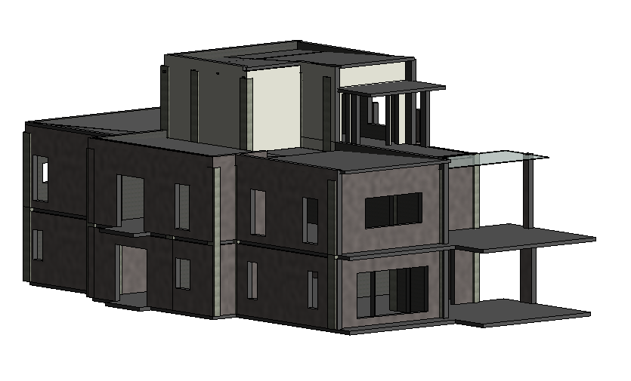Construction activity 1 : Painting on second floor exterior wall and interior wall

Duration : 6 days

Materials : paint

Equipment : paint roller

Skilled worker : General worker (2)

Week 42

Construction activity 2 : Painting on first floor interior wall

Duration 6 days

Material : paint

Equipment : paint roller

Skilled worker : general worker (1)

Week 43

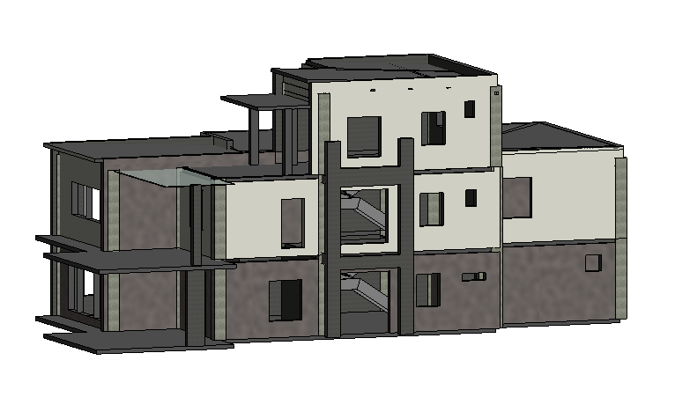

Construction activity 1 : Painting on first floor exterior wall

Duration 6 days

Material : paint

Equipment : paint roller

Skilled worker : general worker (1)

Technical Information : To prevent any unwanted roller marks, apply the paint first in an overlapping W motion, then horizontally.

Week 44

Construction activity 1 : Painting on ground floor interior wall

Duration 6 days

Material : paint

Equipment : paint roller

Skilled worker : general worker (1)

Week 45

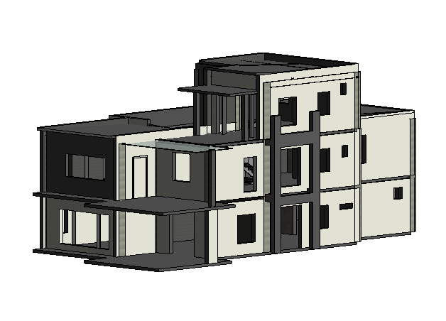

Construction activity 1 : Painting on ground floor exterior wall

Duration 6 days

Material : paint

Equipment : paint roller

Skilled worker : general worker (1)

Week 46 & 47

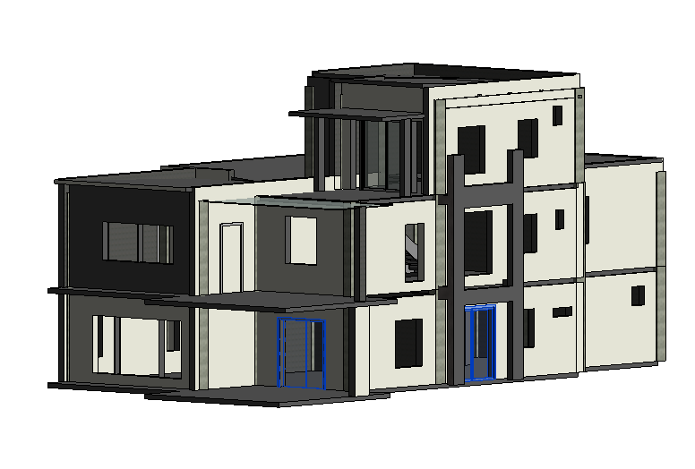

Construction activity 1 : Door panels installation for all 3 floors

Duration : 5 days

Material : glass door panels, hardwood door panel

Equipment : hammer, screw driver

Skilled worker : Skilled door installer (1), General worker (2)

Construction activity 2 : Door handles/locks installation

Duration : 5 days

Material : Door locks and handles

Equipment : Electrical driller drive

Skilled worker : door installer (1)

Week 48

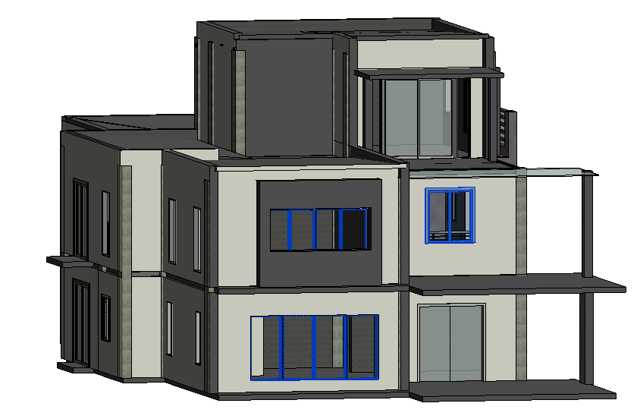

Construction activity 1 : Window frames installation for all 3 floors

Duration : 6 days

Materials : Aluminium window frames

Equipment : Screw driver and driller

Skilled worker : General worker (2)

Technical information : The window frame will be secure by screwing it to the wall.

Week 49 & 50

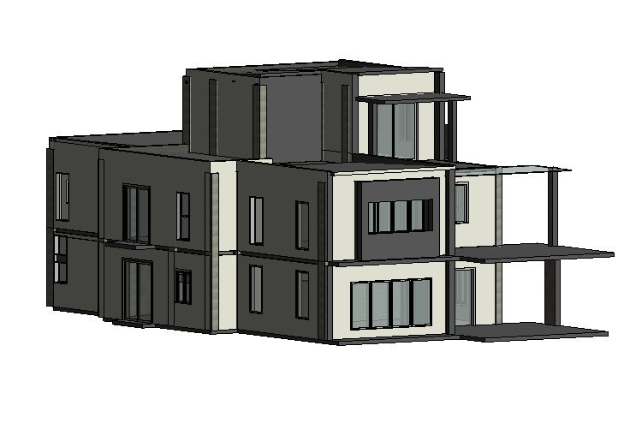

Construction activity 2 : glass panels installation on all 3 floors

Duration : 6 days

Material : glass window panels

Equipment : Electrical drill driver

Skilled worker : Window panel installer(1) , general worker (2)

Technical information : Insert and secure the glass in place, then fill in the empty space with silicon. Wait until the silicon harden and add in the rubber channel so that the windows and doors could have a nice finish.

Week 51

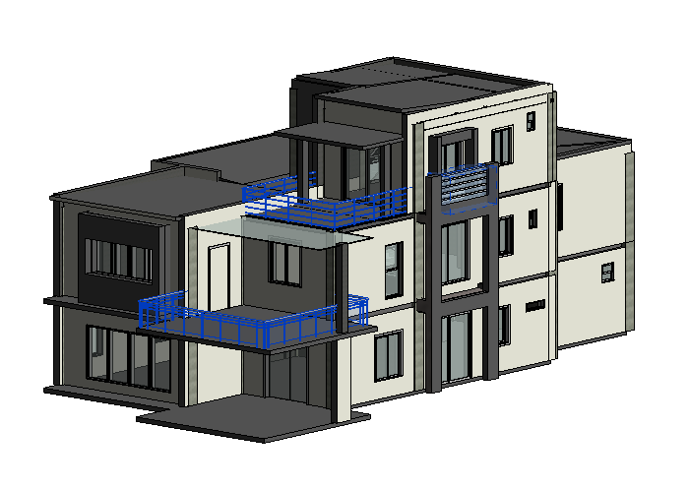

Construction activity 1 : Railing installation

Duration : 3 Days

Materials : Stainless steel railings, Glass panels

Equipment : Electric drill

Skilled worker : Railing installer (1), general worker (2)

Technical information : The railing will be install and connect to the floor slab using a screw. When everything is ready only install the clear glass panels to the railings.

Construction activity 2 : Louver

Duration : 1 day

Material : Louver

Equipment : screw driver , electric drive driller

Skilled worker : general worker

Technical information : -

Week 52

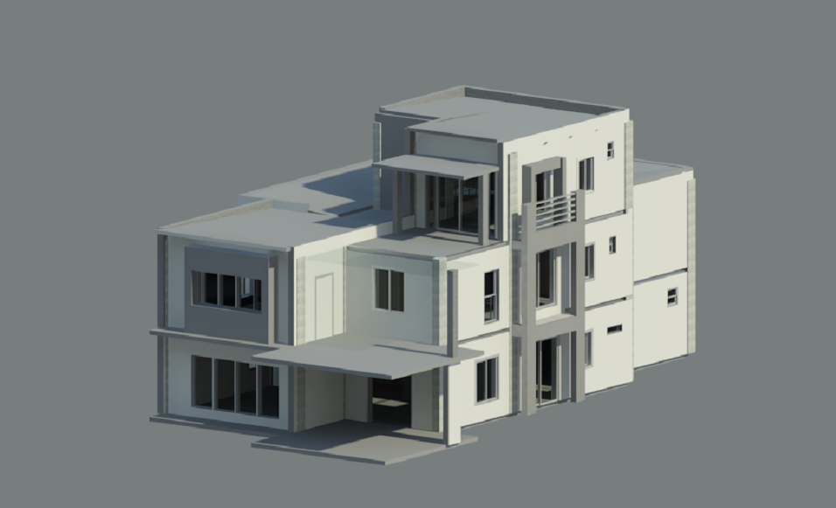

Construction activity 1 : Final touch and defects repair

Duration : 6 days

Material : Wall, Floor , Door , Window finishes

Equipment : Finishing tools

Skilled worker : General worker(2)

Technical information : -



Building Construction 1 ARC1523

Assignment 2: Construction Activities and Process

YEOW YI CHUAN 0317576