Yeow Yi Chuan 0317576

Taman Negara , the tropical rainforest in Malaysia that not only acts as a natural water reservoir, carbon sink where all the carbon dioxide is removed from the atmosphere through a process called ‘Carbon sequestration” but also a main sources of all the raw materials like woods, stone , herbs and many other things. Thus it’s important for us to save the rainforest by all means.

The school trip arranged by university to Taman Negara was truly fascinating. I learned a lot of new thing regarding the rainforest in Malaysia and how it works in maintaining our carbon cycle. Well, from my point of view, government opens the Taman Negara for public visit can bring both positive and negative effects to our nature.

Let’s talk about the benefits of allowing public to visit Taman Negara first. The guided sightseeing in Taman Negara allow us to understand the rainforest even better than before. We could experience, feel and even become one with this environment which this may create awareness among us human to conserve our mother nature. We will eventually realized why rainforest is so important to us and start to find a way to save this land. Second, this provide opportunity to all the professionals in environment conservation field to study the rainforest, and seek for an ultimate solution regarding the deforestation that getting more and more serious, like an alternative synthetic materials that can replace wood. In addition , when this part of forest had been decided to open for public, it’s automatically became a preserved forest, meaning no more development in this area, so I think government could use this as a good start in preserving more forest.

However, it will still have some negative effects on the environment when the rainforest is open for visit. As we can see, in order to provide a safer and a more comfortable sightseeing for the tourists, we will need to construct a lot of facilities like restaurants, toilets, walkway, accommodation and other. The construction of all these will sure disturb the ecosystem in forest area even though how hard they try to minimize the damage. When a place get more people, it will start to be commercialized and waste will start to accumulate and the only way to get rid of all this is either bury it or burn it. How does open burning and bury all the waste that is hard to decompose not harm the forest. The situation just get worsen when there are not much dustbin in forest area, so some of the irresponsible tourists will start to littering in forest. These waste will then be pick up by the animals ,say monkeys for example. They eat it , and die.

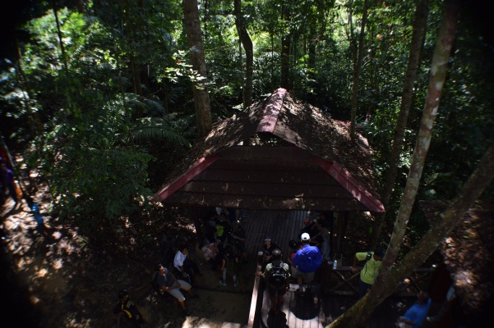 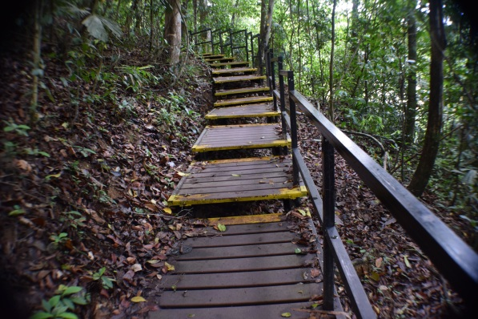

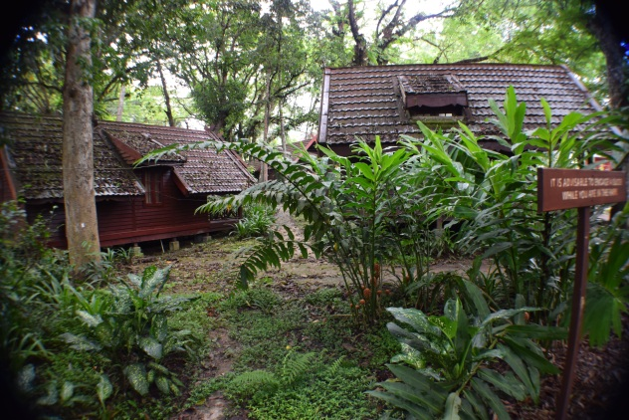

Pavilion, walkway and accommodation that built in forest area .

So in conclusion, I still feel like making rainforest open for public brings more advantages over not open it in long run. I believe with proper education to the next generation, preserving the forest could get easier.