**Environmental Sustainable Design Project 1: Paying it Forward**

**Proposed Project:**

Improve the living conditions of orphans in Philea Home by creating more useful space and multi-functional furnitures.

**Introduction of the organisation**

*Organisation name:* Philea Home

*Contact person:*  Mrs. Yoges Muthu

*Email:*  [philea_04@yahoo.com](mailto:philea_04@yahoo.com)

*Contact number:* +603 3290 2830

*Fax number:* +6012 342 3072 (Yoges)

*Address:* 6, Jalan Harapan 5C/KU7, Sungai Kapar Indah, 42200 Kapar, Selangor.

*Reference:* http://www.hati.my/children/philea-home/

*Background:*

Philea Home is an orphanage home organised by Mr. and Mrs. Yoges, it is registered with the State Welfare Department in Klang. Philea Home is a Children’s Home that provides suitable environment, support and upbringing for children who have been homeless and abused physically, spiritually and emotionally. Mr. and Mrs. Yoges have been collecting foods, school supplies and daily necessities for orphans for more than 10 years. They receive donations from many sources occasionally. Despite donations, other source of income is sale of homemade cookies. However, cookies business runs on festive seasons only, so thus income is not so reliable.

*Exact needs stated by Mrs. Yoges:*

1. A cupboard with doors to store cookies.
2. Repair 2 cupboards with dropped partition board and 1 cabinet with broken door.
3. A children playing area with construction toys( not “Lego” but any economic brand )

**Project Statement:**

1. 14 orphans live in a double-storey terrace house have limited tidy space and furnitures, daily activities and personal storage.
2. To safety concern, cupboards with missing partition and cabinet with broken door are dangerous to be used.
3. Children have active imaginations and are constantly exploring, they need a space for them to express and develop. Colours stimulate children’s mind and create a vibrant learning atmosphere.
4. By selling cookies and cupcakes made by orphans, we raise students’ awareness towards orphanage home. In the process of making pastries, we get to interact with orphans and understand their needs more.

**Project Objectives:**

Achieved all listed below without spending a single cent

1. Build a cupboard, shoe rack from low cost and recycle materials.
2. Repair broken furnitures.
3. Create a children playing area filled with construction toys, some colourful chairs and a table.
4. One-time fund raising by selling packed cookies and cupcakes decorated with icing around campus.

**Proposal:**

Focusing on the problems the orphans are facing: having limited space for activities, limited storage space, using broken cupboards and lack of entertainment. Solution planned is to create multi-functional furnitures that saves space and could store things. Minor repairs on broken cupboards and cabinet will be done. Also, a children playing area with colourful table and chairs will be created. Children playing area is decided to be at a corner and not too big so it doesn’t add to the problem of having limited space.

**Reasoning of selected project:**

In the aspect of environmental sustainability in architecture, we know that architecture is not designing amazing buildings, but creating buildings that don’t give burden to our environment and it’s what makes buildings more amazing. Relate this to our project, we got an output which is we could use recycle material to create something that is functional yet in aesthetic point of view, nothing is being compromised. We use our architecture knowledge on anthropometry and ideas on environmental sustainability to help the orphans who have limited space to use. Multi-functional furnitures are created and it leaves extra space in interior for activities. Through this, we are actually teaching them an adaptation method to the problem, this is something they learn that they could apply in everyday life, but not just for this particular problem. Ergo, our project is not a one-time project but one that teach a skill, its impact lasts.

**Duration of Project:**

A month and a half, thrice a week, 3 hours each time.

**Service Site:**

Preparation- Yeow Yi Chuan’s house, Puchong.

Assembly- Philea Home, Kapar.

**Beneficial Party:**

Mr. and Mrs. Yoges and the orphans.

**Task Delegation:**

|  |  |
| --- | --- |
| 1.Wong Kah Voon | * Contact sponsor * Repainting old furniture * Assembling (Tyre chair) * Interview |
| 2. Adnan Ibrahim | * Repaint old furniture * logistic * Assembling (Wood pallet bench) * Measuring (Wood pallet bench) |
| 3.How Pei Ngoh | * Look for sponsor * Repainting old furniture * Assembling ( Tyre Chair) * Packaging cookies |
| 4.Yeow Yi Chuan | * Look for sponsor * Collect material * Designing ( Container Shelf) * Assembling (Container Shelf) |
| 5.Yii Hong Gin | * Repainting old furniture * Collecting material * Designing (Tea Table) * Assembling (Tea Table) |
| 6. Teh Xue Kai | * Logistic * Designing ( Wooden Roll Table) * Assembling (Wooden Roll Table) * Baking cookies |
| 7.Lucas Wong Kok Hoe | * Origami lesson * Collecting material * Designing ( Shoe Rack) * Measuring ( Shoe Rack) |
| 8.Yang Ge Shen | * Collecting material * Logistic * Measuring (Container Shelf) * Assembling (Container Shelf) |
| 9.Chia Wei Pink | * Contact sponsor * Collecting material * Designing (Tyre Chair) * Assembling ( Shoe Rack) |
| 10.Sumitchai Thamdee | * Collect material * Measuring (Tea Table) * Assembling (Wood Pallet Bench) * Packaging cookies |

**Schematic drawings and information of sponsors**

Furniture 1 : RECYCLED TYRE CHAIR

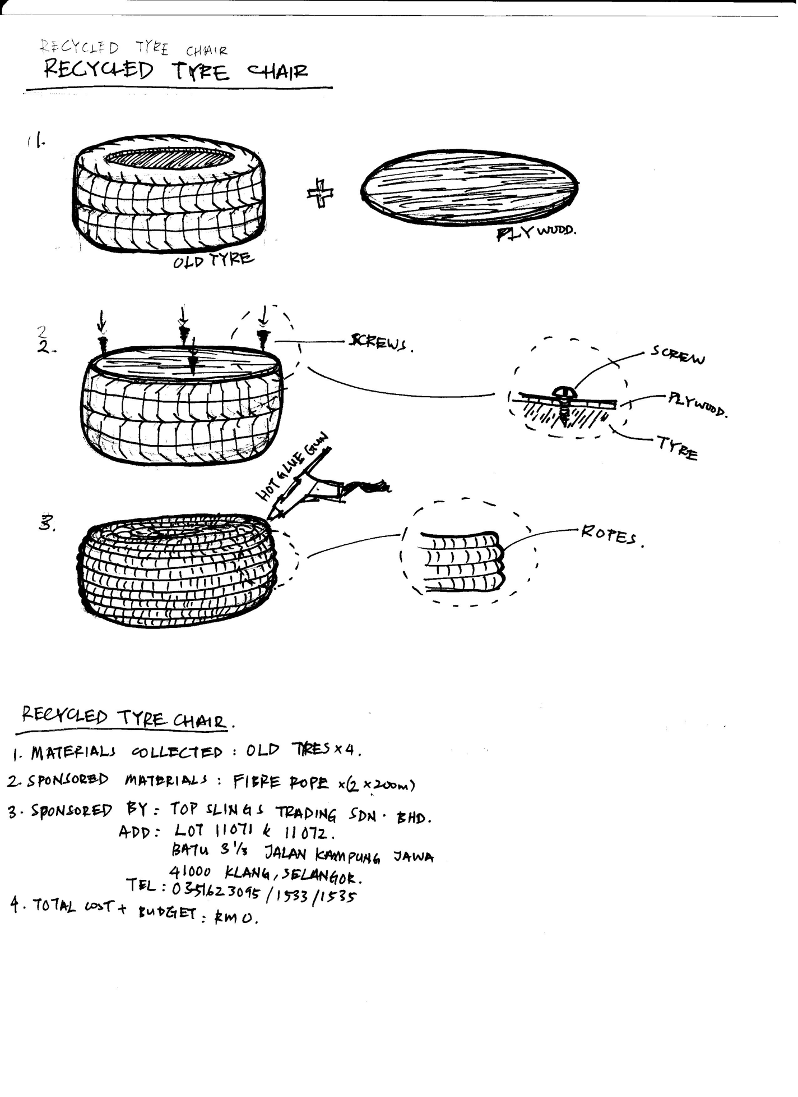

|  |  |  |
| --- | --- | --- |
| Sponsored material | Material | Quantity |
| * Old tyres * Rope (200m) | 4  1 |
| Sponsored by | Top Slings Trading SDN.BHD | |
| Address | LOT 11071 & 11072,Batu 3 1/3 Jalan Kampung Jalan,41000 Klang, Selangor | |
| Tel | 0351623095/1533/1535 | |
| Total cost + Budgets | RM 0 | |

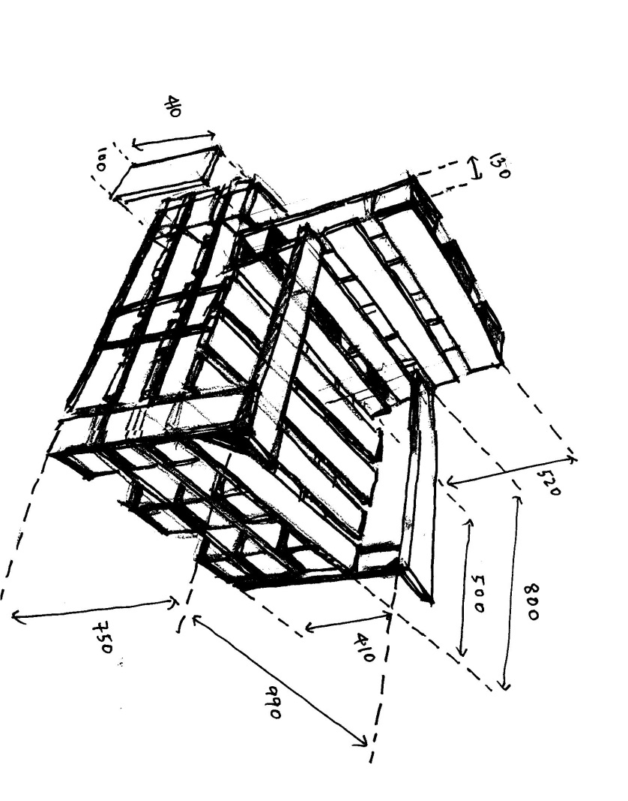Furniture 2 : WOOD PALLET BENCH

|  |  |  |  |
| --- | --- | --- | --- |
| Sponsor material | Material | | Quantity |
| * Box of nails * Block of wood * Imported high quality wood pallets | | 1  10  6 |
| Sponsored by | Guan Joo Hin Hardware SDN.BHD | Kah Ban Trading SDN.BHD | |
| Address | KM 274, Batu 13 ¾ , Jalan Kelemak,  78000 Alor Gajah, Melaka | No.21, Jalan Songket, Taman Maznah Batu 3 ¾ , Kampung Jawa, 41300 Klang, Selangor | |
| Tel | 06-5561619 / 06-5561669 | 03-33731390/91 | |
| Total cost + Budgets | RM 0 | | |

Furniture 3 : WOODEN ROLL TABLE

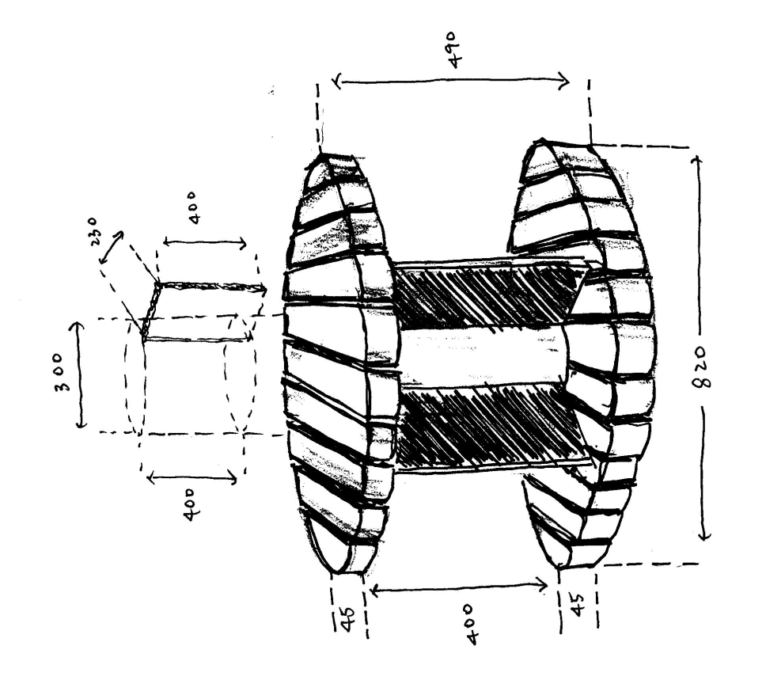

|  |  |  |
| --- | --- | --- |
| Sponsored material | Material | Quantity |
| * Wooden roll (20 Ft) * White paint * Sand paper (a range of different roughness), | 1  1  3 |
| Sponsored by | Top Slings Trading SDN.BHD | |
| Address | LOT 11071 & 11072,Batu 3 1/3 Jalan Kampung Jalan,41000 Klang, Selangor | |
| Tel | 0351623095/1533/1535 | |
| Total cost + Budgets | RM 0 | |

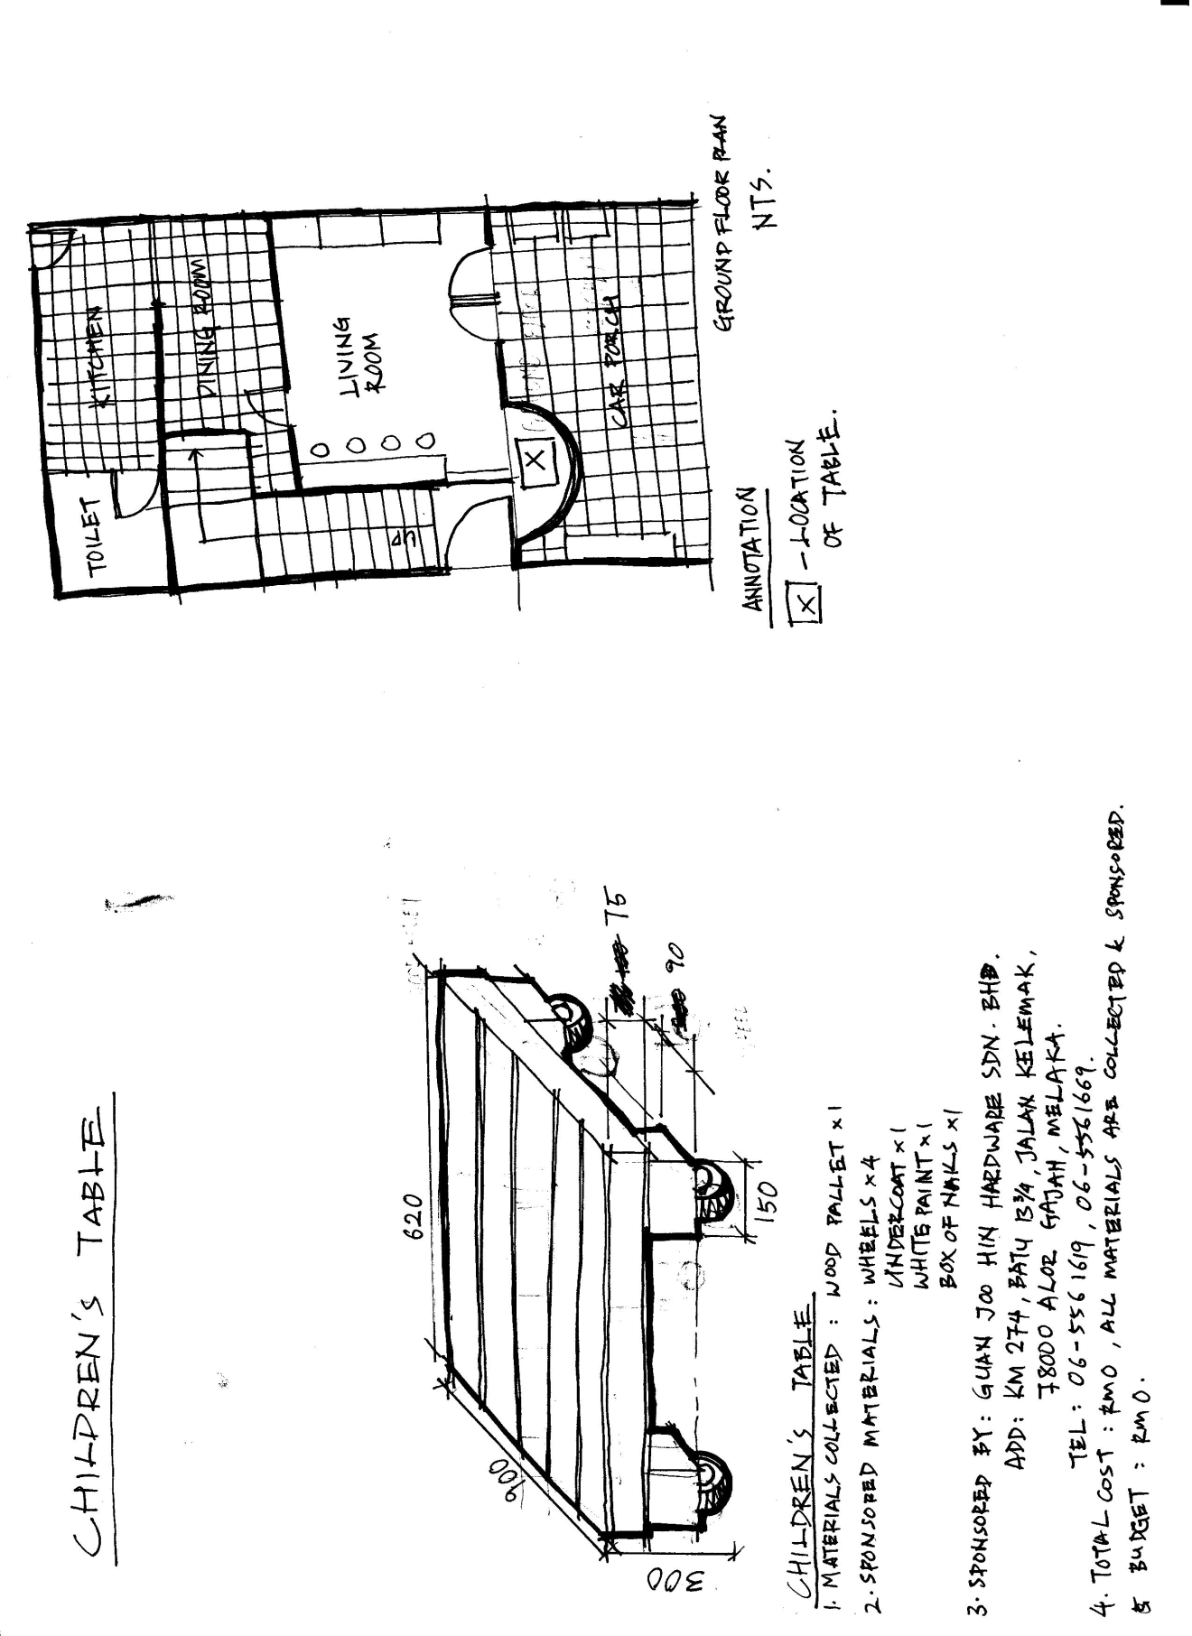Furniture 4 : Tea Table

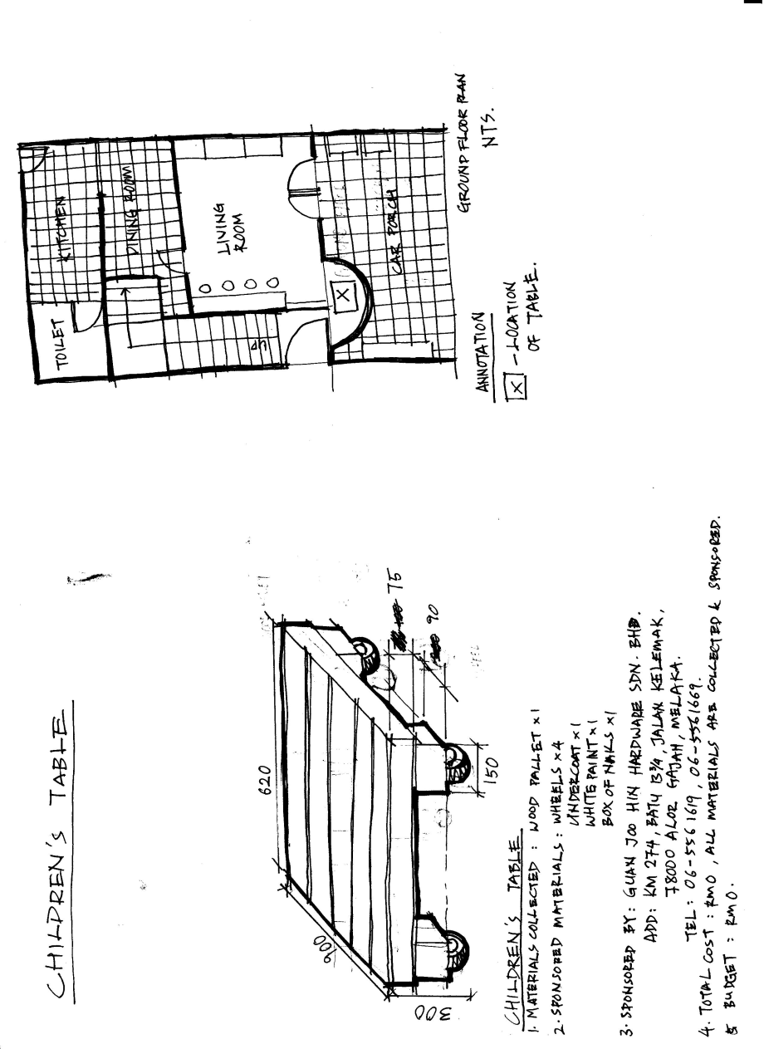

Sketch of children’s table

Location of Children’s table

|  |  |  |
| --- | --- | --- |
| Sponsored material | Material | Quantity |
| * Wood Pallet * Wheels * Undercoat * White paint * Box of nails | 1  4  1  1  1 |
| Sponsored by | Guan Joo Hin Hardware SDN.BHD | |
| Address | KM 274, Batu 13 ¾ , Jalan Kelemak,  78000 Alor Gajah, Melaka | |
| Tel | 06-5561619 / 06-5561669 | |
| Total cost + Budgets | RM 0 | |

Furniture 5 : CONTAINER SHELF

|  |  |  |
| --- | --- | --- |
| Sponsored material | Material | Quantity |
| * PVC pipes * PVC elbow * PVC T * PVC glue * Pallet board | 4  8  12  1  4 |
| Sponsored by | Yong Hardware Trading SDN.BHD | |
| Address | Lot 1402E, Batu 6 ½ , Jalan Puchong, 58200 Kuala Lumpur. | |
| Tel | 603-77830122/77830120 | |
| Total cost + Budgets | RM 0 | |

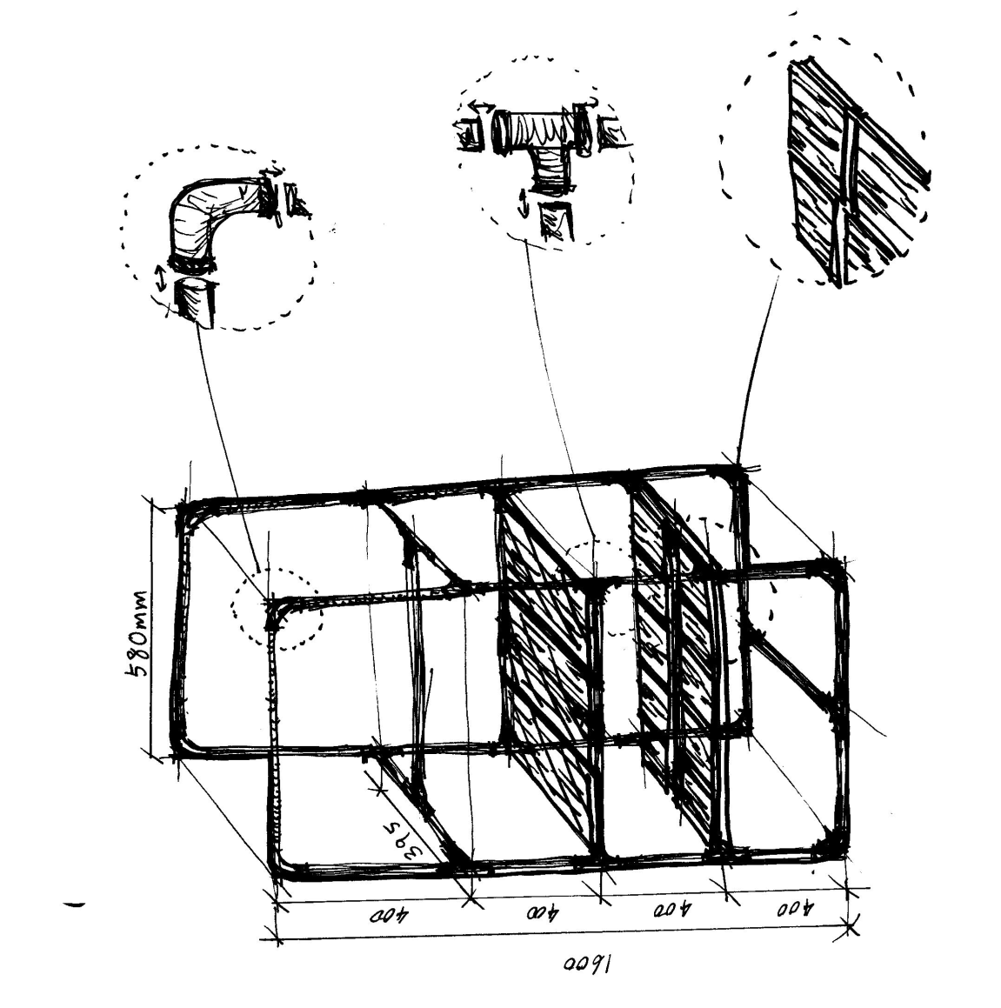

Wood pallet board

PVC pipes inserted and connected to PVC tee

PVC pipes inserted and connected to and with PVC elbows

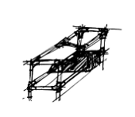Furniture 6 and 7 : SHOE RACK I & II

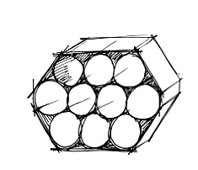

Shoe Rack II

Shoe Rack I

|  |  |  |
| --- | --- | --- |
| Sponsored material | Material | Quantity |
| * PVC pipes * PVC elbow * PVC T * PVC glue | 2  4  8  1 |
| Sponsored by | Yong Hardware Trading SDN.BHD | |
| Address | Lot 1402E, Batu 6 ½ , Jalan Puchong, 58200 Kuala Lumpur. | |
| Tel | 603-77830122/77830120 | |
| Total cost + Budgets | RM 0 | |

Additional Programme I ( Origami Lesson )



Person in charge : Lucas Wong Kok Hoe

Need : Philea’s home owner request a program that can help the children there to generate ideas and creativity

Aim : We offer origami lesson to help develop children’s mind and at the same time also improve their cookies business by offering more attracting boxes, which made during origami lesson.

Material used : Old magazine

Total Cost : Free

Additional Programme II ( Renew old furniture )

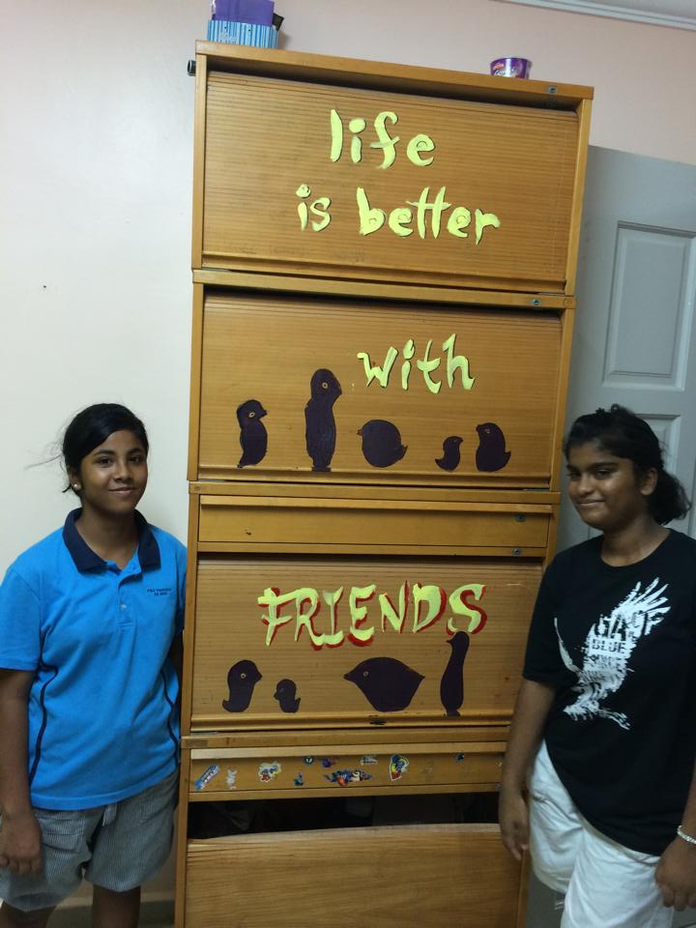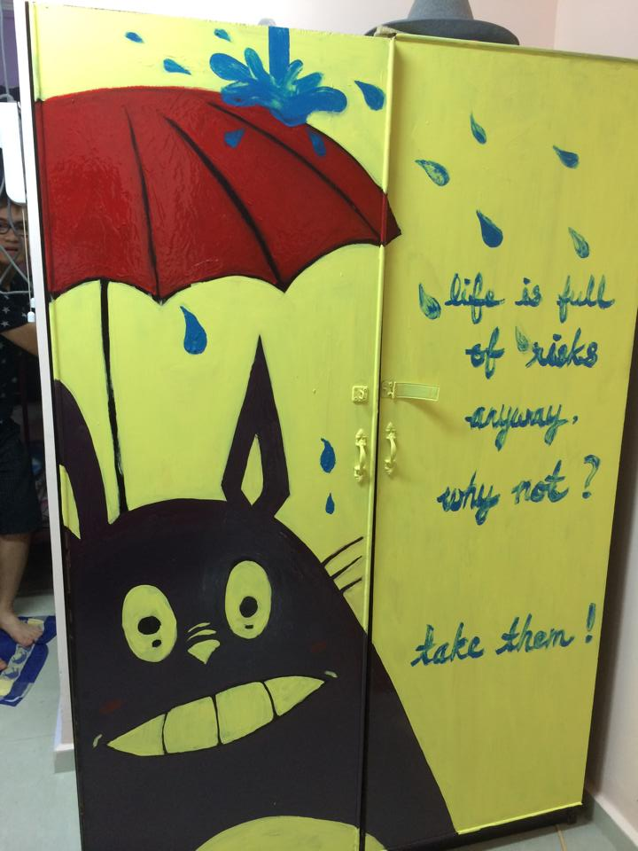 *Renewed and repainted wardrobe Renewed and repainted bookshelf*

Person in charge : Yii Hong Gin

Ibrahim Adnan

Wong Kah Voon

How Pei Ngoh

Need : To repair and repaint all the broken furniture

Aim : we understand that we are not capable of repairing broken furniture by using only recycled materials, so we decided to paint something on the door of cupboard, which in order to make the orphanage home looks livelier. Hoping by doing this, the orphanage may gain some happiness.

Material used : Paints and brushes (sponsored by Yong Hardware Trading SDN.BHD)

Total cost : RM 0

Additional Programme III ( Baking Cookies session )

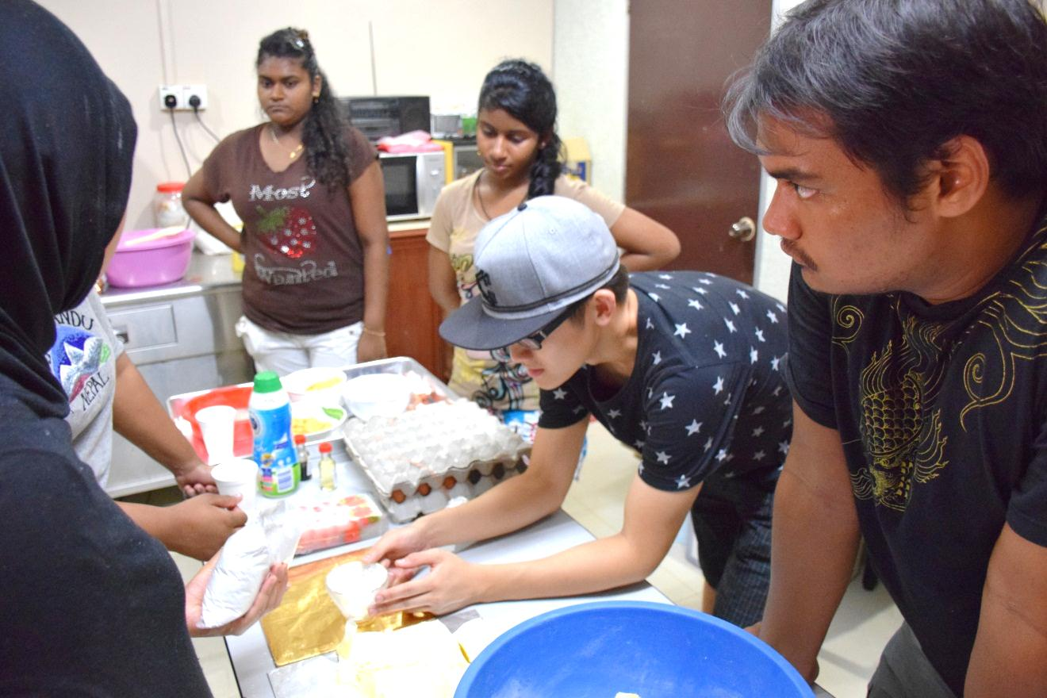

Person in charge : all members

Need : To bake cookies with orphans of Philea’s home and sell it at Taylor’s University for charity

Aim : As Philea’s Home still unable to get a stable sponsorship, so we decided to host a fundraising by selling cookies, which in order to improve the economic situation even though that is only a little help. During the baking session, we hope that we could be more understand the orphans and also let them know that they are not alone.

Material used : baking tools and ingredients (provided by Philea’s Home)

Total cost : RM 0

Profit : RM 584

**Financial Statement:**

|  |  |  |  |
| --- | --- | --- | --- |
| Fund Raising: | | | |
| Types | Price per pack/ RM | Sales/ packs | Revenue/ RM |
| Almond | 5 | 40 | 200 |
| Chocolate Chips | 4 | 50 | 200 |
| Cornflakes | 3 | 50 | 150 |
| Subtotal |  |  | 550 |
| Donation |  |  | 37 |
| Total |  |  | 587 |
| Statement of Sponsor of Materials: | | | |
| Company Name | Sponsored Materials | | Quantity/ units |
| Yong Hardware Trading SDN. BHD. | PVC Pipe | | 4 |
| PVC elbow | | 8 |
| PVC T | | 12 |
| PVC glue | | 1 |
| Pallet board | | 4 |
| Brush | | 6 |
| Wooden roll | | 1 |
| Paint | | 3 |
| Kah Ban Trading SDN. BHD. | Wooden Block | | 4 |
| Imported high quality wood pallet | | 6 |
| Top Slings Trading SDN. BHD. | Old tyre | | 4 |
| Rope (200metres) | | 1 |
| Guan Joo Llin Hardware SDN. BHD. | Box of nails | | 2 |
| Wheel | | 4 |
| Undercoat | | 1 |
| White paint | | 1 |

** Income from fund raising and donation, which is RM 587 are donated to Philea Home. All materials are sponsored, so no expenditure is incurred.

**Sustainable and Environmental Strategies Adopted:**

1. 3R (Reduce, Reuse and Recycle), eg. turn used thick cardboard rolls/ PVC pipe/ extra MDF board collected into new shoe racks.
2. By reduce, reuse and recycle, we reduce the carbon emission during manufacturing.
3. Raise the awareness of the mass by suggesting the idea that by using recycle materials, we could help improve living conditions of the needy.

**Life Cycle Assessment(LCA)**

* Cradle-to-grave approach for analysing industrial system.

LCA of Wood Pallet:

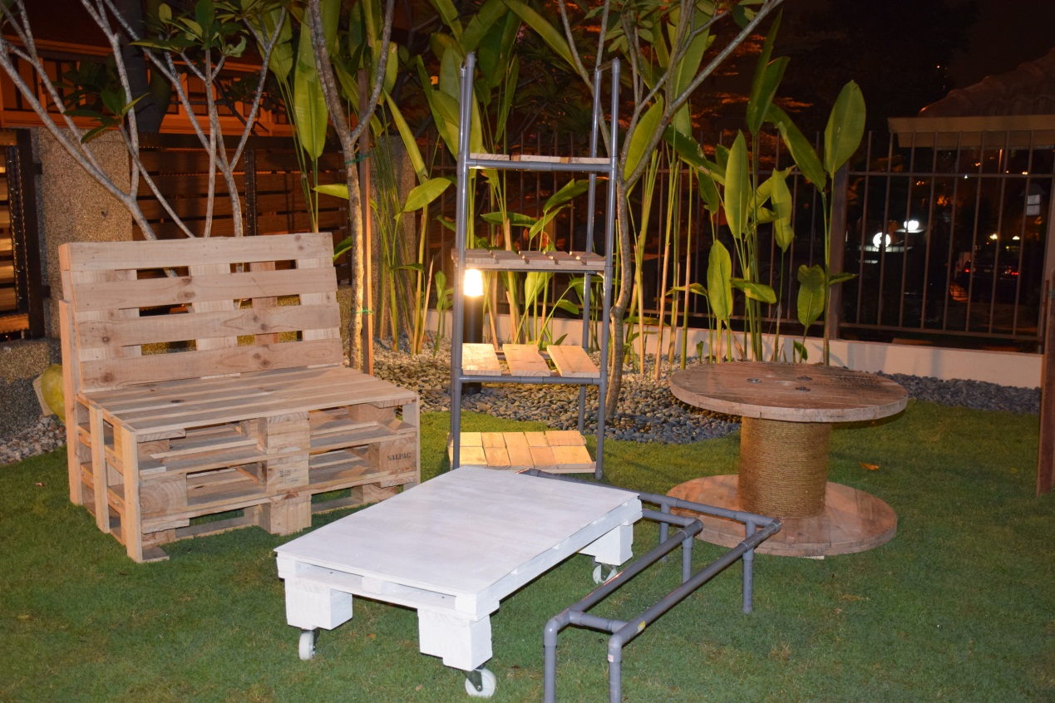

*\*Furnitures we made for this project by using recycled pallet woods*

LCA of PolyVinyl Chloride(PVC):

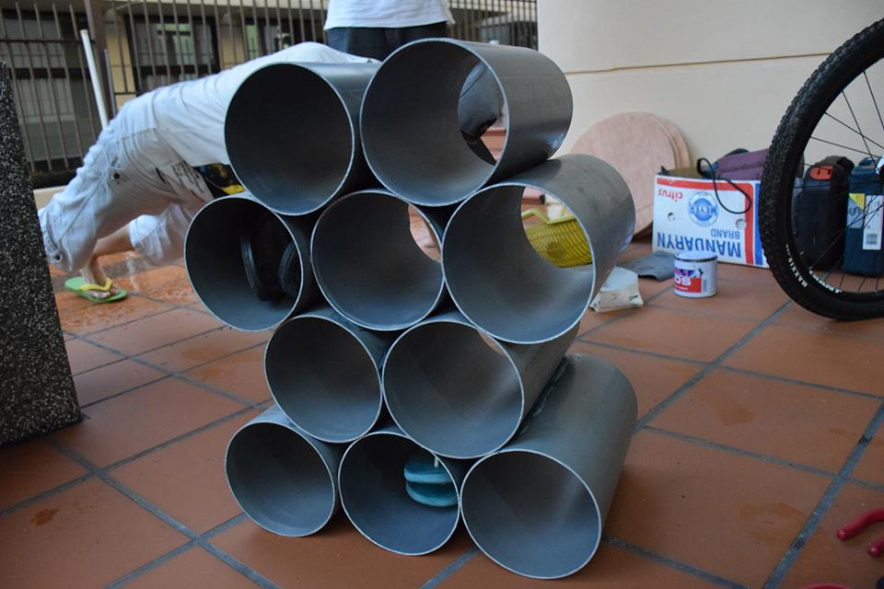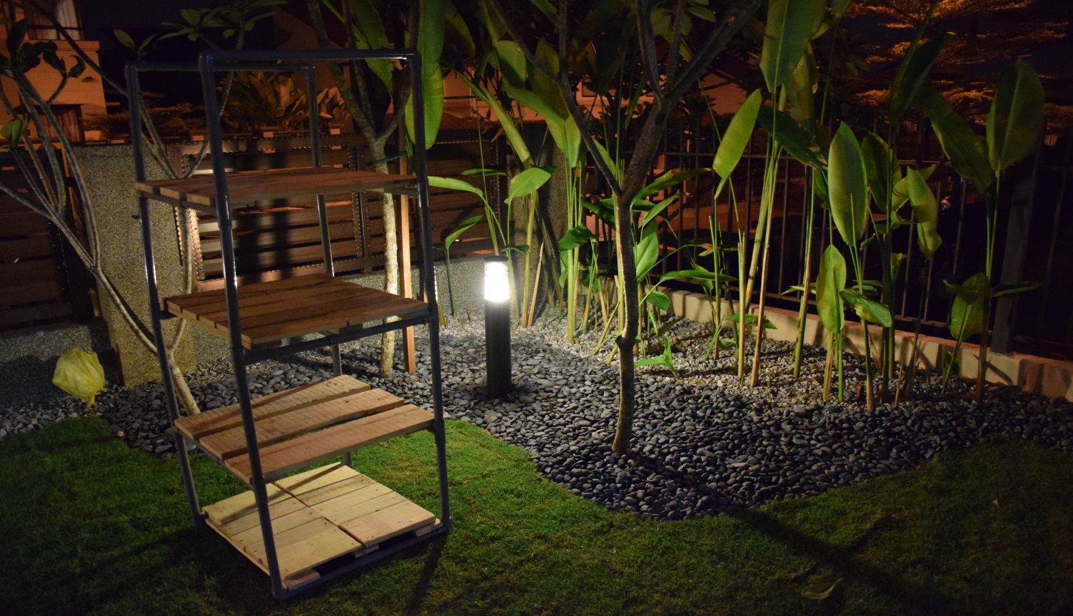

*\*Furnitures we made by using unwanted PVC pipes*

Approximate Environment Footprint of 1m3 of Material:

*eq.= equivalent

|  |  |  |  |  |
| --- | --- | --- | --- | --- |
| No. | Environmental Impact | Unit | Indicator value in manufacturing | |
|  |  |  | Wood pallet | PVC |
| 1 | Consumption of energy |  |  |  |
|  | Renewable energy | MJ | 13000 | 148 |
|  | Non-renewable energy | MJ | 5297 | 1237 |
| 2 | Total water consumption | m3 | - | 249 |
| 3 | Global warming | kg eq. CO2 | 7456 | 336 |
| 4 | Ozone depletion | kg eq. CFC-11 | 195 | 269 |
| 5 | Acidification | kg eq. SO2 | 123 | 682 |
| 6 | Eutrophication | kg eq. PO4 | 232 | 613 |
| 7 | Photochemical oxidant formation | kg eq. C2H4 | 105 | 455 |

**Conclusion:**

Producing recycle products itself is creative in the way that people would not think that wood pallets and PVC can be reused and turned into a shoe rack, a bench, and a table that really function and are durable. In order to make furniture functions, we applied principles we learned from anthropometry, that is we take measurements like suitable depth of seat and hand rest of chair before designing furnitures.

Via social media, simple example: like and share the Facebook page of Philea Home and post video of what we were doing for it, we are showing people a way to care about the needs and help them.

Although we are doing a small scale project, but imagine when everyone does it, the amount of energy saved will times.

Our creativity in applying sustainable ideas we learned in architecture classes, to help the needs, will influence the society to continue what we started. Thus, our project is meaningful and the impact lasts.