Daylight factor

The daylight factor is defined as the ratio of the natural illuminance at a particular point on a horizontal plane to the simultaneously occurring external illuminance of the unobstructed overcast sky. In Malaysia, the Eo(unobstructed skylight level) = 32000.

DF formula :

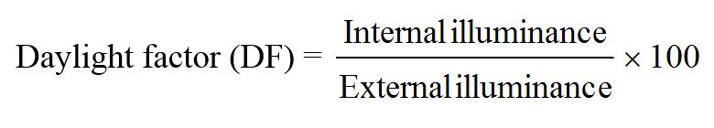

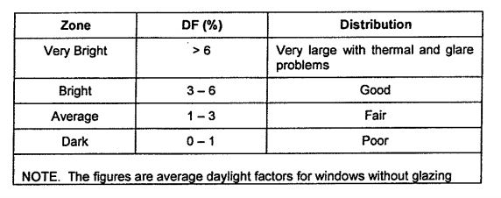According to MS 1525 : 2007 , the desired daylight factor distributions should be as below :

2.0 Lighting proposal

2.1 Daylight

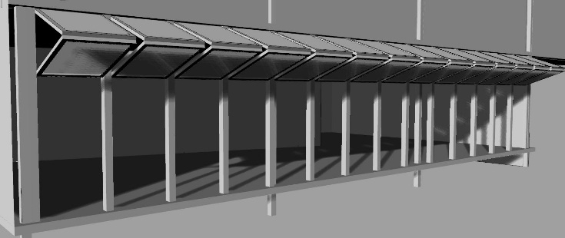Carving & weaving area

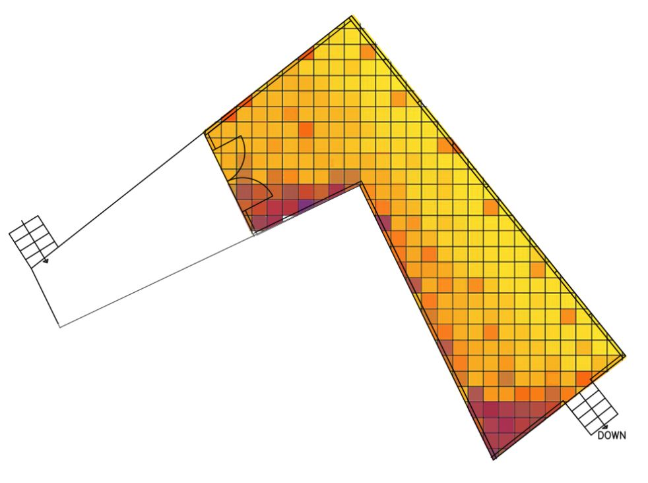

Perspective showing how the daylight is being controlled.

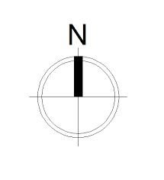

Light contour retrieved from Autodesk Ecotech 2011

Daylight factor calculation

|  |  |
| --- | --- |
| Floor area ( m2 ) | 61.5 |
| Opening/Skylight area ( m2 ) | 21.8 |
| Daylight factor, DF ( % ) | ( 21.8/61.5 ) x 100%  = 35.45% x 0.1  = 3.55% |

Referring to the MS 1525 standards, this part of building have a good daylight factor, which is 3.55% when all the panels are fully opened.

For the highlighted part, the adjustable louver panels, is designed to overcome any issues regarding the day lighting. These panels can be adjusted to capture more daylight during cloudy day, or to block the unnecessary glare/direct heat source from sun.

As for the illuminance level, given the Eo = 32000 in Malaysia,

EEi = ( DF x Eo ) / 100%

= 3.55 x 32000 / 100%

=1136 lux

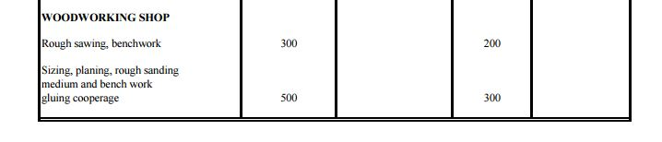

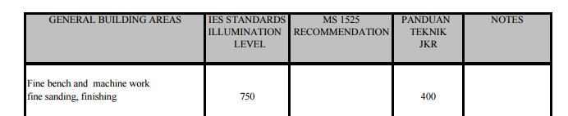

( Source : <http://www.pioneerlighting.com/new/pdfs/IESLuxLevel> )

According to the IES standard, the suggested illumination level generally is from 300-750 lux. However, based on the calculation, the daylight level received for the carving and weaving area is 1136 lux. So, the adjustable panels should be lower down a bit to lower the illumination level to suitable condition.

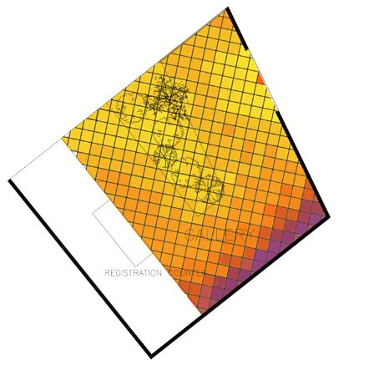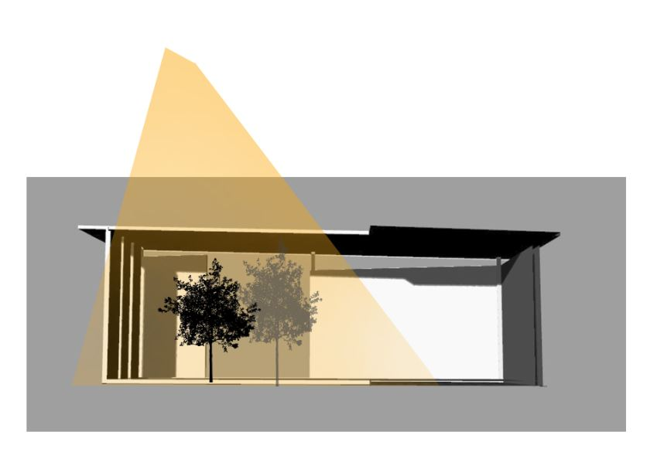Gallery

Sunlight



Light contour retrieved from Autodesk Ecotech 2011

Sectional perspective to show the daylighting strategy.

Daylight factor calculation

|  |  |
| --- | --- |
| Floor area ( m2 ) | 80.6 |
| Opening + Skylight area ( m2 ) | 31.28 |
| Daylight factor, DF | ( 31.28/80.6 ) x 100%  = 38.81% x 0.1  = 3.88% |

Again, with a Daylight Factor, DF of 3.88%, the distribution of daylight is considered good. The lux level of skylight is just enough to illuminate the interior of the gallery. Natural sunlight is needed here to illuminate the artworks and sculptures, and make the textures and colour stand out. In order to cope with the heat gain and to control the glare problems, double glazed low e glass is used for the surrounding curtain wall. However, even the lux level hits the suggested requirement, some of the paintings or sculptures still need to be illuminate by the accent lights.

As for the illuminance level, given the Eo = 32000 in Malaysia,

EEi = ( DF x Eo ) / 100%

= 3.88 x 32000 / 100%

=1241.6 lux

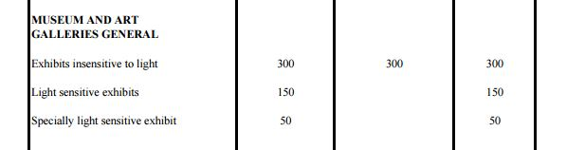

( Source : <http://www.pioneerlighting.com/new/pdfs/IESLuxLevel> )

Referring to the table above, the recommended illumination level for gallery should be kept at 50-300 lux. The final calculation shows that the daylighting for the calculation is 1241.6 lux, which is so much higher. This is due to the large opening at the courtyard area in the gallery which serves as public realm ground garden. So tall plants are planted here to filter out some of the skylight to keep it the natural illumination comfortable.

2.2 Artificial light

Space 1 : Gallery

Gallery is a place where the artworks, paintings and sculptures are exhibited, so it should be properly illuminated at all time to ensure that the visitors can enjoy the arts “true-self”. The lighting strategy should be designed to meet the requirements, and also to allow the visitors to enjoy the artworks under comfort environment, especially during night. Hence, the Philips MASTER LEDspotMV Value 4.3W GU10 LED Spotlight is proposed as this light bulbs offer benefits such as :

* Cost effective, uses only 13 W but delivers the same light quality and brightness as a 60W bulb
* Long life-span, a 8000 hours rated life

Product details :

|  |  |
| --- | --- |
| Product name : GE 31064 Compact Fluorescent (CFLs) 13 Watt |  |
| Voltage | 150 |
| Incandescent equal | 60 W |
| Lumens (initial) | 825 |
| Wattage | 13 W |
| Bulb colour | Warm white |
| Base type | Medium E26 |
| Colour Temperature | 2600 K |
| Life hours | 8000 |

( Source : <http://www.lightbulbs-direct.com> )

|  |  |
| --- | --- |
| Location | Gallery |
| Activity | Artworks exhibition |
| Dimensions (m) | Length, L = 10  Width, W = 9.5 |
| Total floor area (m2) | 95 |
| Standard required Illuminance (lux)  ( referring MS1525 and IES standards) | 150-300 |
| Ceiling height (m) | 3.75 |
| Height of luminaires (m) | 3.25 |
| Height of work level (m) | 0.8 |
| Mounting height/H (hm) | 2.45 |
| Reflection factor | Plaster ceiling : 0.7  Plastered wall : 0.5  Timber flooring : 0.2 |
| Room Index / ( RI ) K | 1.99, approximately 2 |
| Utilization factor, UF | 0.51 |
| Maintenance factor, MF | 0.8 |
| Number of fittings required , N | N = ( 150 x 95 ) / ( 825 x 0.54 x 0.8 )  = 14250 / 356.4  = 39.98  = 40 bulbs |

Assuming spacing to height ratio ( SHR ) is 1 : 1, Hm = 2.45m, so the spacing shouldn’t be exceeding 2.45m.

Thus, width/W = 9.5m divided by spacing 2.45m,

9.5/2.45 = 3.88 ( take 4 rows of light )

Then, since the number of light bulbs needed is 40, so 40/4 = 10 bulbs each rows.

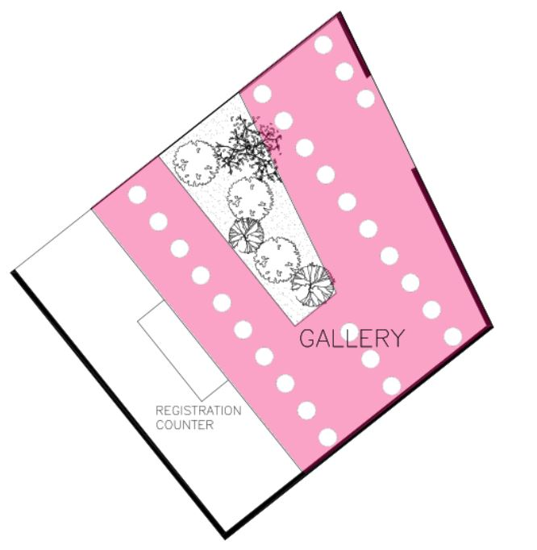

Reflected ceiling plan at the gallery to show the light fittings pattern.

However, the above calculations are done in a rigid square to ease the calculation, after fitting it into the plan, and with simple adjustments, the final light bulbs orientation are shown as above. Since the centre courtyard is opened for daylight, so light bulbs are not installed.

Conclusion, with the omission of some unnecessary light bulbs, only a total of 26 light bulbs are needed to illuminate the gallery during night time.