**GETTING BACK TO NATURE OR GETTING NATURE BACK?**

**Malaysia Environment**

The Malaysian environment is out of balance. After a century of ravages visited upon its natural resources the accumulated toll is manifesting itself in the form of denuded hill slopes, polluted rivers, endangered and extinct species, foul air, contaminated food supplies and climatic changes. The introduction of exotic species such as rubber and oil palm has changed the Malaysian landscape forever, as lowland rainforests, mangroves, wetlands and the other habitats diminished to make land available for these economic crops. As one of the world's largest tropical log suppliers, Malaysian forests continue to deteriorate due to overzealous logging, with little emphasis on protecting non-commercial species and replanting programs.

The 21st century will not be able to proceed like the last one. First of all, there are too few natural renewable resources remaining to sustain the excessive exploitation rates of the previous century. And whatever can be harvested from steep-sloped forest, limited fishery stocks, and polluted waterways will only last a few decades if short-term thinking continues to pervade commercial activities. Secondly, the steady output of greenhouse gases, toxic chemicals, hazardous waste and organic loads into the environment is over whelming the natural capacity of forests, oceans, land and the atmosphere to absorbs pollutants and contaminants. Nature also has its limits and Malaysia is on the verge of testing that hypothesis to the extreme.

**Over Population , deforestation and global warming**

The world is facing environmental crisis like over-population which is the main factor that leads to the rapid depletion of natural resources, deforestation and global warming. The world population is currently increasing at the rate of 1.3% annually, and it's predicted the population will be doubled in 54 years. Over-population eventually results in this climate change as more fossil fuels is used for human activities and more trees are cut down to provide timber.

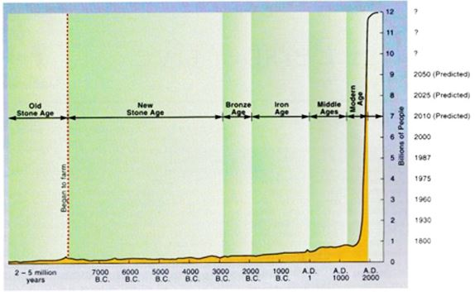Fig 1. This graph shows that the rapid growth of human population from 1200 until now.  
(*sources*: Environmental Science by Mcgraw Hill 2004)

The rapid growth in human population cause severe deforestation which affect the ecosystem of forest. Human should be aware of the current situation and the impacts of deforestation that might bring to us and find a better solution to this issue.

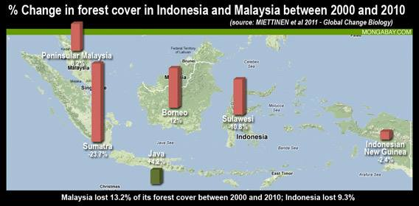

(*Source*: Miettinen et al 2011 - Global Change Biology)

**Forests**

**Introduction**

Rainforests represent the essence of Malaysia's magnificent ecosystems indeed, the country is one of the 12 most biologically diverse countries in the world. Forests are the dominant natural ecosystem in Malaysia. They are a source for a number of timber and non-timber goods, and perform a number of critical ecologies functions.

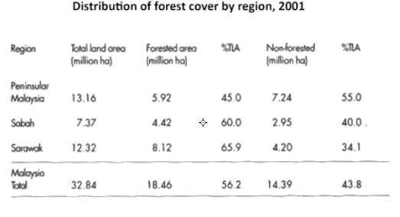

*Sources*: Department of Statistics, Malaysia 2002(drawn from Forestry Department)

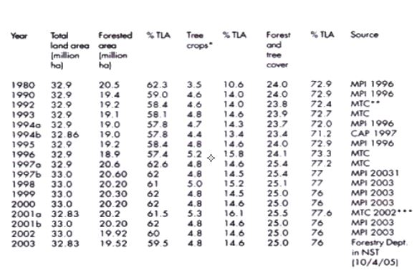

*Sources:* Forestry & Department fact sheet 2002, *Malaysia Environment in Crisis*

**Environmental and social impacts of deforestation**

Forest sustain an enormous variety of animal and plant life, continuous encroachment on their habitats may force forest species into ever smaller ranges, threatening their reproductive capability, perhaps leading to their extinction within our own lifetimes. Natural species literally exist in " a web life" where the fate of plants, animals, insects and other life forms are tied together in fascinating and complex ways. The destruction or removal of one part of this web can cause other related species to suffer and perhaps die. Rapid over-harvesting of timber and non-timber products by big commercial interests with little or no ecological regard can exceed the capacity of the forest to replenish itself. In addition, forests often disappear through logging which open the way for conversion to other land uses seriously disturb the physical integrity of the once forest-bearing earth. Logged areas fail to cache rain water, instead exposed topsoil is washed along leading to cloudy rivers and health impacts on organism life. Besides, a worldwide threat posed by the loss of our rainforests is the onset of disastrous global warming. Fossil fuel-based industrialization, urbanization and massive deforestation over the last 150 years have released immense amounts of greenhouse gases.

**Sustainable forest management**  
  
According to Forestry Department and Statistics Malaysia 2002, the comparisons in the last decade revealed that log production decreased from a high of 13,030,000m3 in 1992 to a mere 4,155,130m3 in 2001. Since 1994, the logging activities for timber, plywood, and veneer dropped significantly too. With substantial decreases in log production in both Peninsular Malaysia and Sabah, that left Sarawak to carry the harvest load. From 1994 to 1997 over 16,000,000m3 were extracted from natural forests each year. Only in 1998 did the chainsaws subside with total of 11,307,000m3 harvested. Considering the total log production for Malaysia in 1998 is 21,656,000m3, Sarawak`s share amounted to over 50% or in other words, equal to the annual production from both Peninsular Malaysia and Sabah combined. So without much doubt, Sarawak is the leader in logging in Malaysia and will be pressured to continue its mean cutting regime.

**References**  
1. N.Manokaran, 1997. *The role and Importance of Malaysia's Rainforests*  
2.Prof.Dato'Dr Sham Sani, editor, 1998. *The encyclopedia of Malaysia, Volume 1: The Environment.* Editions Didier Millet  
3.Department of Wildlife and National Parks &DANCED, 1996. *A Master Plan on Capacity Building & Strengthening of the Protected Areas System in Peninsular Malaysia*. DWNP, Kuala Lumpur  
4.Jomo, et al.2003. *Deforestation Malaysia*, London: Zed Books, P.51  
5.*Malaysia Environment in Crisis*, Chapter 1

Nowadays the number of vehicle is increasing and deforestation is getting serious. Forest is the lung of earth and the place where earth store carbon. This result leads to air pollution and global warming.

**Air pollution**

Living in the urban jungle is hard on the lungs. Vehicular exhaust fumes, factory smokestack plumes, burning refuse and all contribute to the inhalation of suspended particles and noxious gases each breathing day. In the 1990s, as cited by the Department of Environment, the total emission load from mobile sources, stationary sources and the burning of municipal and industrial wastes more than doubled from 1992(1,574tonnes) to 1997(3,583tonnes).

According to Department of Environment(DoE), the major source of air pollution which contribute to at least 70%–75% have been transportation. The rest are from stationary sources which is 20%–25%, and open burning that contributed approximately 3%–5% .A study from DoE in 1996 showed that motor vehicles contributed 82% to air pollution, 9% were from power station, 5% from industrial fuel burning , 3% from industrial production process ,0.2% from domestic and commercial furnaces and 0.8% from open burning at solid-waste disposal sites.

In year 2004, investigation on air pollution showed that transport sector were for the major cause of

Nitrogen oxide (NOx) which was 35% of the total particulate matter (PM) emissions in the country while the majority of Sulfur Dioxide(SO2) and PM emissions were the power and industrial sector. The power sector took up to about 60% of the total Sulfur Dioxide emissions, 50% of the total PM emissions, while the industries accounted for about 20% of the total SO2 and PM emissions.

Source: WWF Malaysia, 1999. Air Pollution. *Environmental Pollution Threats in Malaysia Series.*

**Emissions Inventories of PM, SO2, and NOx by Sources in 2004 (Tons)**

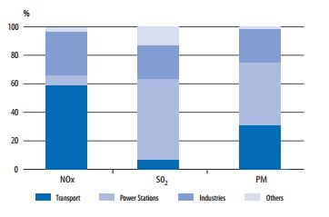

*Source*: Country Synthesis Report on Urban Air Quality Management 2006

**Air Quality Management**

Legislation and Mandate

In order to improve air quality, the environmental management department, The Environmental Quality Act(EQA) was enacted in 1974 in Malaysia. DoE is the environmental regulatory agency at federal level(part of Ministry of Natural Resources and Environment currently) that established to administer and enforce EQA. In order to ensure a better environment, Malaysia adopts prevention and pollution control approach such as the National Policy on Environment, which integrates with the sustainable development. The objectives of this policy is to promote continued economic, social, and cultural progress and the enhancement of the quality of life of Malaysians through environmental and sustainable development.

**Ambient Air Quality Standards**

A set of air quality guidelines called the Recommended Malaysian Air Quality Guidelines (RMG)

were formulated by DoE in 1989(see Table 5.1). DoE consequently developed

the Malaysian Air Quality Index (MAQI) in 1993 base on the guidelines.

**Malaysia and WHO 2005 Ambient Air Quality Guidelines**  
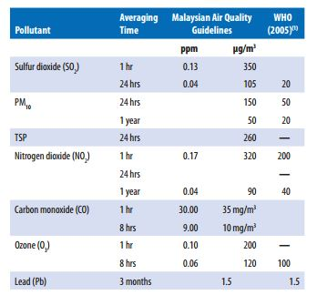

*Source*: Country Synthesis Report on Urban Air Quality Management 2006

Management of Mobile Sources

The Motor Vehicle Rules were enacted by government as part of road traffic ordinance of 1958 in 1977 to control smoke and gas emissions. Then, to further implement the air quality management, Malaysia has adopted Euro 1 emissions standard for light-duty vehicles in year 1997 and Euro 2 standards for gasoline vehicles in year 2000. The Malaysians’ preference of private transportation and overlook of public transport have been undermined. In addition, encouragement of a modal shift from using private vehicles to public transport have been done under The Ninth Malaysia Plan(2006-2010), includes urban transportation strategies focusing on the development of an integrated, efficient, and reliable public transport system.

**Transportation**

Traffic jam are a constant occurrence in Malaysian urban centre, vehicle registration increased from 5.5 million to 7.7 million from 1992 to 1996. In the mid 1990s, the Sustainable Transport Action Network for Asia and the Pacific found that the Klang Valley had the dubious distinction of being "the most private- vehicle-oriented of any of the Asian cities".

Recently the government seems to be making long-awaited steps towards transport integration. Integrasi Sistem Pengangkutan Awam Lembah Klang announced that Klang Valley  
would have a single company own and develop all public transport infrastructure. A single operating company will solely manage and operate both bus and light rail services in the area.  
As Malaysia motors towards 2020, city planners need to keep the masses in mind and concentrate businesses near well-served public transportation lines, in addition to building-in urban walkways and cycling paths to encourage taking the road less travelled. Hopefully, great progress can be made in sustainable public and private transportation.  
  
*Source*: Department of Environment, 2003. Malaysia: *Environment Quality Report 2002*

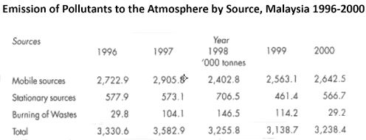

*Source*: Department of Statistic 2003

According to the findings of climate research, the carbon dioxide concentrations in the atmosphere have greatly increased in the last 150 years, from 280 ppm(a value typical for warm periods during at least the past 700000 years)to the level of 383 ppm in year 2007.( Global Carbon Project, 2008 ) This increase is mainly due to the burning of fossil fuels and deforestation. Carbon dioxide is the gas that affects the Earth’s climate by changing its radiation budget. Since 1900 , the temperature of earth have been raised by 0.8C . Temperatures in the past 10 years have been the highest since measured records in 19th century.

**Impact and risks from Deforestation and Global Warming**

**Increase in sea level and loss of ice sheets**. Sea level is rising at the rate of over 3 cm per decade, about 50% faster than prediction from IPCC Third Assessment Report( Rahmstorf et al., 2007) If the warming is not limited , the sea level will possibly rises about 1 metre by 2100. Even the warming is halted at 3C , the rise will like to reach few metres in the following centuries as a delayed response.

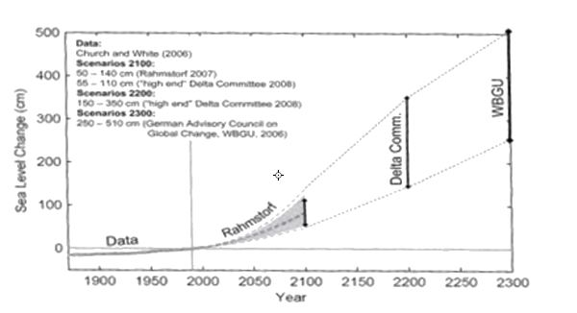

**Loss of ecosystem and species**. If the temperature continues to go higher uncontrolled, about one third of all species could face extinction by the year 2050 as studies show that the change in global climate at current rate will be too fast for all these species to adapt to.

**Risk of extreme events**. Air can hold 7% more water for each degree Celsius of warming, as a result , the risk of extreme flooding will likely to increase.

**Risk to water and food supplies**. Some poorer and warmer countries may experience reductions in yield production because of water shortage and extreme weather. Agricultural productivity is expected to decline globally in the event of warming between 2C and 4C.( Parry et al. , 2007) This is even worst when the reduction in food productivity meets the growth in population.

**Counteract the dangerous climate change**

**Global deal**. Nations should cooperate in tackle climate-related challenges to prevent the worst impacts of climate change. This will be a great initiative for the process of reconstructing the global economy toward ecologically oriented growth(low carbon industries).

**Developing a vision for international climate protection**. Low carbon development should be introduced. All countries should agree to achieve their national economic and development goals under low carbon strategy that safeguard the nature, ready for sustained economic welfare.

**Reducing emissions from deforestation and degradation(REDD) and other land use sector**. Governments will have to improve the ecosystem management that can avoid substantial amount of emission and restore the carbon sinks once existed. 17% of global emission are caused by carbon deforestation and forest degradation(Metz et al., 2007) In response to this issue, each countries may submit a national deforestation plan that outline the country’s commitment and strategy to reduce deforestation emissions from an agreed national baseline, provided that financial support from industrialized countries is guaranteed. Invention in efficient mechanism must also be done to provide this funding within framework of a carbon market.

**References**1. Hans Joahim Schellnhuber , *Global Sustainability, A Nobel Cause Cambridge  
2.*Sahabat Alam Malaysia*, Malaysia Environment in Crisis  
3.*McGraw Hill , *Environmental Science*

**Conclusion**

**Sustainable living**

For nearly fifty years Malaysia has travelled on the path to progress without sober reflection on the unsightly side of development, preferring to forge ahead until disaster strikes. Environment concerns should not be seen as somehow separable from development ambitions. The time is long overdue for a new approach to our environmental as well as economics progress. Government policy and decision making needs to hold sustainable development at the heart of our national achievements. Without integrating environmental implications economic development needs environmental concerns will find themselves alienated from the need to improve the living standards of the poor and disadvantaged. These are sustainable development **policy for sustainable living** in order to improve environment**:**

**A sound theoretical framework**  
Development policy and planning should recognize that in addition to human labour and the workings of finance an indisputable pillar of economic development is the contribution of nature in the form of materials, energy, and a hospitable climate and environment.   
 **Accurate and relevant data**The data with which government ministries base their decisions upon needs to be accurate, up to date and relevant to holistic resource management. Picking the wrong data to track process or using bad data is likely to lead to serious oversight and false predictions.  
  
**Appropriate institutions and policies**  
The sound and sustainable management of our country`s natural resources and the protection of the environment for the benefit of nature and humans requires appropriately designed institutions. These provide the basis for appropriate and effective laws and policies as well as relevant and useful avenues for action and public service.  
**Good governance, transparency and accountable**  
Decision making must be grounded in good governance, transparency and account-ability. Where laws give wide discretion to the government to act, as in the power is used to forge the public interest.  
  
**Effective implementation and enforcement**It is no use having good policies, plans and laws on paper if they are not implemented or enforced if public confidence in the government and it`s apparatus is to be inspired.

**Public participation and awareness**Policy making which will benefit is likely to be flawed if it is a solely specialist and top-down affair. As the subjects of development policies the public needs to be able to participate in decision making in meaningful ways.

Important policy-making departments in the government rely upon such statistics in order to gauge the impact of their policies and where future improvements may be needed. The accuracy or inaccuracy of such data can have significant impacts on whether the upper echelons of government have a clear picture of how Malaysia is fairing, which brings us to the attempts to quantify Malaysia's quality of life.