1.0 INTRODUCTION
1.1 PROJECT BRIEF
This project required a group of 6 members to obtain floor plan of a maximum 3 storeys bungalow. Students are required to carry out structural framing and prepare structural drawings for the bungalow. Structural plans should include foundation plan, ground floor plan, first floor plan and roof plan.
Then, within the group, 2 members are to form another subgroup of 2 to propose an extension work to the bungalow that meet the following criteria:
(A) The area of extension should not exceed 30% of the existing floor area (max 100m2 each floor).
(B) The extension should be sideway.
(C) The extension should be of two storeys.
After that, frame the extension by using appropriate structural members i.e. columns, beams, slabs, or trusses. Lastly, identify and quantify the load acting on the structure, and then analyse it.
1.2 INTRODUCTION OF CASE STUDY
We chose to extend one of the 2 ½ storeys bungalow under GJH construction’s project located in Ayer Keroh, Melaka. The project, named Vista Kirana, is an exclusive bungalows estate within a gated and guarded community. We chose the type E bungalow bungalow with an effective built up area of 413.54m². The total land size is approximately 883m² which means that we have up to more than 400m² of potential open area for extension.

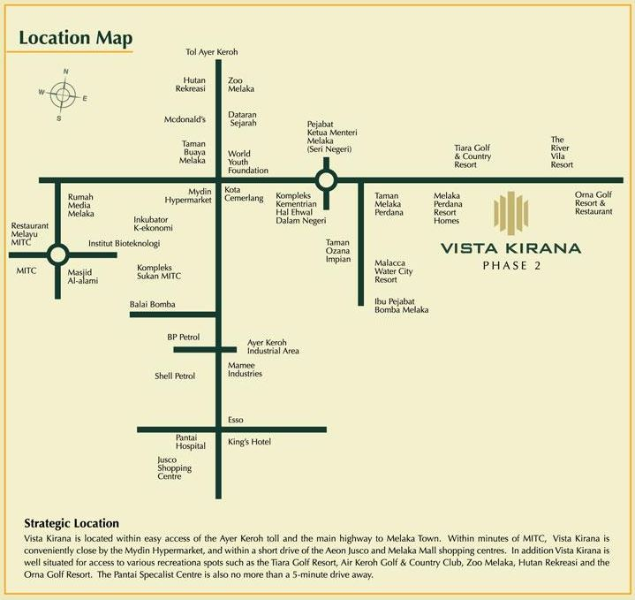
- Location plan showing the way to the residential area of Vista Kirana Phase 2
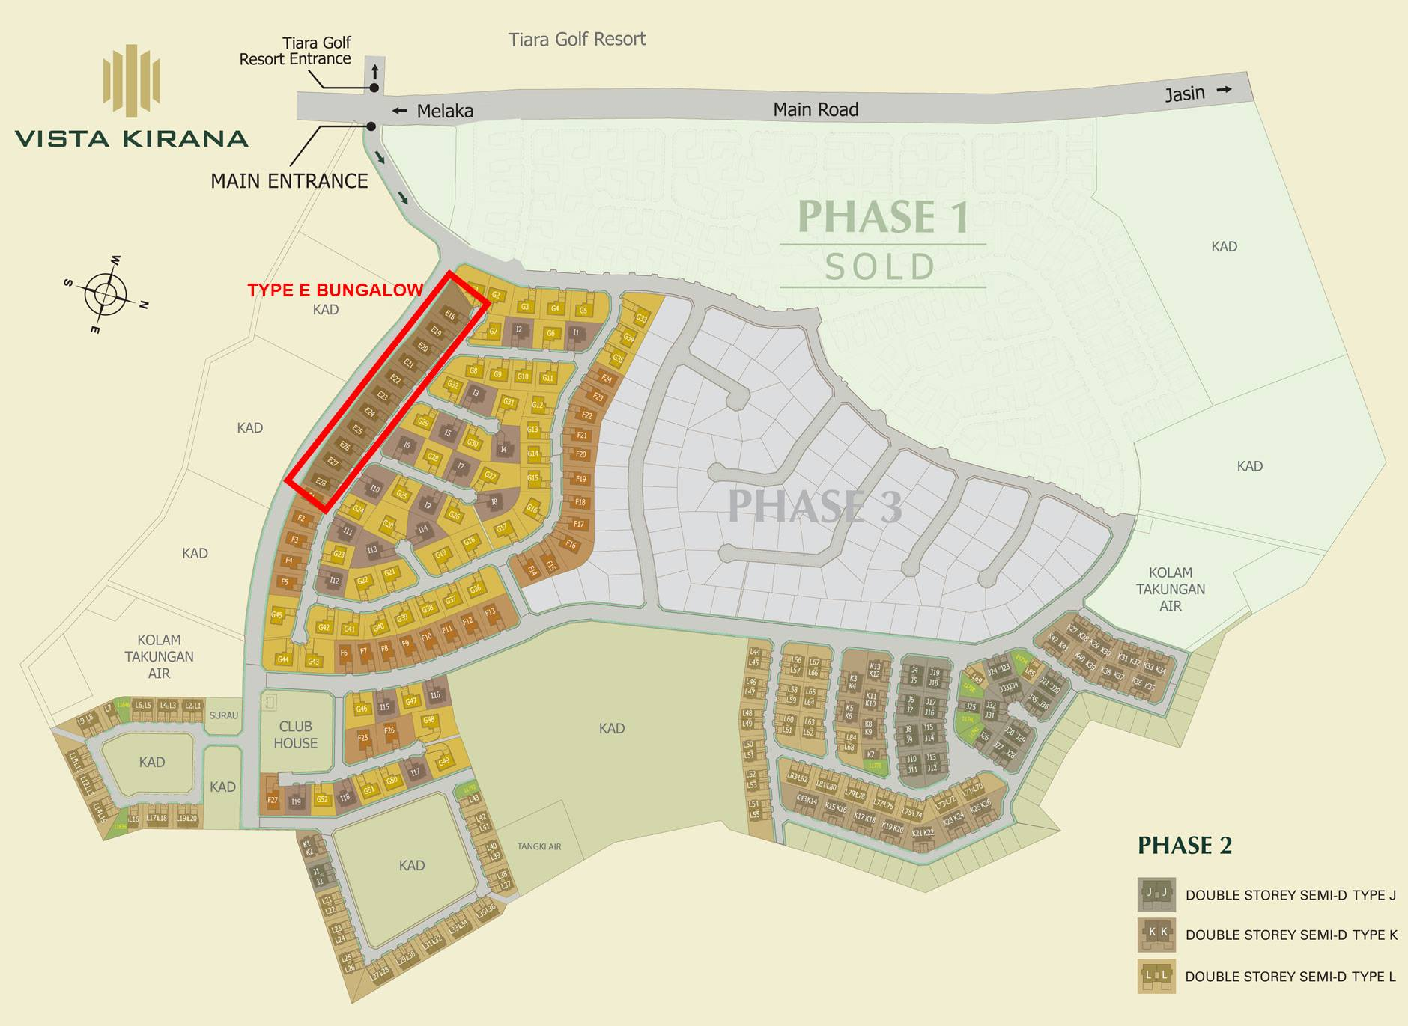
Development Site Plan of Vista Kirana housing area showing the Type-E Bungalow chosen
(Highlighted in Red Boundary)

Ground Floor Plan _{from brochure}
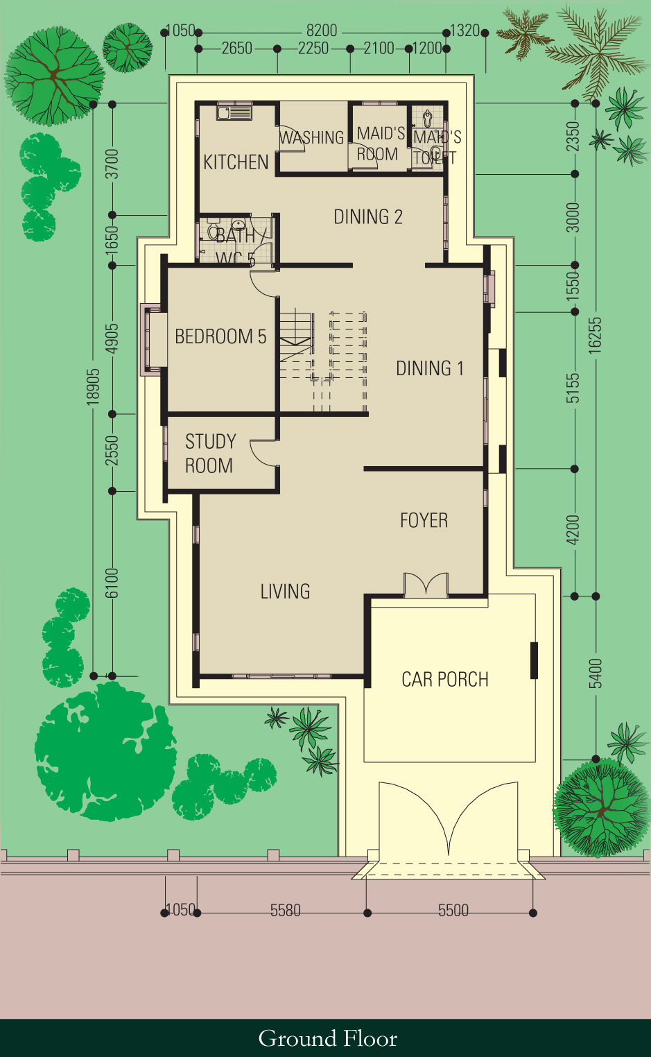
First Floor Plan _{from brochure}
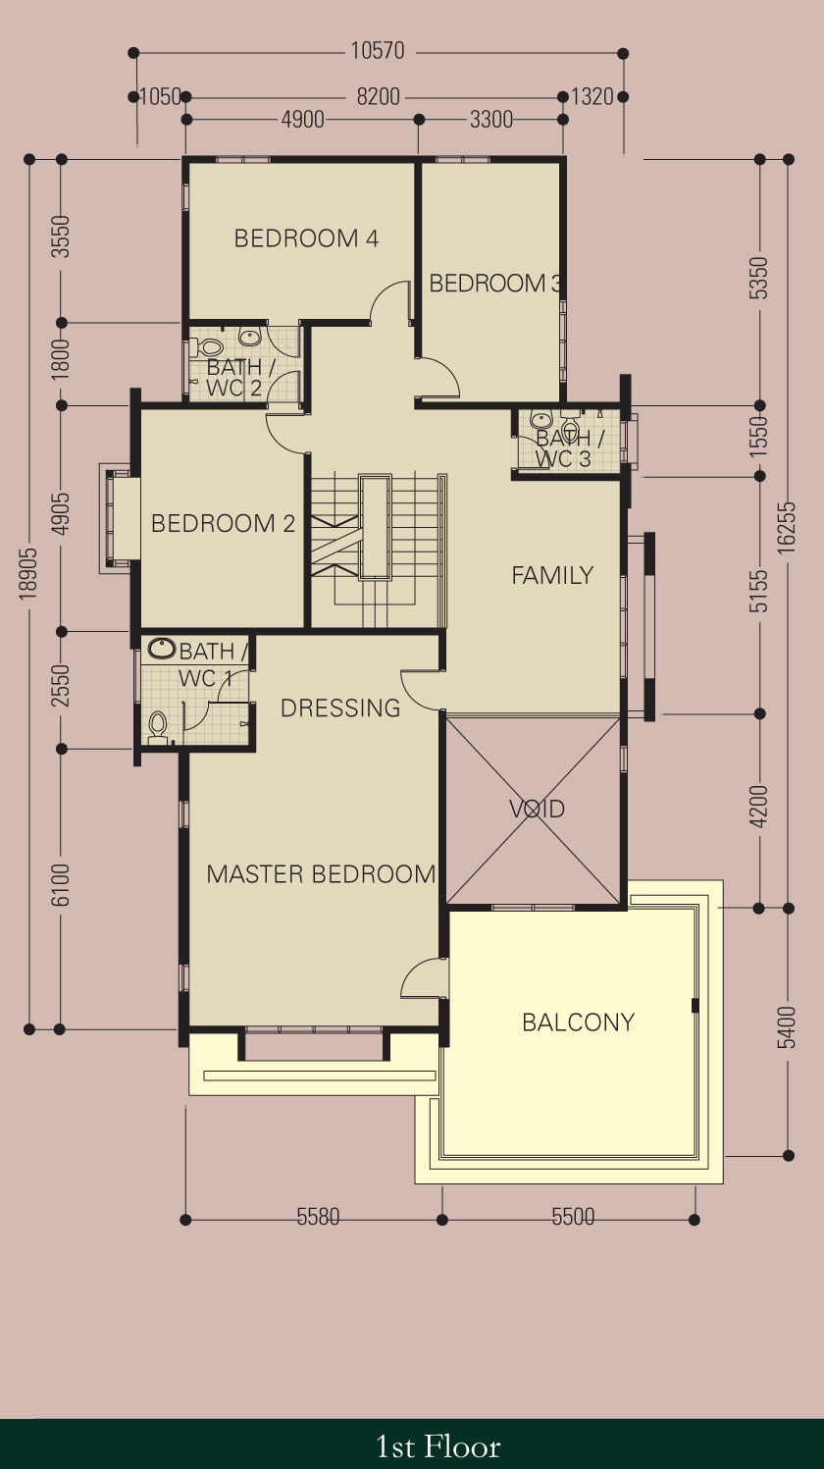
Attic Floor Plan _{from brochure}
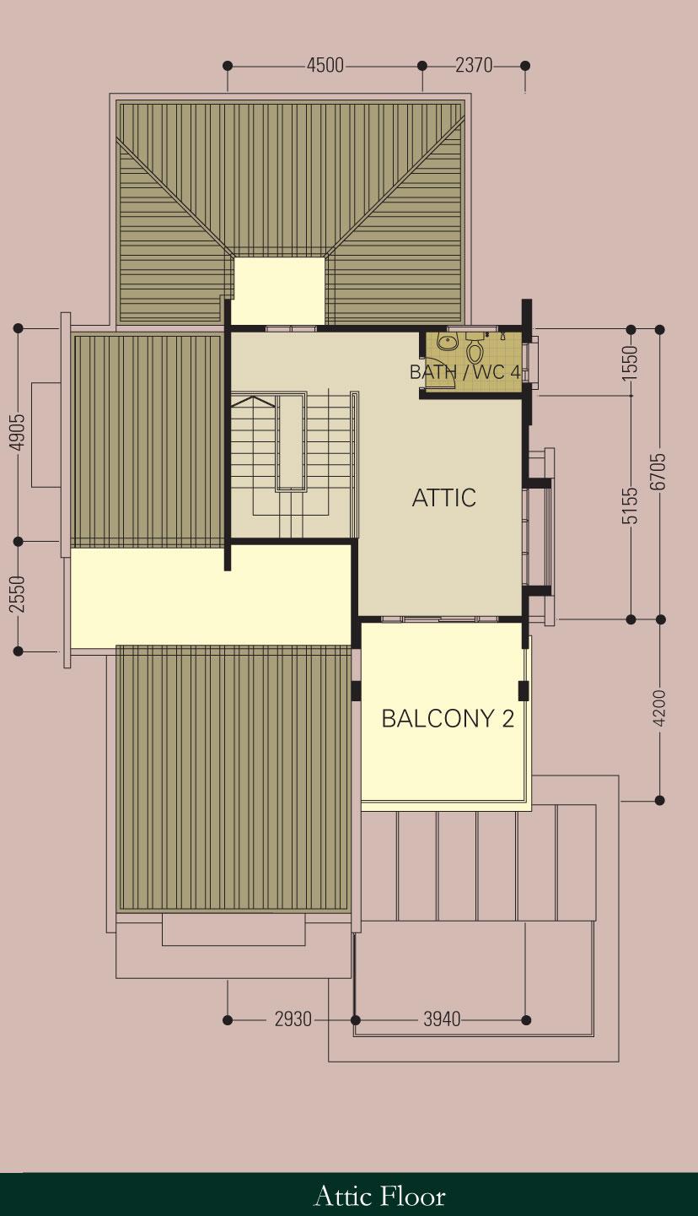
1.2.1 FLOOR PLAN
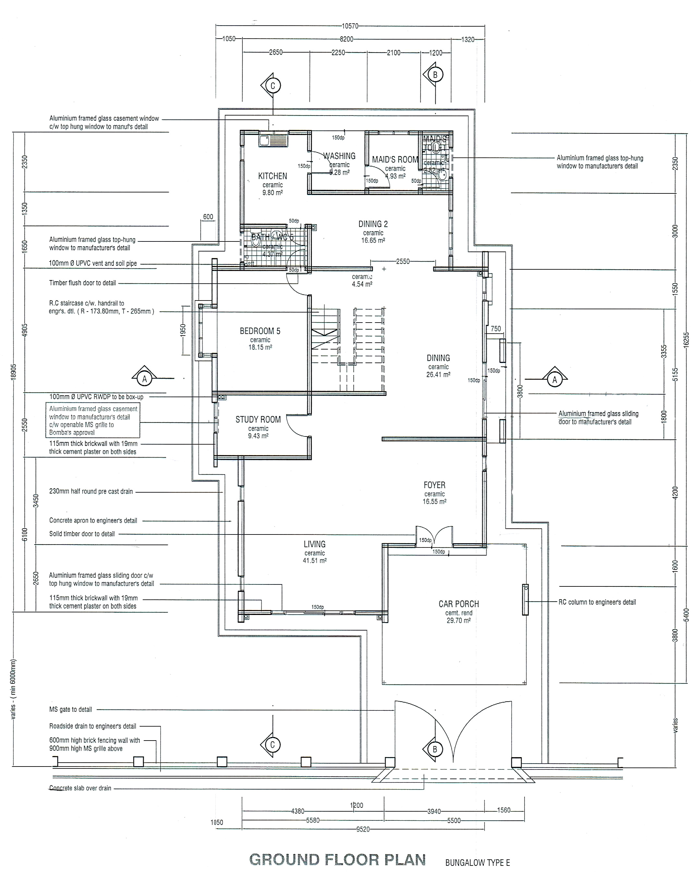Ground Floor Plan

FIRST FLOOR PLAN
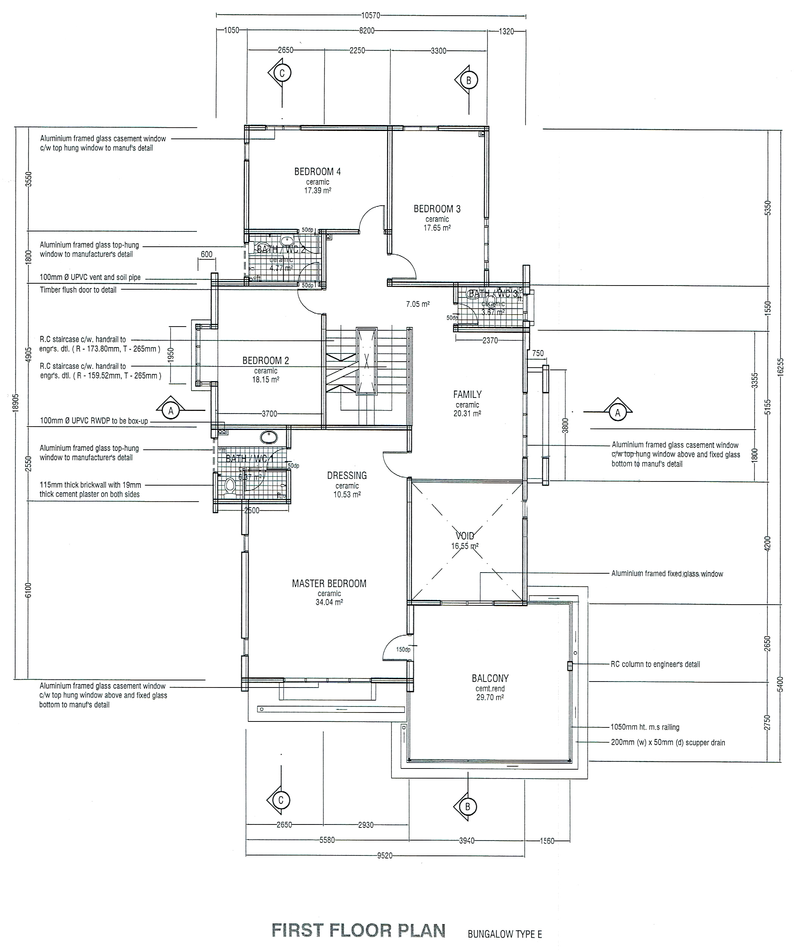
ATTIC FLOOR PLAN
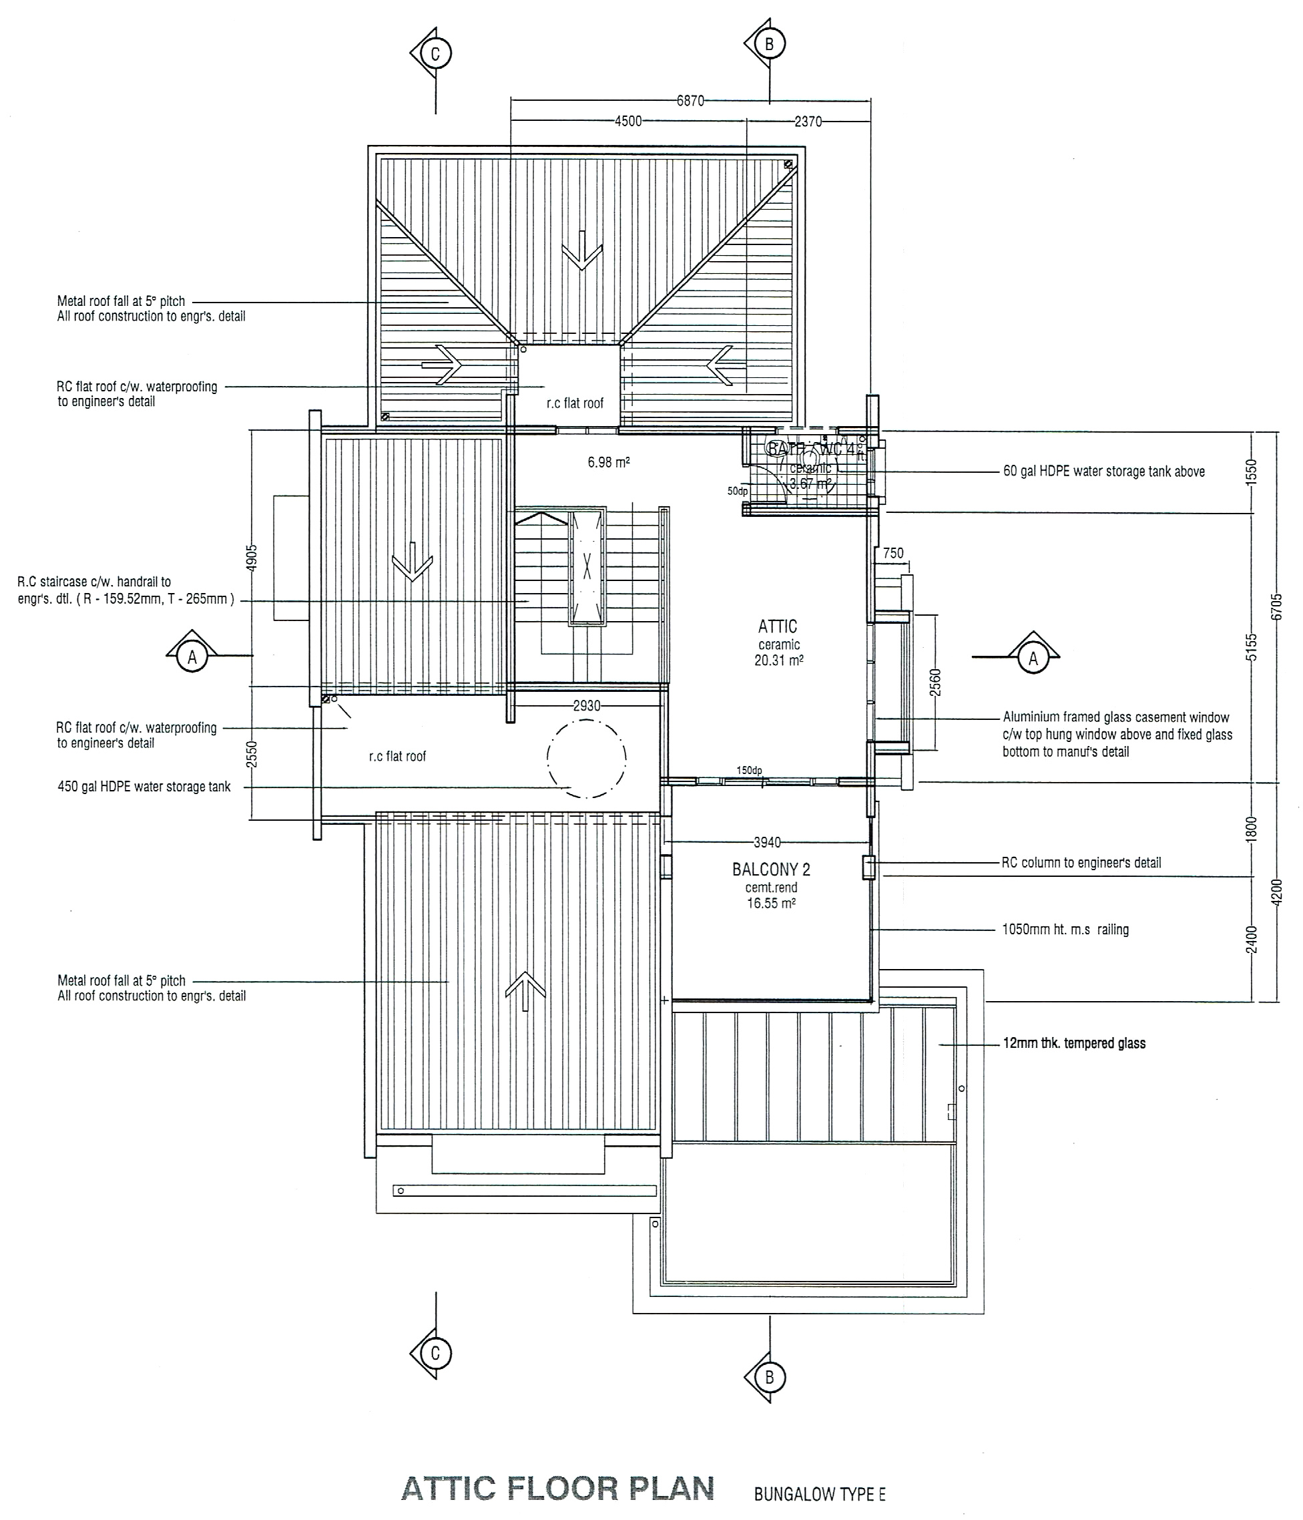

1.2.2 ELEVATIONS
FRONT ELEVATION & REAR ELEVATION

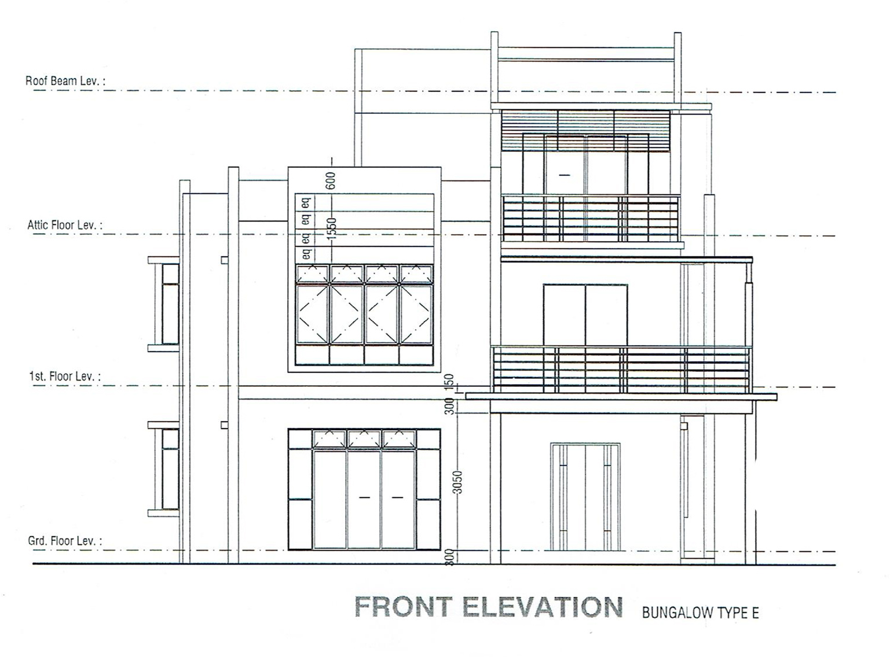

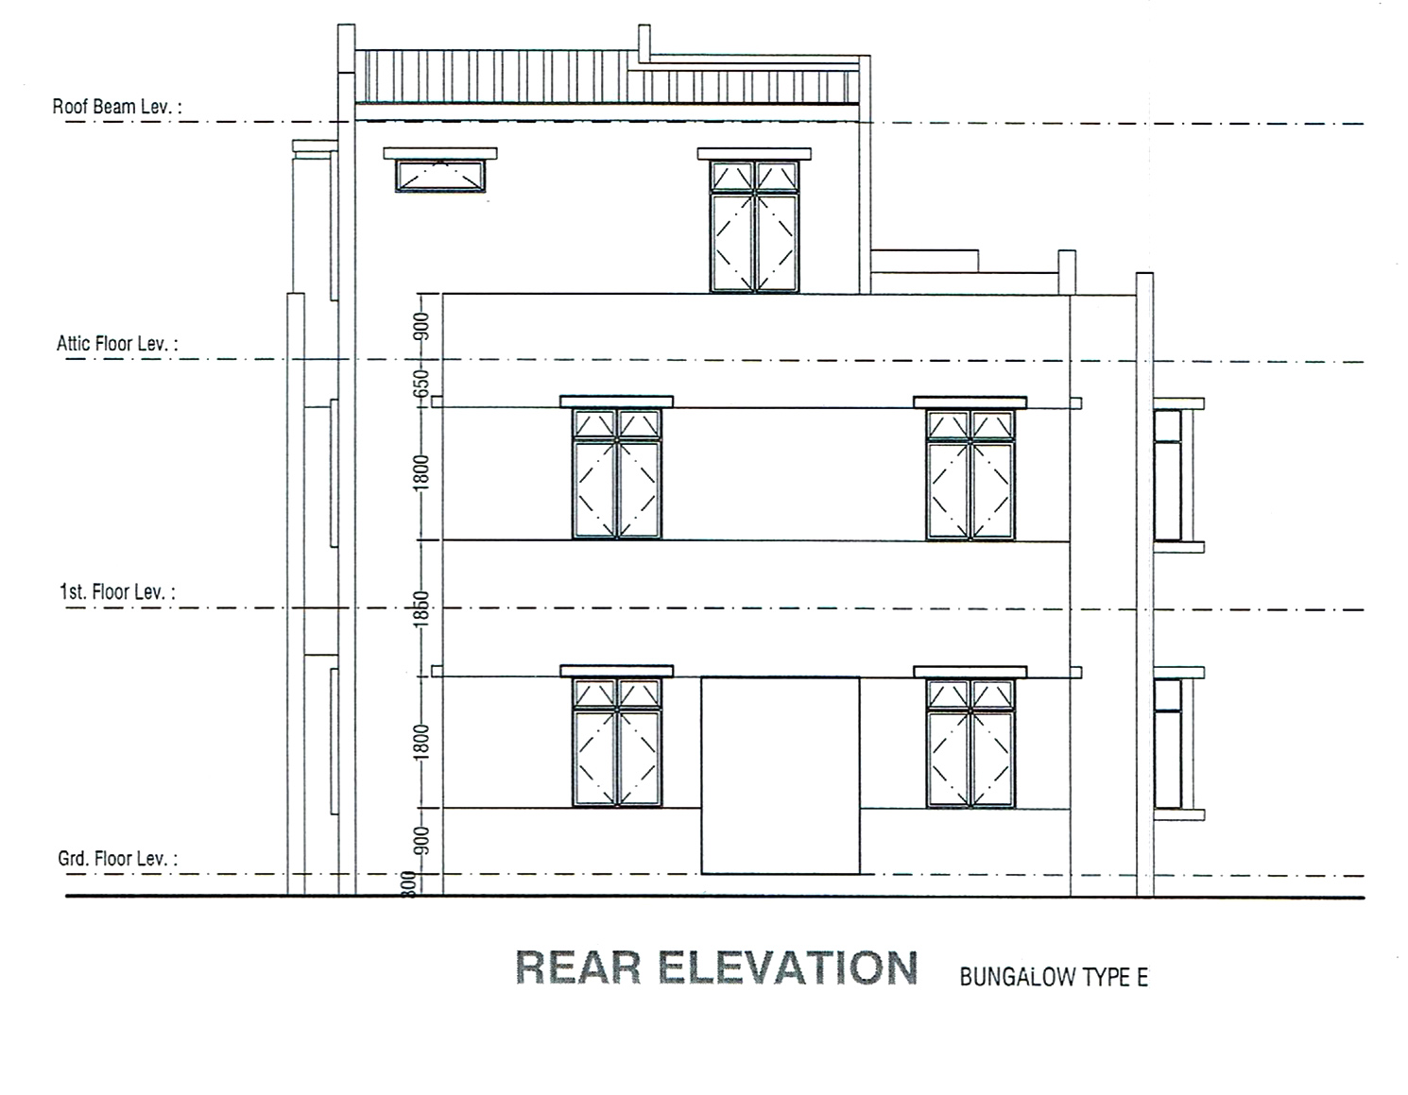

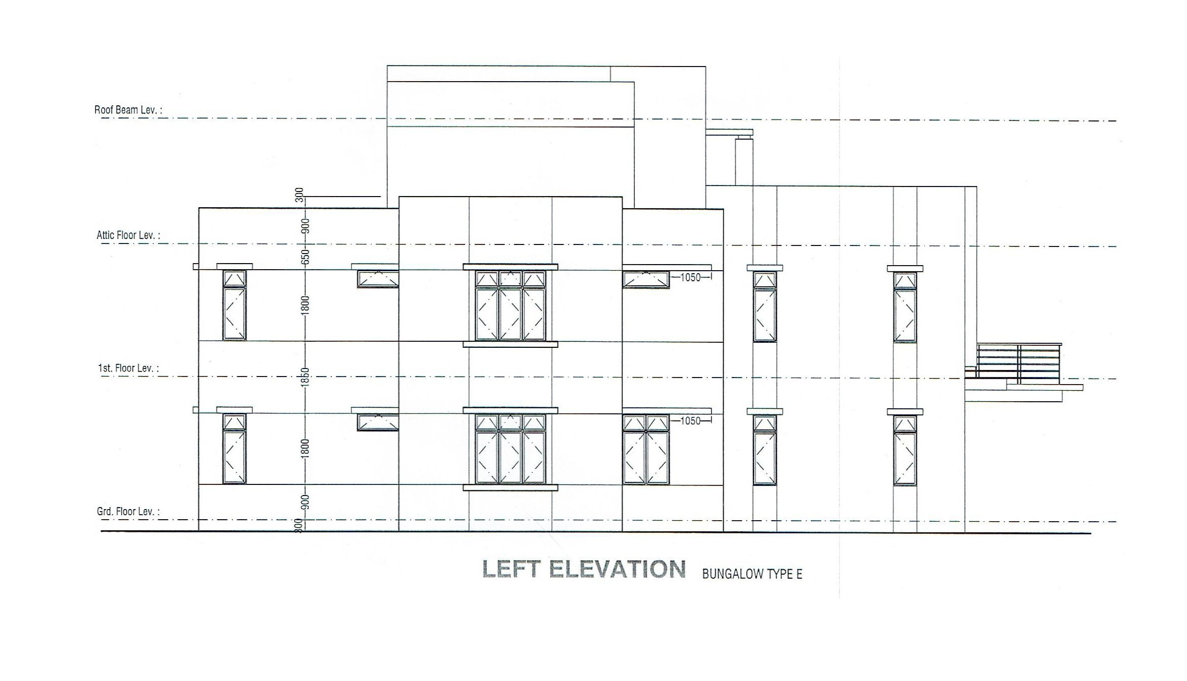LEFT ELEVATION & RIGHT ELEVATION
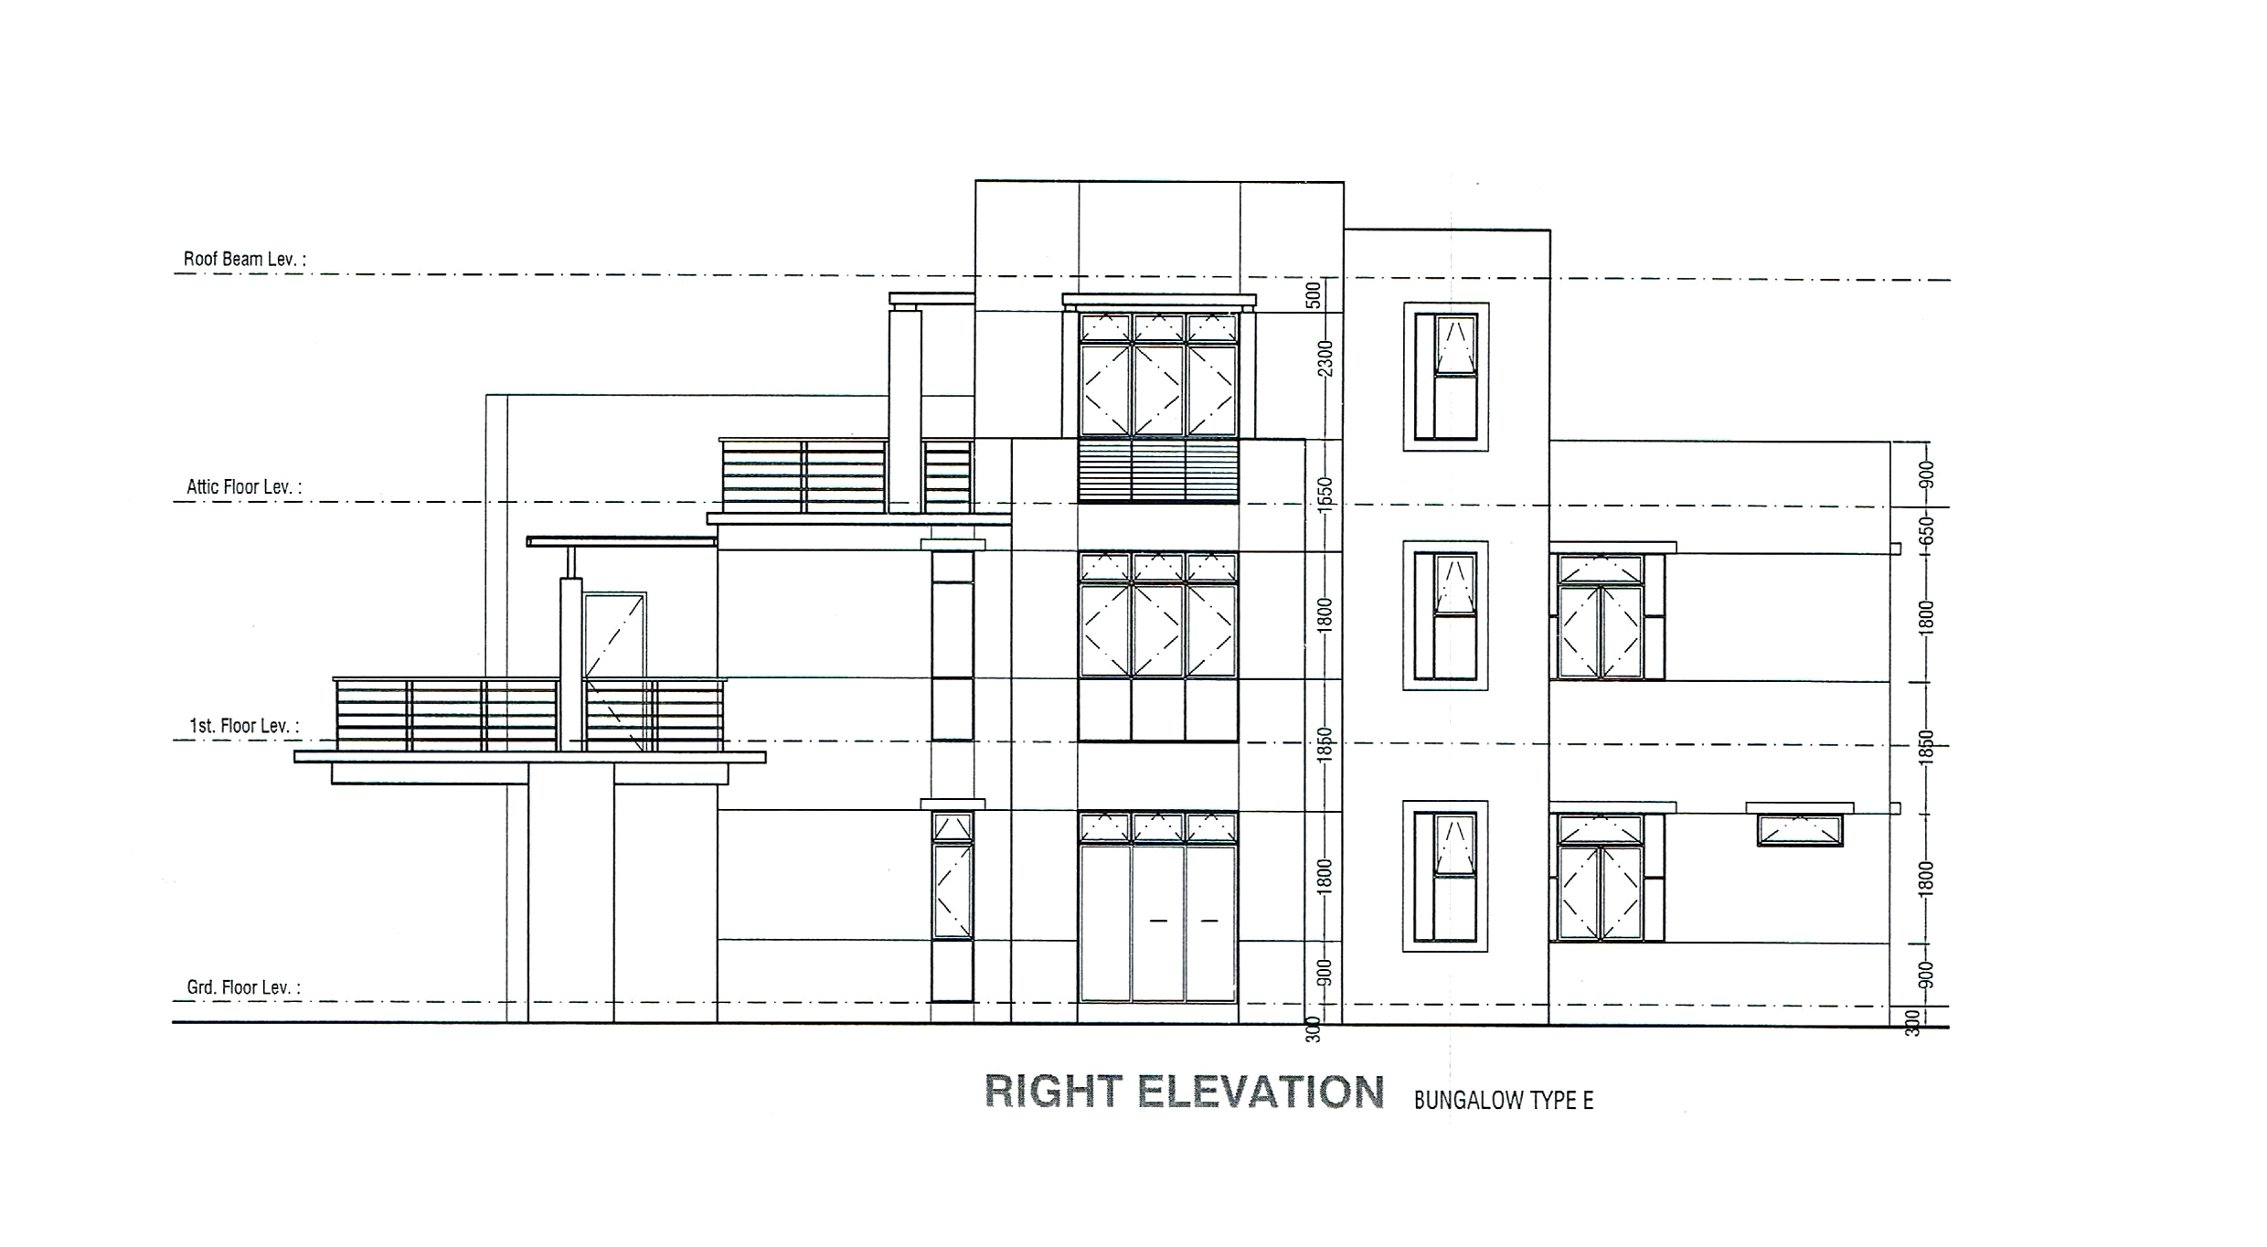

1.2.3 PERSPECTIVE
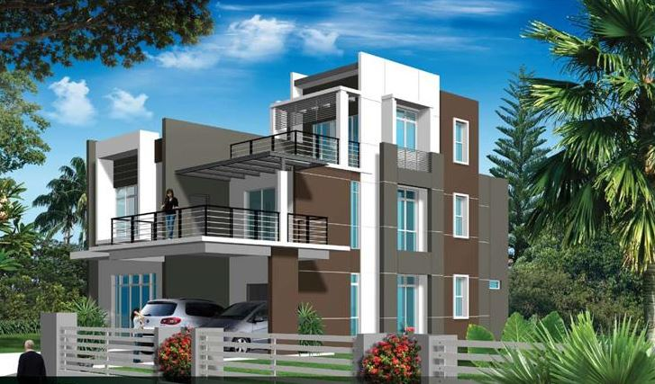
Interior Perspective

Exterior Perspective

1.2.4 STRUCTURAL PLANS
FOUNDATION PLAN
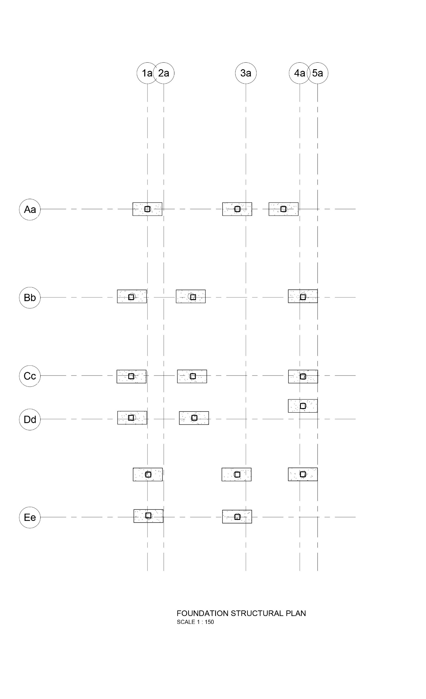

GROUND FLOOR STRUCTURAL PLAN

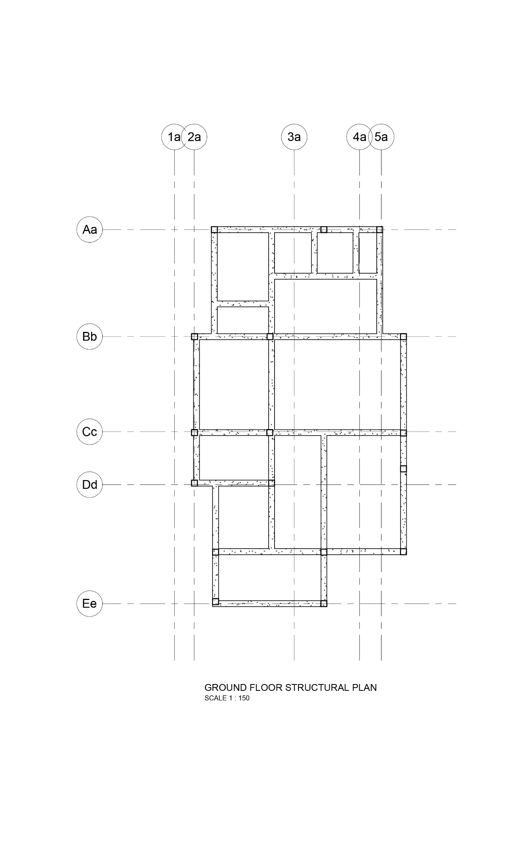
FIRST FLOOR STRUCTURAL PLAN

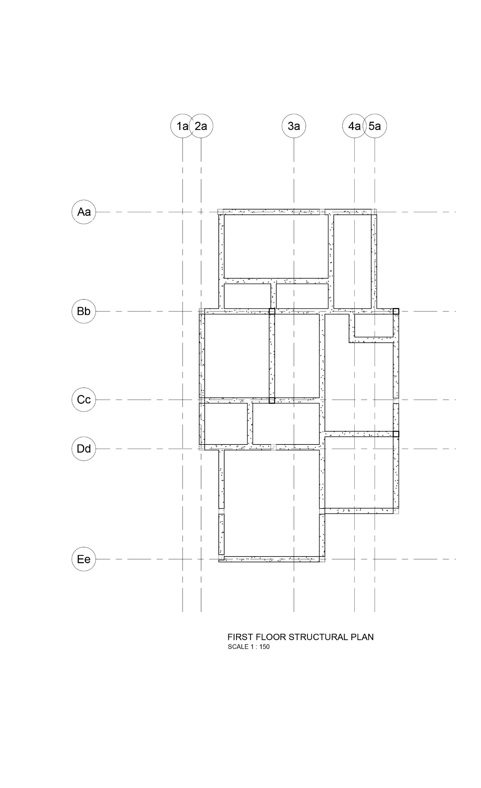
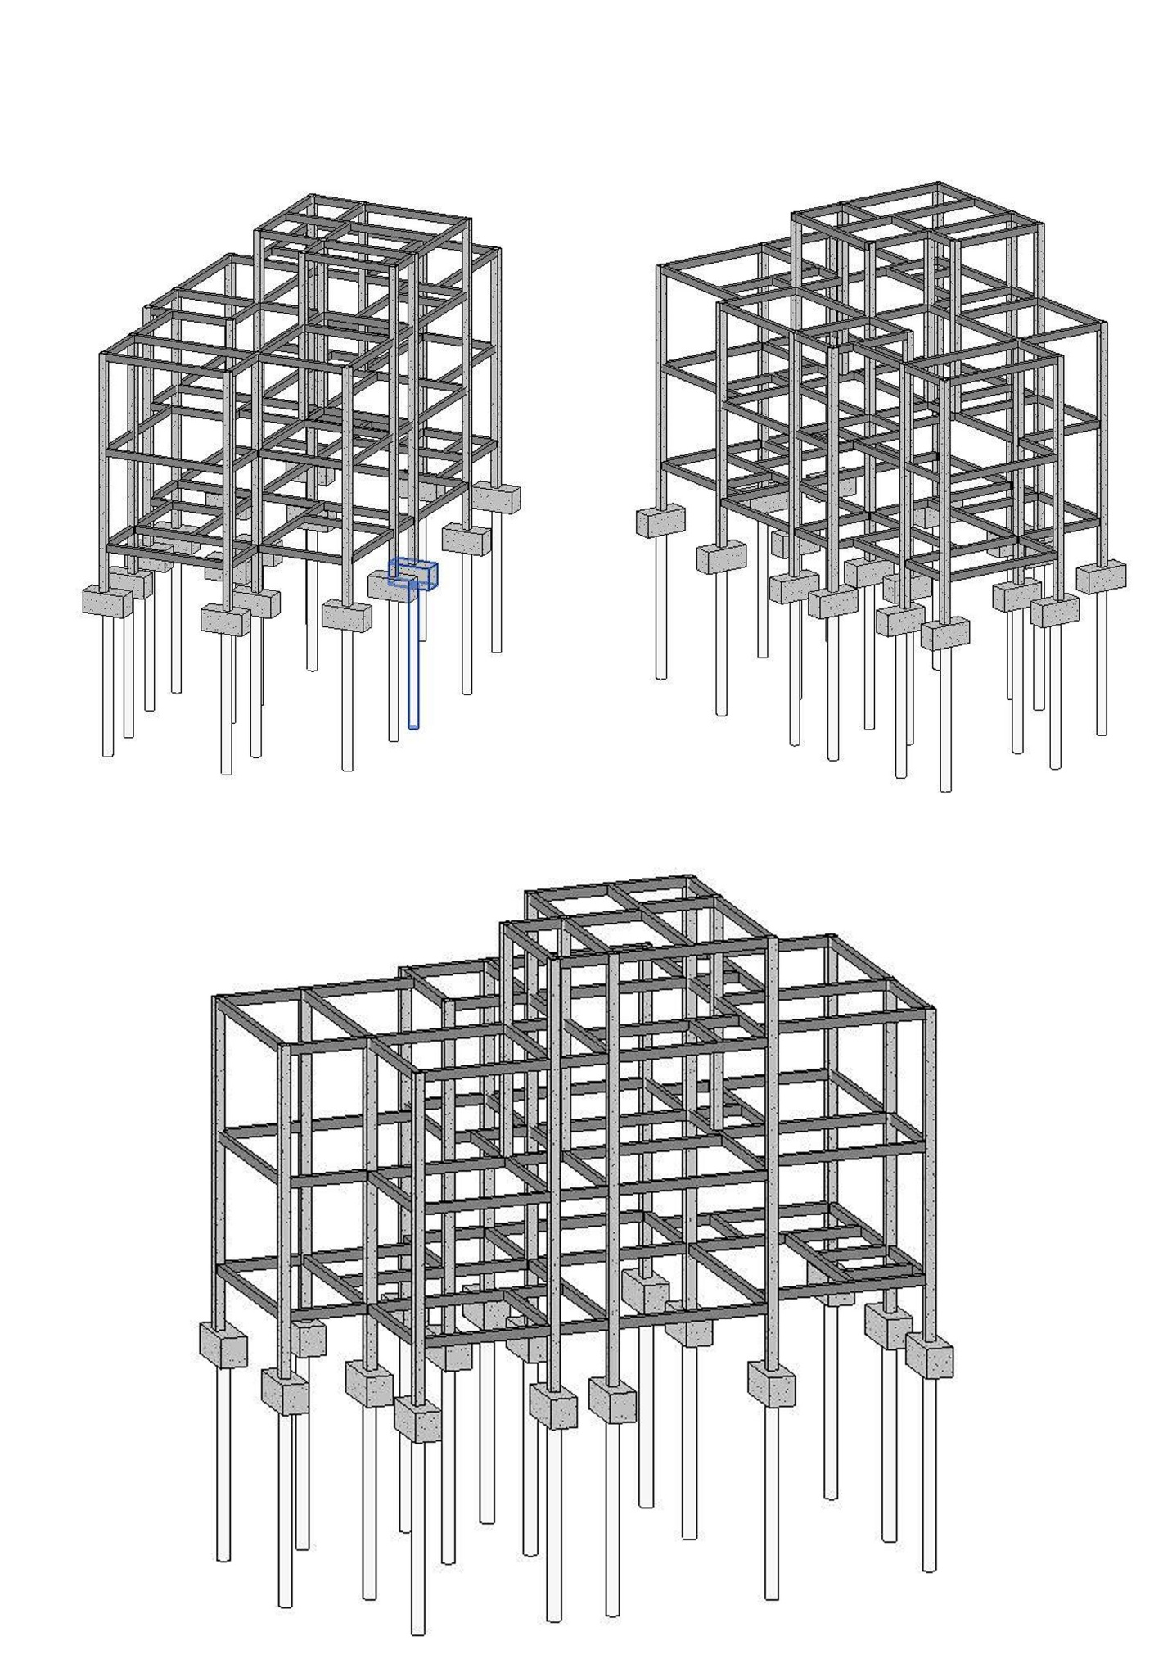
1.2.5 3D STRUCTURAL MODEL

ATTIC FLOOR STRUCTURAL PLAN
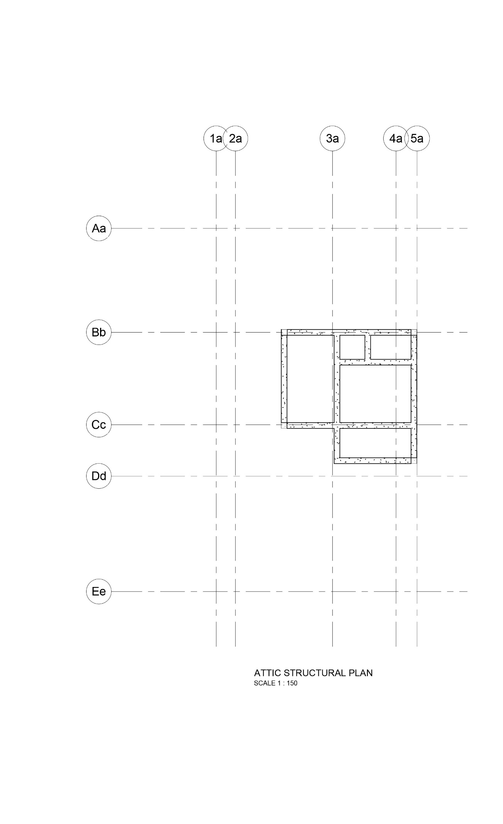
TABLE OF CONTENTS

- INTRODUCTION
1.1 PROJECT BRIEF
1.2 INTRODUCTION OF CASE STUDY
1.2.1 FLOOR PLANS
1.2.2 ELEVATIONS
1.2.3 PERSPECTIVE
1.2.4 STRUCTURAL PLAN
1.2.5 3D STRUCTURAL MODEL
2.0 INDIVIDUAL PROPOSAL
2.1.1 DESIGN BRIEF
2.1.2 FLOOR PLANS
2.1.3 STRUCTURAL PLANS
2.1.4 3D STRUCTURAL MODEL
2.1.5 LOAD DISTRIBUTION ANALYSIS
2.1.6 BEAM ANALYSIS
2.1.7 COLUMN ANALYSIS

2.0 INDIVIDUAL PROPOSAL
2.1 DESIGN PROPOSAL (YEOW YI CHUAN & LEE YUAN JUNE)

2.1.1 DESIGN BRIEF

This project require a group of 2 to propose an extension work to the bungalow that meet the following criteria,
a. The area of extension should not exceed 30% of the existing floor area (max 100m2 each floor)
b. The extension should be sideway.
c. The extension should be of two storeys
2. Frame the extension by using appropriate structural members i.e. columns, beams, slabs, or trusses.
3. Identify and quantify the load acting on the structure.
4. Each member is required to: a. analysis minimum 6 beams (each beam must subject to different types of load, i.e. UDL from one or more than one slabs, beam with point load(s) or combination of UDL and PL) b. analysis minimum 3 columns (from roof to foundation level)
5. Prepare foundation plan, ground floor plan, first floor plan and roof plan for the extension.

2.1.2 FLOOR PLAN
PROPOSED EXTENSION - GROUND FLOOR PLAN
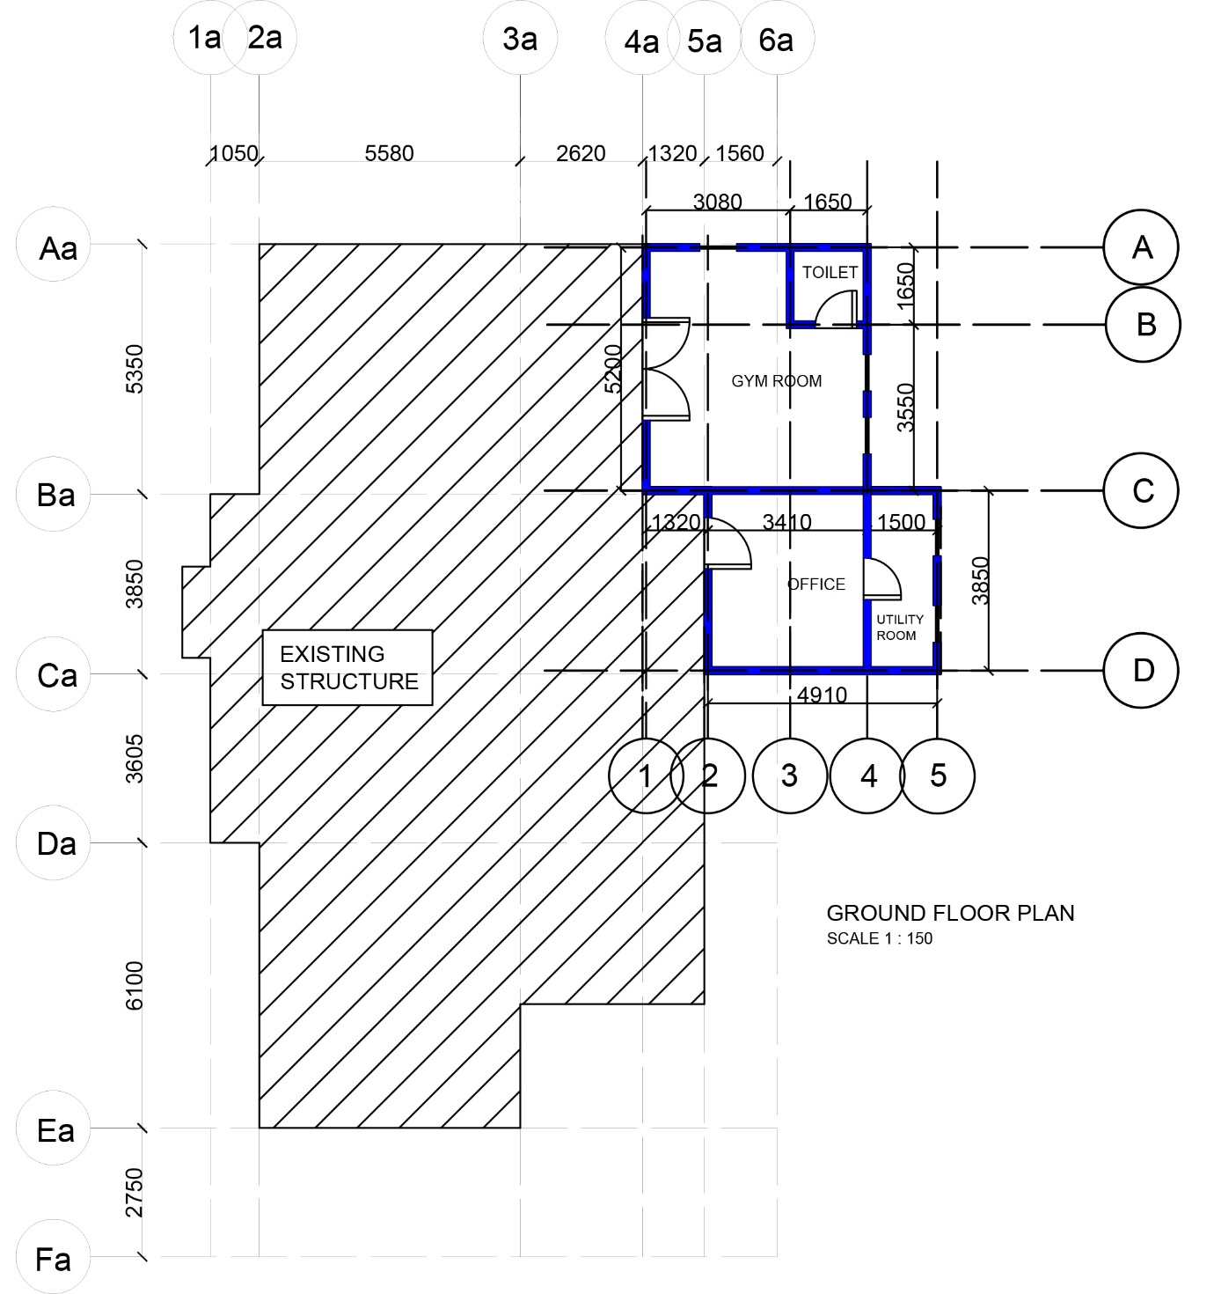

PROPOSED EXTENSION - FIRST FLOOR PLAN
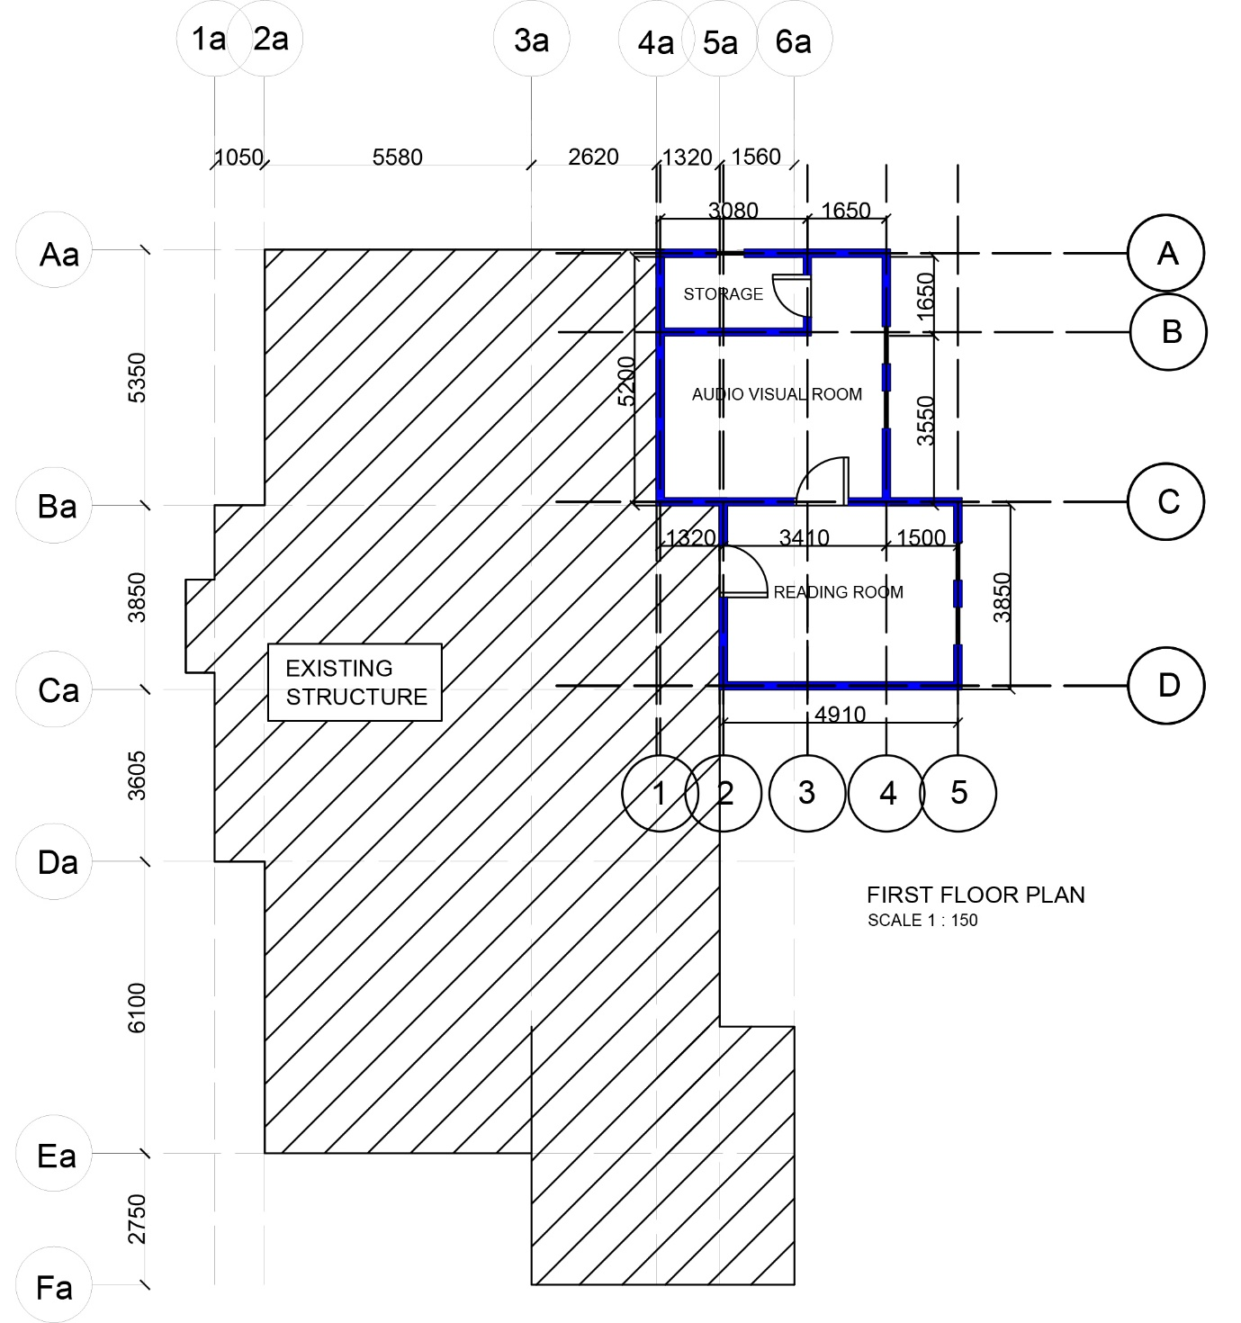

PROPOSED EXTENSION - ROOF PLAN

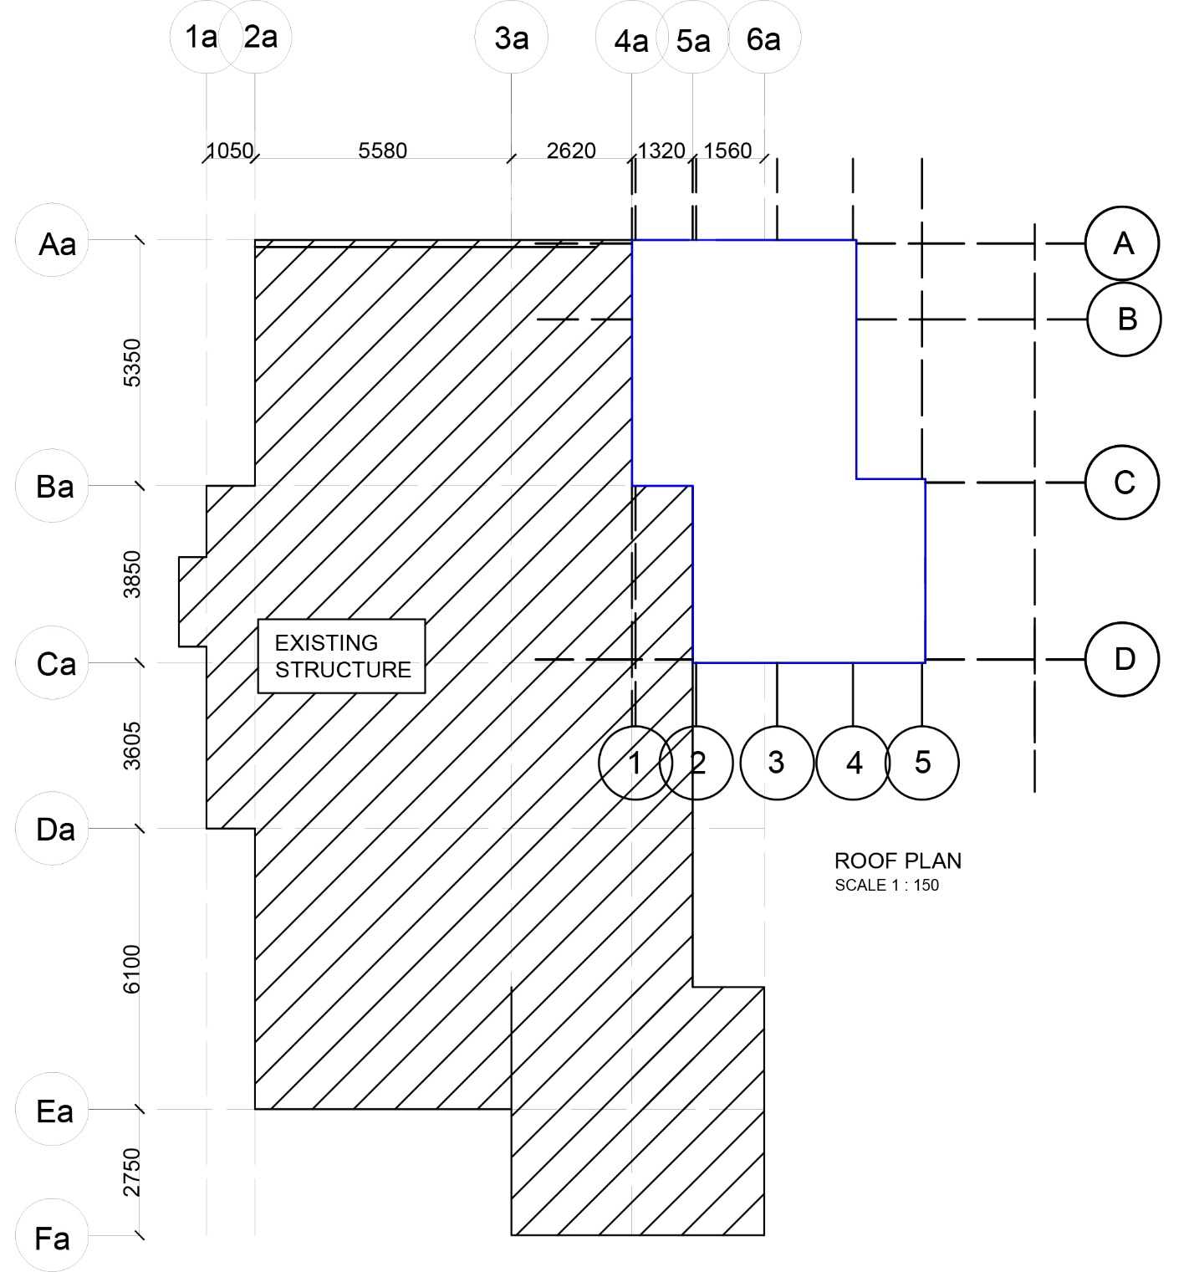
PROPOSED EXTENSION - FOUNDATION PLAN

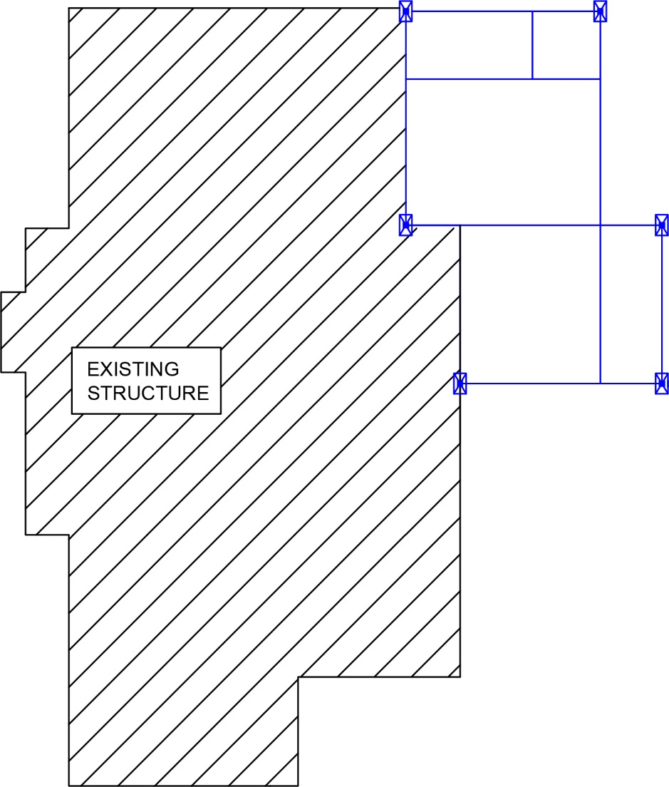

2.1.3 STRUCTURAL PLAN
PROPOSED EXTENSION - GROUND FLOOR STRUCTURAL PLAN

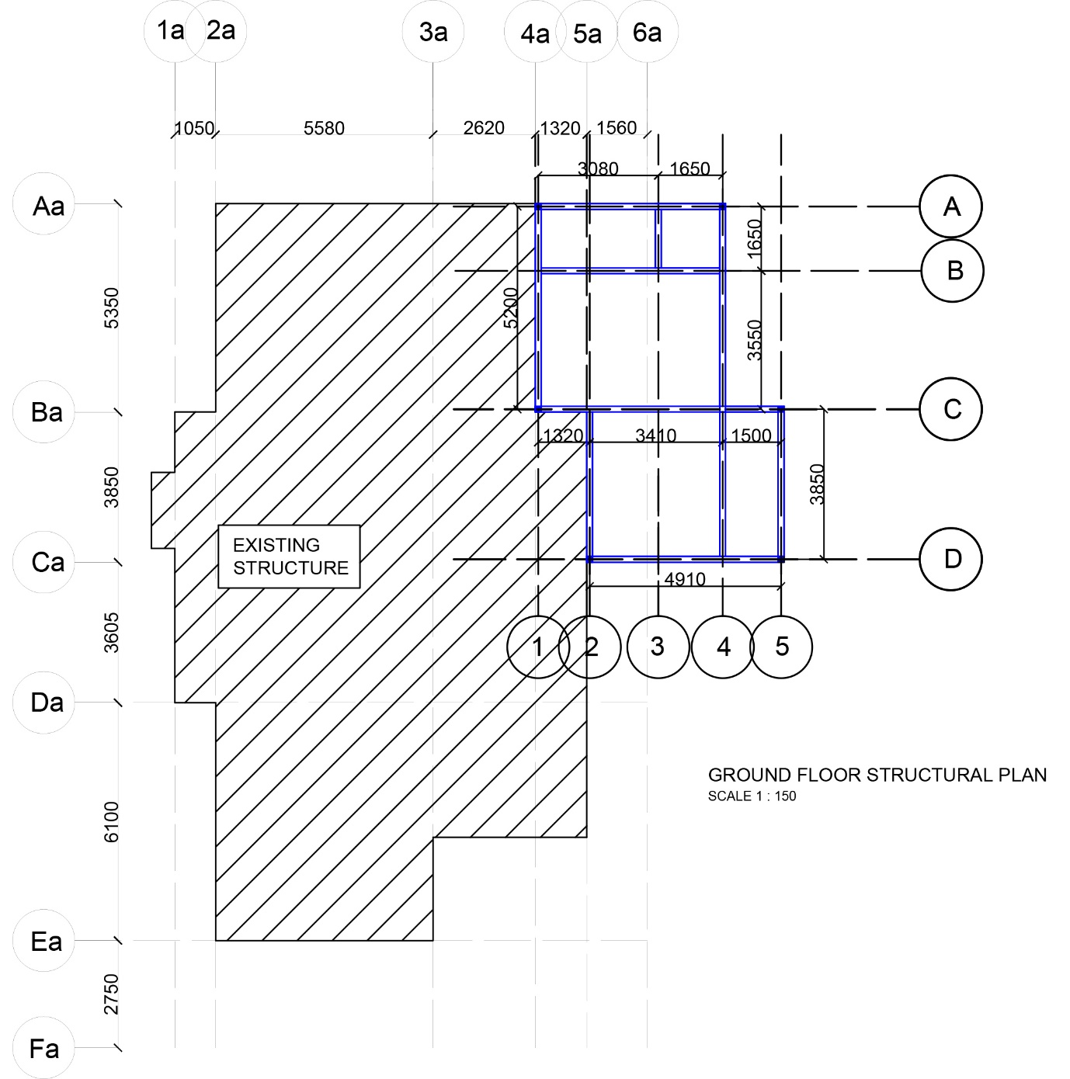
PROPOSED EXTENSION - FIRST FLOOR STRUCTURAL PLAN

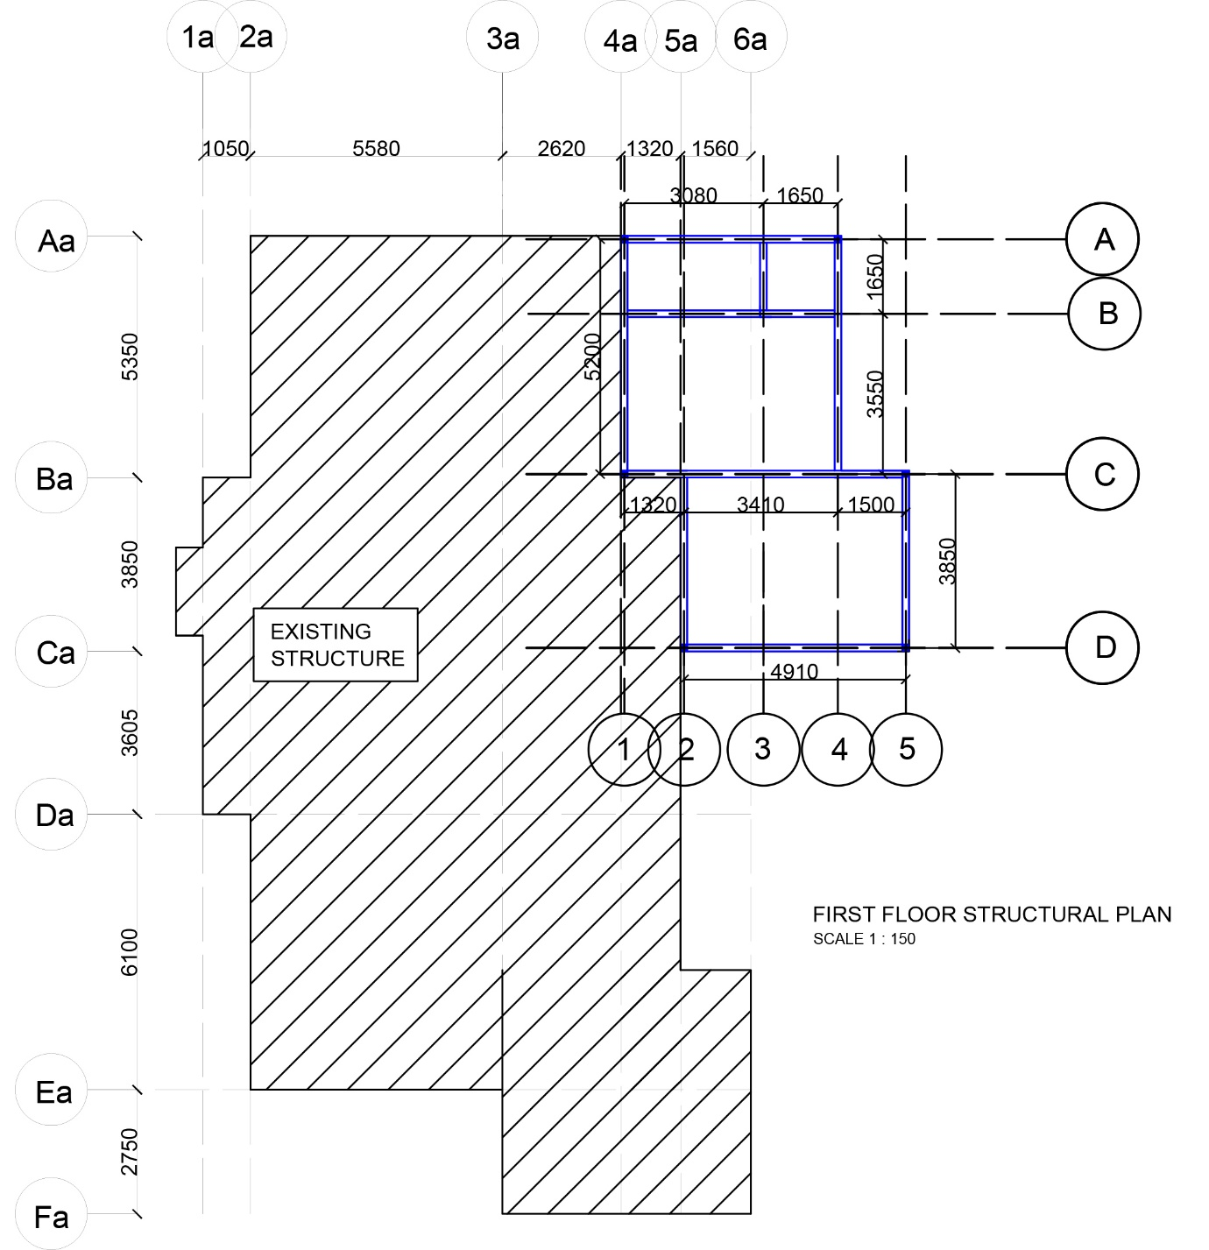

PROPOSED EXTENSION - ROOF STRUCTURAL PLAN
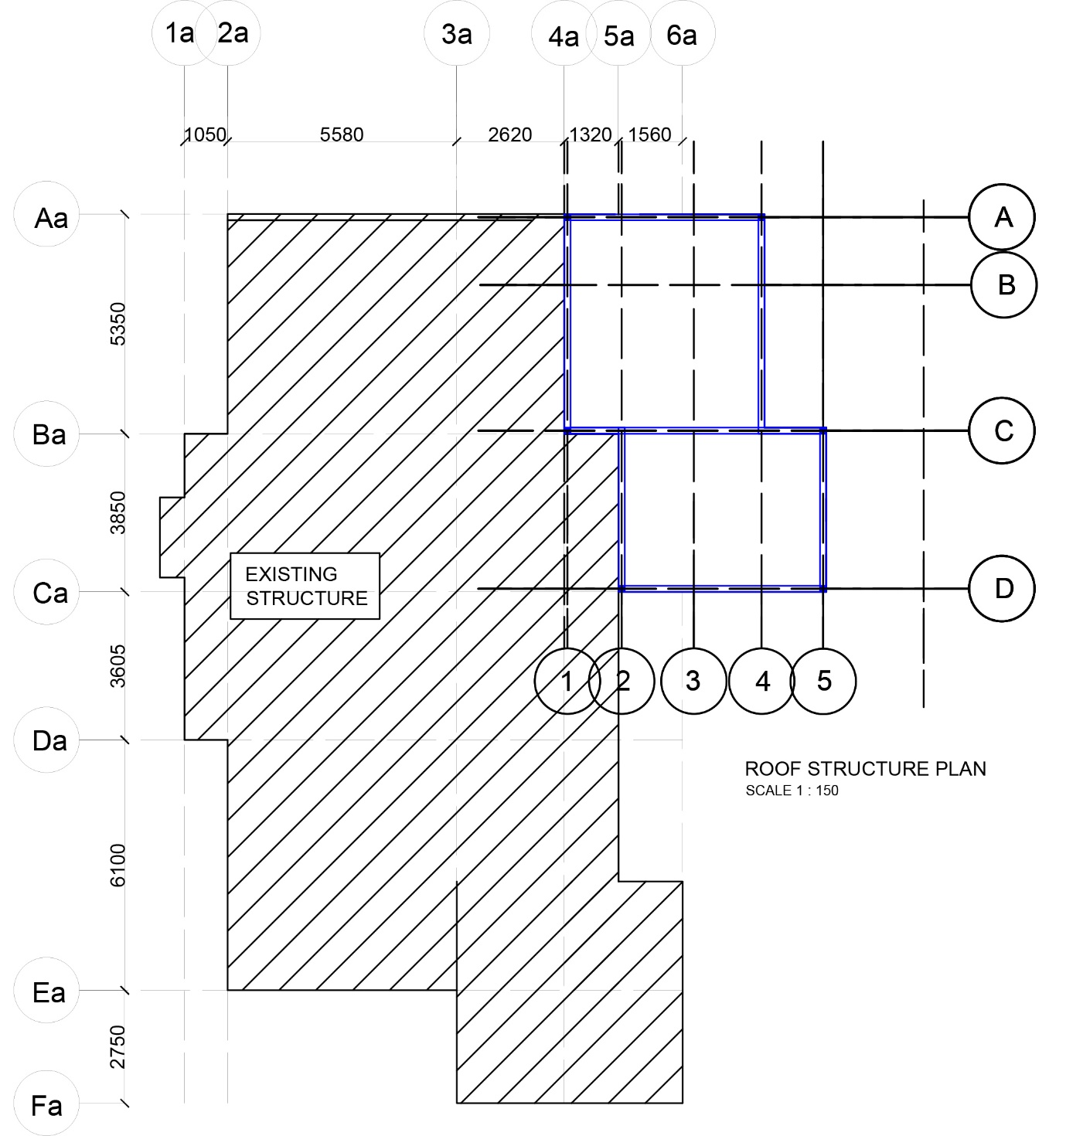
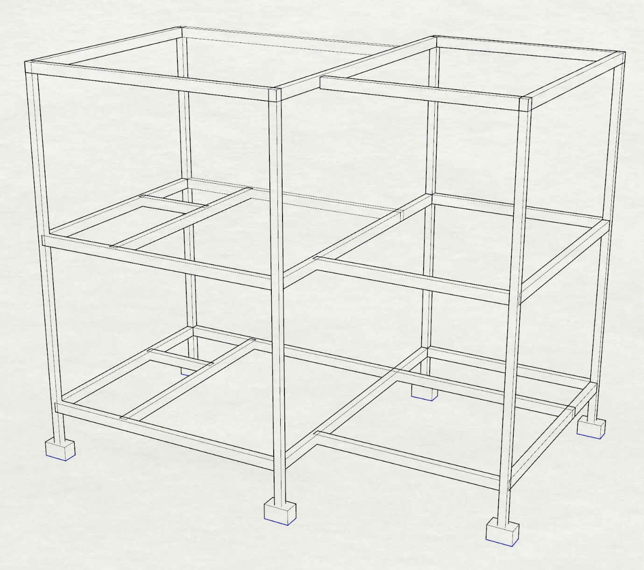
2.1.4 3D STRUCTURAL MODEL

2.1.5 LOAD DISTRIBUTION ANALYSIS
GROUND FLOOR PLAN
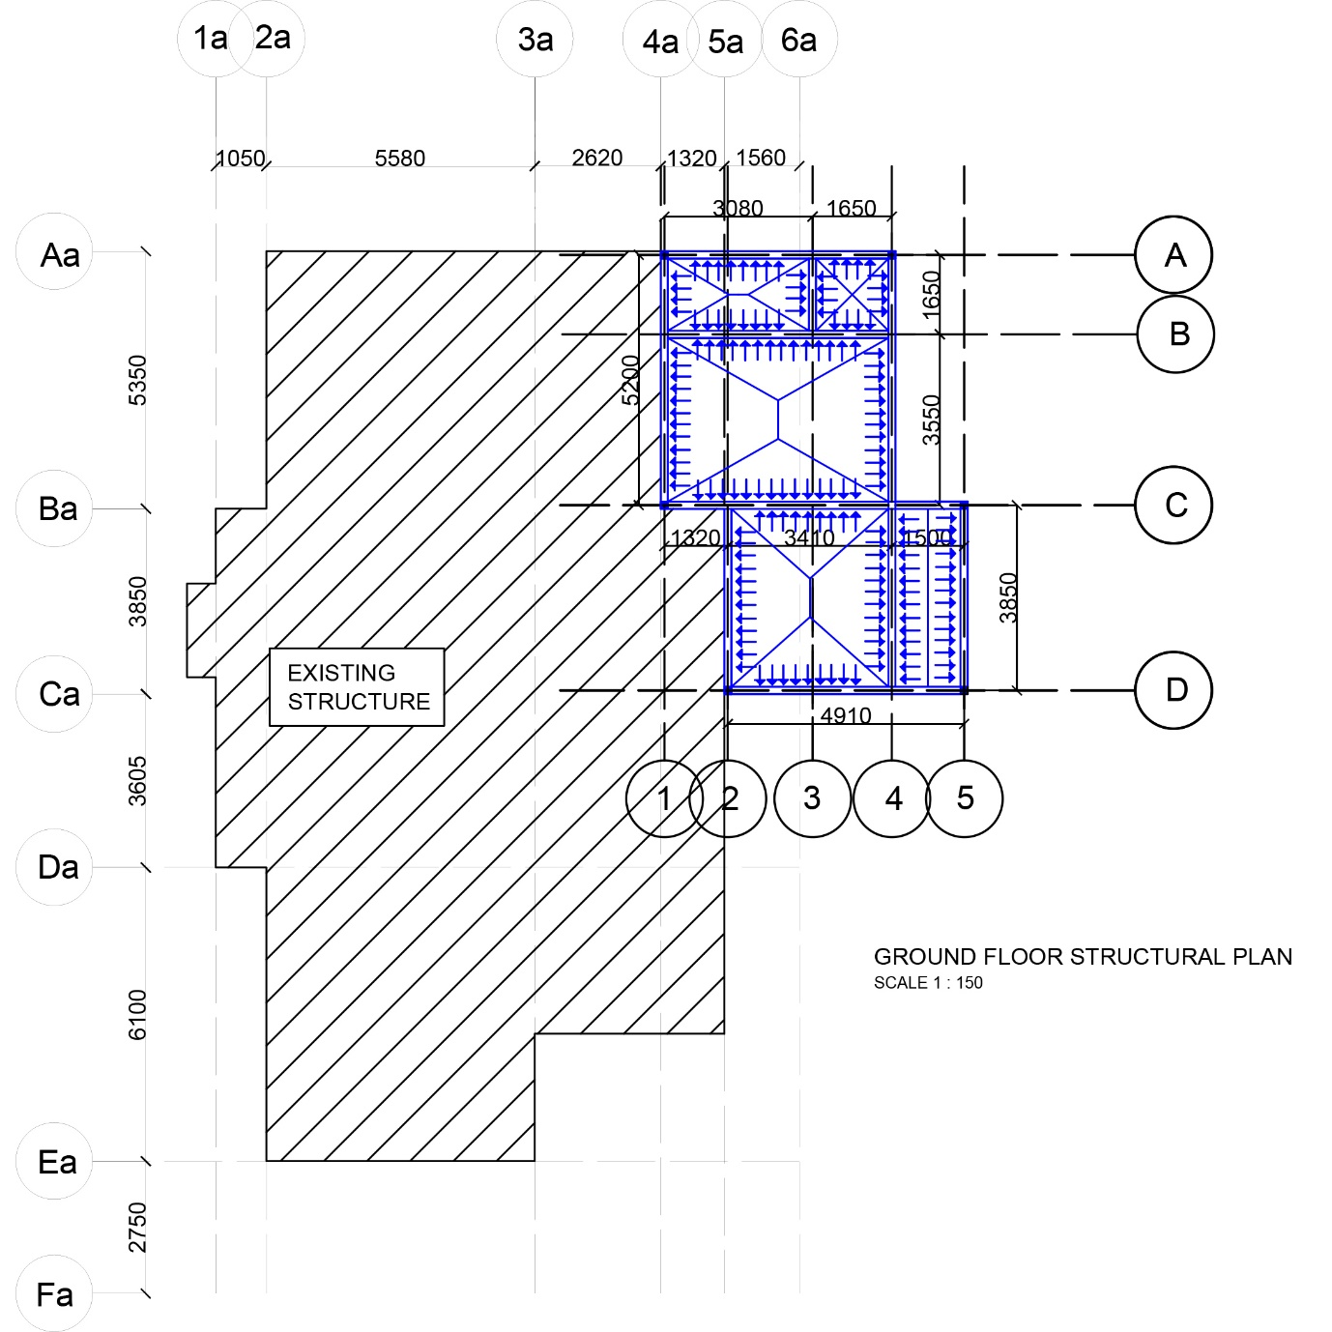
FIRST FLOOR PLAN
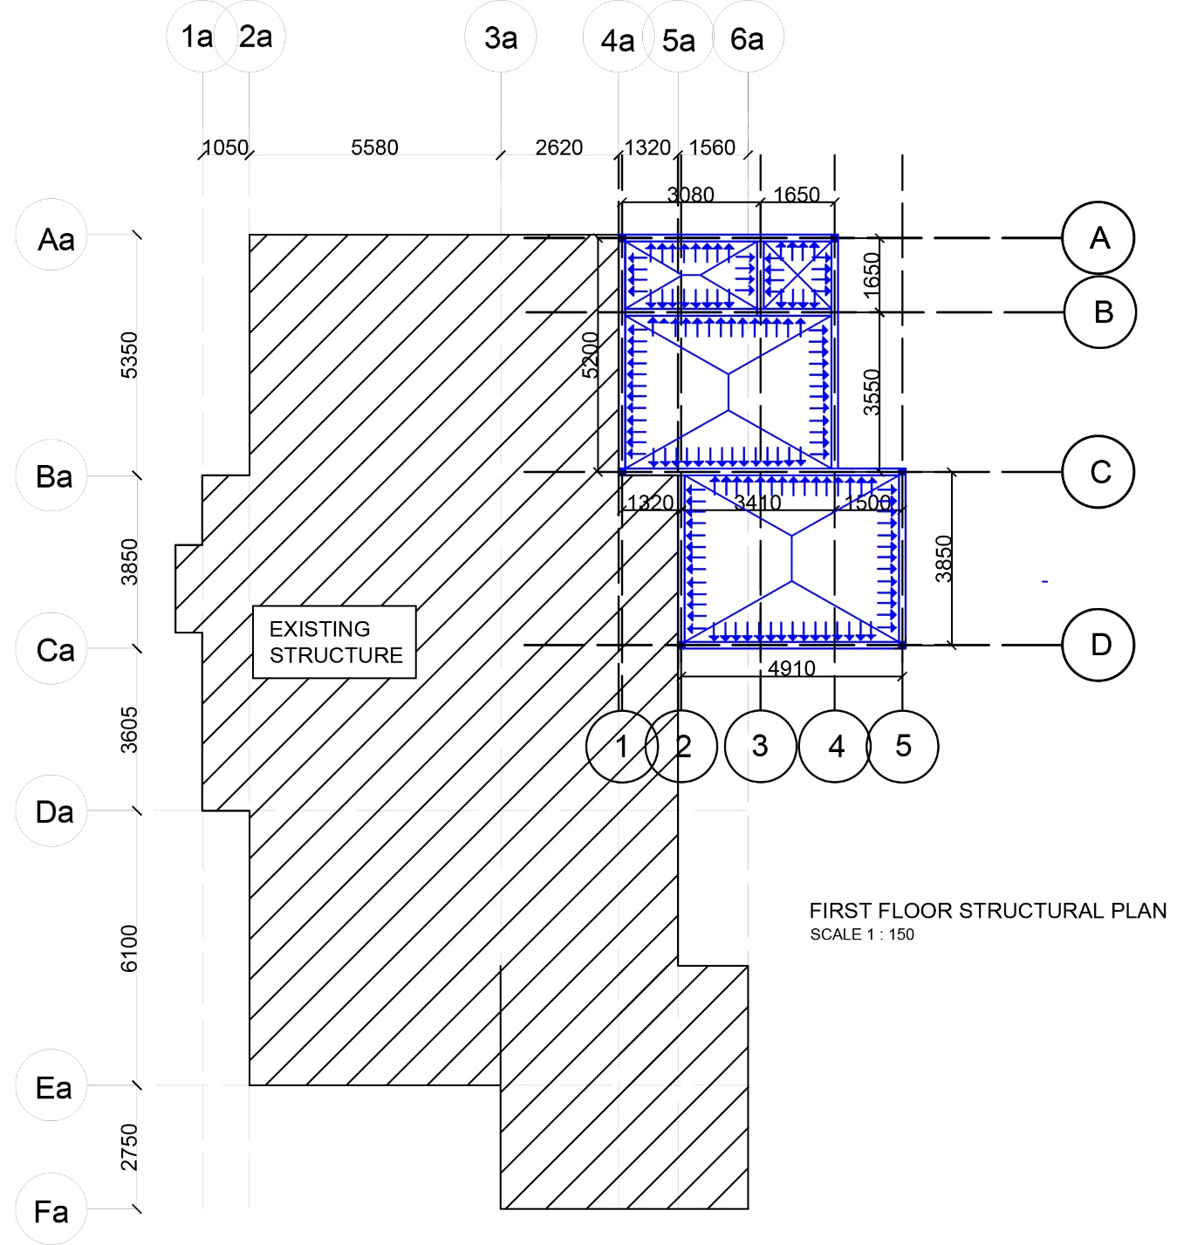

LOAD DISTRIBUTION ANALYSIS
Identify one way or two way slab

GROUND FLOOR

Office
3850mm / 3410mm = 1.13 < 2 (two way slab)

Gymnasium
3080mm / 1650mm = 1.87 < 2 (two way slab)
4730mm / 3550mm = 1.33 <2 (two way slab)

Toilet
1650mm / 1650mm = 1 < 2 (two way slab)

Utility room
3850mm / 1500mm = 2.57 > 2 (one way slab)

Reading room
4910mm / 3850mm = 1.28 < 2 (two way slab)

Audio visual room
4730mm / 3550mm = 1.33 <2 (two way slab)
1650mm / 1650mm = 1 < 2 (two way slab)

Storage room
3080mm / 1650mm = 1.87 < 2 (two way slab)

Quantify Dead Loads Acting On Structure

Ground Floor

Gymnasium :
Slab Thickness : 150mm
Slab Self weight = 0.15 x 24kN/m³
= 3.6kN/m²
Office :
Slab Thickness : 150mm
Slab Self weight = 0.15 x 24kN/m³
= 3.6kN/m²
Toilet :
Slab Thickness : 100mm
Slab Self weight = 0.1 x 24kN/m³
= 2.4kN/m²

First Floor

Audio Visual Room :
Slab Thickness : 150mm
Slab Self weight = 0.15 x 24kN/m³
= 3.6kN/m²
Reading Room :
Slab Thickness : 150mm
Slab Self weight = 0.15 x 24kN/m³
= 3.6kN/m²

Storage :
Slab Thickness : 150mm
Slab Self weight = 0.15 x 24kN/m³
= 3.6kN/m²
Quantify Live Loads Acting On Structure

Ground Floor

Gym Room :
5.0kN/m²

Office :
1.5kN/m²

Toilet :
2.0kN/m²

First Floor

Audio Visual Room :
2.0kN/m²

Storage:
2.0kN/m²

Reading Room :
2.0kN/m²

2.1.6 BEAM ANALYSIS CALCULATION
GROUND FLOOR BEAM, 3 / A – B
- Self weight = Beam size x Density
= 0.25m x 0.15m x 24kN/m³

= 0.9 kN/m
- Weight of brick wall = Height x Width x Density
= 3.5m x 0.15m x 19kN/m³
= 9.975kN/m
- Slab’s dead load & live load : Slab 1 – 3 / A – B , Slab 3 – 4 / A - B

Dead load of slab 1 – 3 / A - B (2 way slab)
Load is transferred to beam 3 / A - B in a trapezoidal form. Convert the trapezoidal load into UDL form.
Dead load = Dead load on slab x (L_{x}/2)m
= 3.6kN/m² x (1.65/2)m

= 2.97kN/m

Dead load of slab 3 – 4 / A - B (2 way slab)
Load is transferred to beam 3 / A - B in a triangular form.
Dead load = Dead load on slab x (L_{x}/2)m
= 2.4kN/m² x (1.65/2)m
= 1.98kN/m
Convert triangular load to UDL by applying factor of 2/3.
So , dead load of slab 3 – 4 / A – B = (2/3) x 1.98 kN/m
= 1.32 kN/m

Total dead load on beam 3 / A – B = 0.9 kN/m + 9.975kN/m + 2.97kN/m + 1.32kN/m
= 15.165kN/m

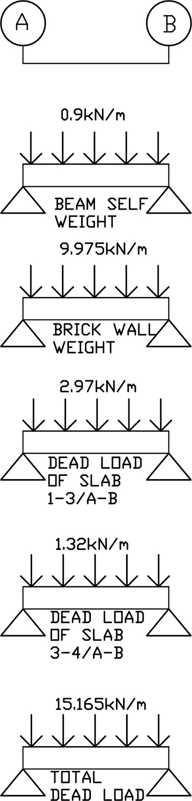
TOTAL DEAD LOAD DIAGRAM OF BEAM 3 / A - B

Live load of slab 1 – 3 / A - B (2 way slab)(gymnasium)
Load is transferred to beam 1-4/A in a trapezoidal form. Convert the trapezoidal load into UDL
Live load = Live load on slab x (L_{x}/2)m
= 5.0kN/m² x (1.65/2)m
= 4.125kN/m

Live load of slab 3 – 4 / A - B (2 way slab)(toilet)
Load is transferred to beam 1-4/A in a triangular form.
Live load = Live load on slab x (L_{x}/2)m
= 2.0kN/m² x (1.65/2)m
= 1.65kN/m
Convert triangular load to UDL by applying factor of 2/3.
Live load of slab 3 – 4 / A – B = (2/3) x 1.65kN/m
= 1.1kN/m

TOTAL LIVE LOAD DIAGRAM
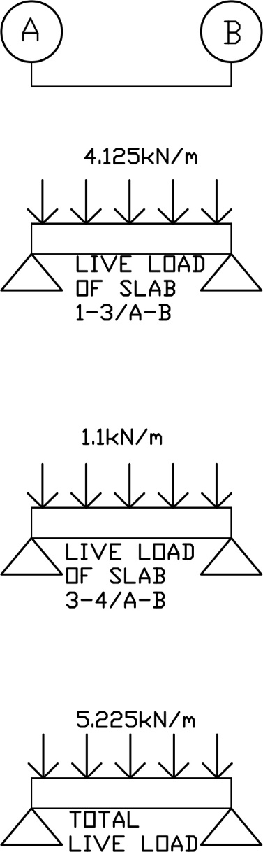

ULTIMATE LOAD
Apply factor 1.4 and 1.6 to dead load and live load respectively.

Dead load A – B = 15.165kN/m x 1.4
= 21.231kN/m
Live load A – B = 5.225kN/m x 1.6
= 8.36kN/m
Ultimate load A – B = 29.591kN/m

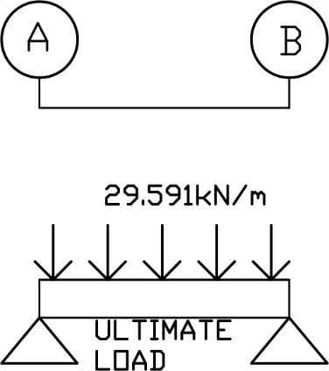

ULTIMATE LOAD DIAGRAM

REACTIONS
∑M_{A} = 0
0 = (29.591)(1.65)(0.825) - R_{BY}(1.65)
R_{BY}(1.65) = 40.28
R_{BY =} 24.4 kN

∑F_{Y} = 0
R_{AY} + R_{BY} + (-29.541)(1.65) = 0
R_{AY} = 48.74 – (24.4)
= 24.34 kN

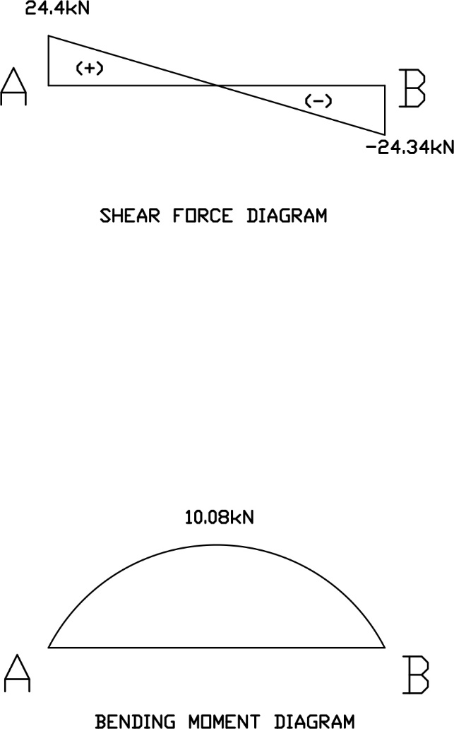
GROUND FLOOR BEAM, 1 - 4 / A
- Self weight = Beam size x Density
= 0.25m x 0.15m x 24kN/m³
= 0.9 kN/m

- Weight of brick wall = Height x Width x Density
= 3.5m x 0.15m x 19kN/m³
= 9.975kN/m

- Point load from beam 3 / A – B

- Slab’s dead load & live load : Slab 1 – 3 / A – B , Slab 3 – 4 / A - B

From previous calculation,

Dead load of slab 1 – 3 / A - B (2 way slab)
= 2.97kN/m

Dead load of slab 3 – 4 / A - B (2 way slab)
= 1.32 kN/m

Total dead load 1 – 3 = 0.9kN/m + 9.975kN/m + 2.97kN/m
= 13.845kN/m

Total dead load 3 – 4 = 0.9kN/m + 9.975kN/m + 1.32kN/m
= 12.195kN/m

TOTAL DEAD LOAD DIAGRAM

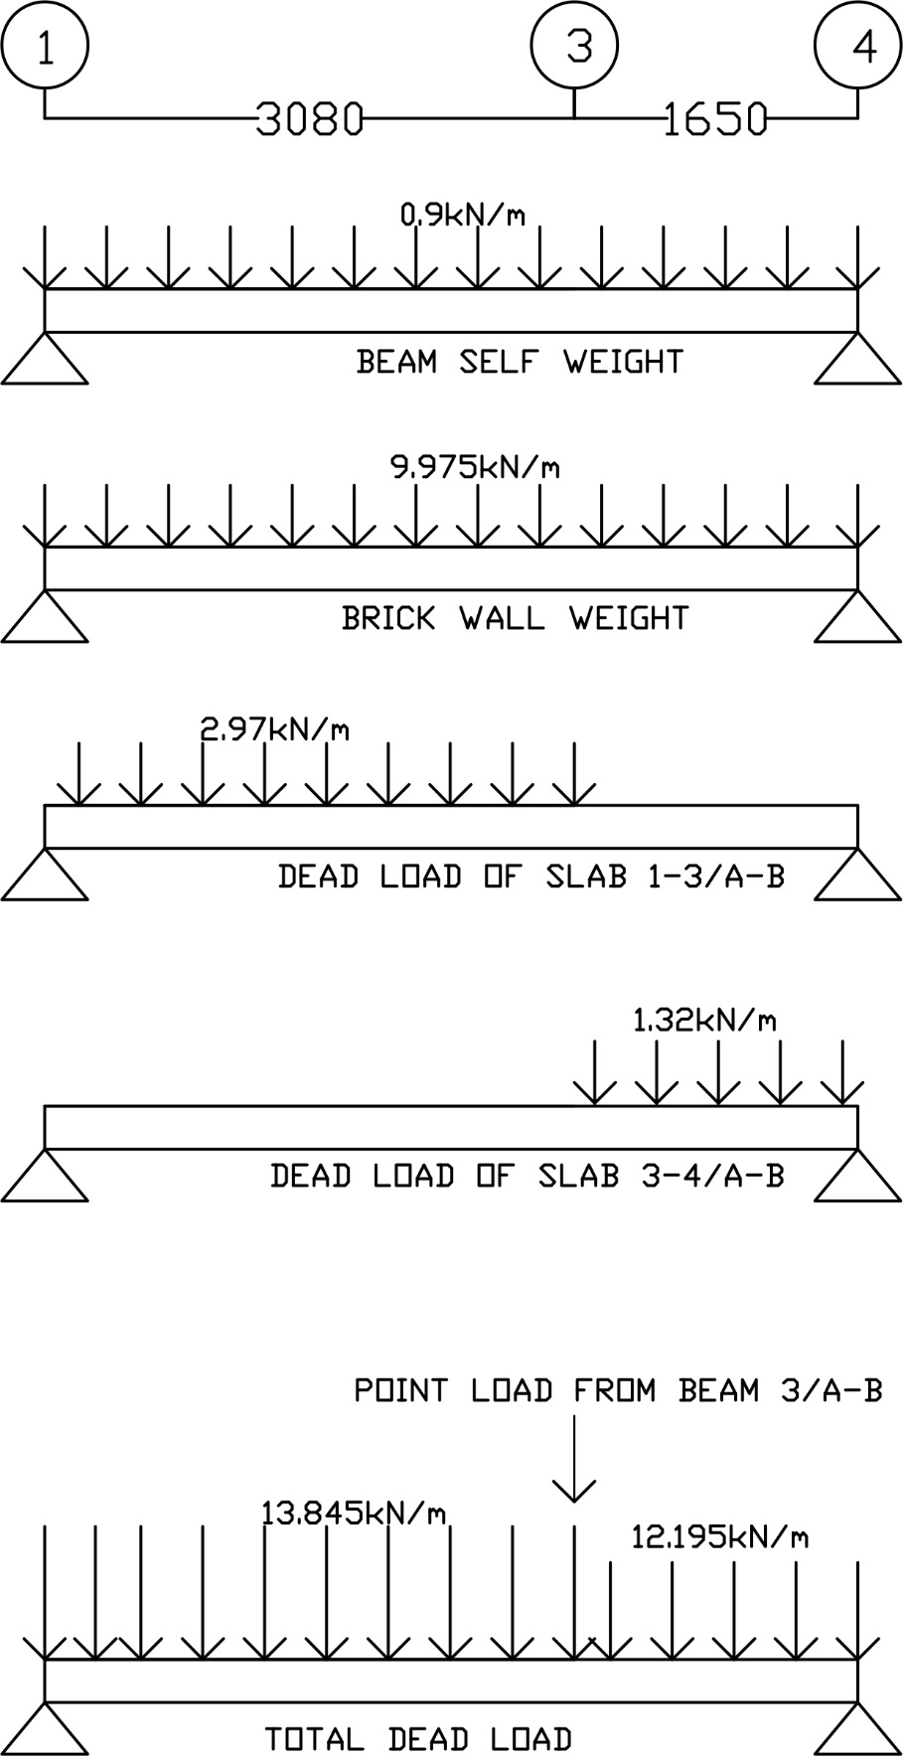

From previous calculation,

Live load of slab 1 – 3 / A - B (2 way slab)(gymnasium)
= 4.125kN/m

Live load of slab 3 – 4 / A - B (2 way slab)(toilet)
= 1.1kN/m

Total live load 1 – 3 = 4.125kN/m
Total live load 3 – 4 = 1.1kN/m

TOTAL LIVE LOAD DIAGRAM

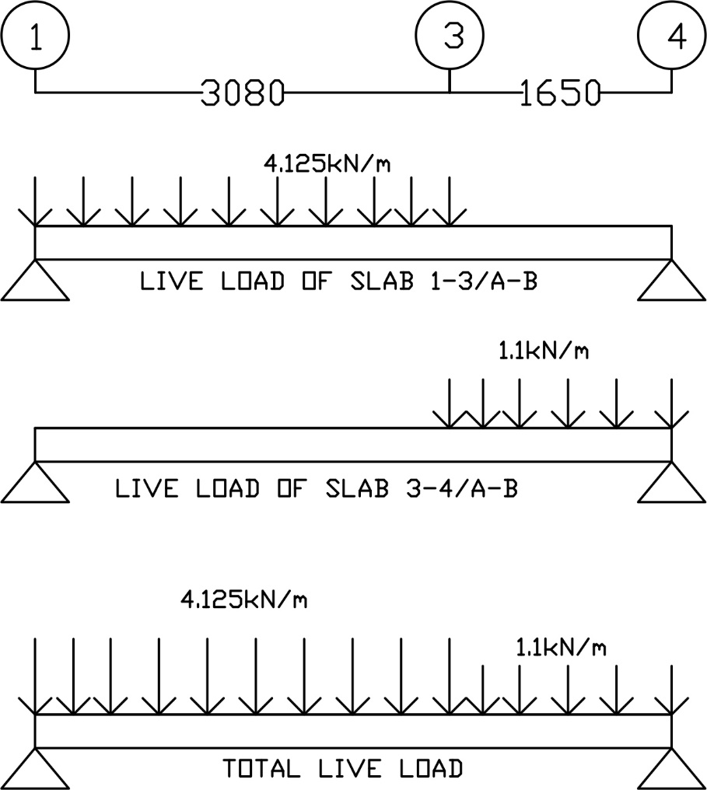

ULTIMATE LOAD
Apply factor 1.4 and 1.6 to dead load and live load respectively.

Total dead load 1 – 3 = 13.845kN/m x 1.4
= 19.383kN/m

Total dead load 3 – 4 = 12.195kN/m x 1.4
= 17.073kN/m

Total live load 1 – 3 = 4.125kN/m x 1.6
= 6.6kN/m
Total live load 3 – 4 = 1.1kN/m x 1.6
= 1.76kN/m

Ultimate load 1 – 3 = 19.383kN/m + 6.6kN/m = 25.983kN/m
Ultimate load 3 – 4 = 17.073kN/m + 1.76kN/m = 18.833kN/m

ULTIMATE LOAD DIAGRAM
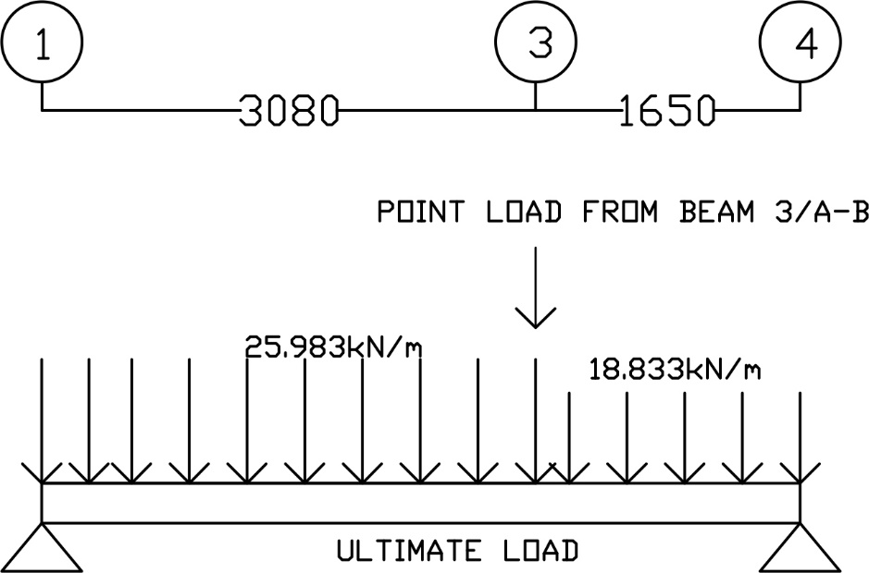

REACTIONS
∑M₁ = 0
(25.983)(3.08)(1.54)+(24.34)(3.08)+(18.833)(1.65)(3.905)-R_{4Y}(4.73) = 0
R_{4Y}(4.73) = 123.24 + 74.97 + 121.35
R_{4Y} = 67.56kN

∑F_{Y} = 0
R_{1Y} + (-25.983)(3.08) + (-24.34) + (-18.833)(1.65) + R_{4Y} = 0
R_{1Y} = 135.44 - R_{4Y} = 67.88kN

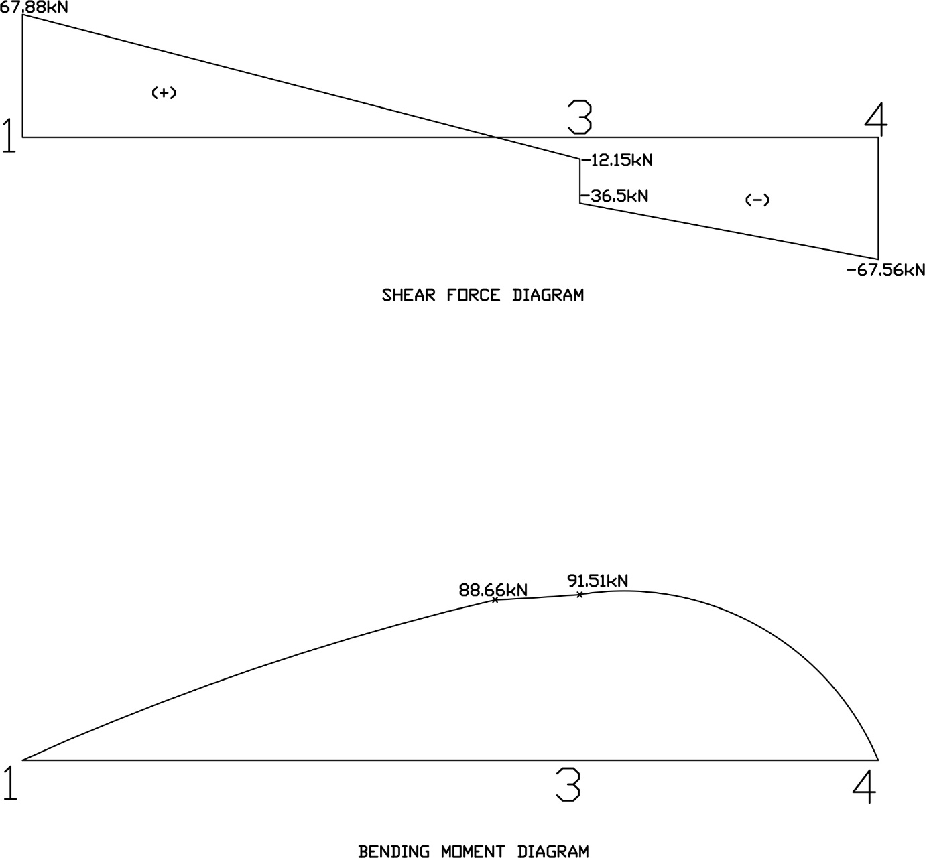

GROUND FLOOR BEAM, 1 - 4 / B
- Self weight = Beam size x Density
= 0.25m x 0.15m x 24kN/m³
= 0.9 kN/m

- Weight of brick wall = Height x Width x Density
= 3.5m x 0.15m x 19kN/m³
= 9.975kN/m

- Point load from beam 3 / A – B

- Slab’s dead load & live load : Slab 1 – 3 / A – B , Slab 3 – 4 / A – B , Slab 1 – 4 / B - C

From previous calculation,

Dead load of slab 1 – 3 / A - B (2 way slab)
= 2.97kN/m

Dead load of slab 3 – 4 / A - B (2 way slab)
= 1.32 kN/m

Dead load of slab 1 – 4 / B - C = 3.6kN/m² x (3.55/2)m
= 6.39kN/m

TOTAL DEAD LOAD
Total dead load 1 – 3 = 0.9 + 2.97 + 6.39 = 10.26kN/m
Total dead load 3 – 4 = 0.9 + 9.975 + 1.32 + 6.39 = 18.585kN/m

DEAD LOAD DIAGRAM
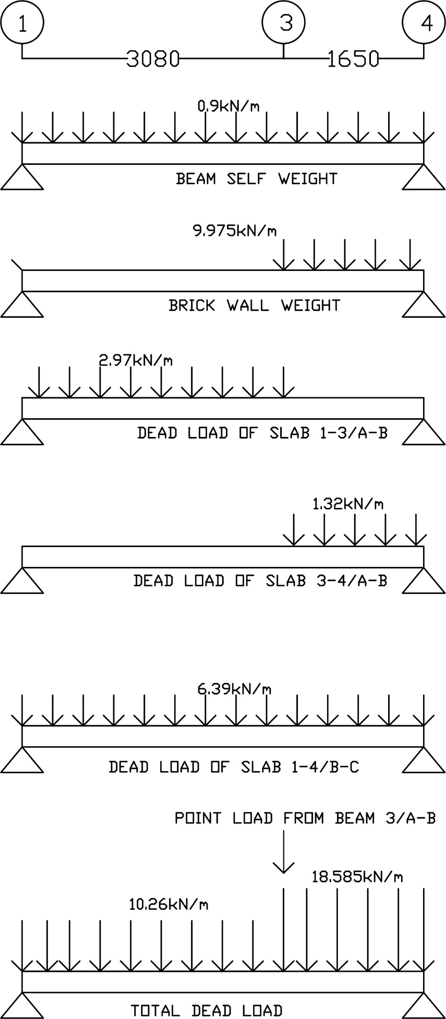

LIVE LOAD
From previous calculation,

Live load of slab 1 – 3 / A - B (2 way slab)(gymnasium)
= 4.125kN/m

Live load of slab 3 – 4 / A - B (2 way slab)(toilet)
= 1.1kN/m

Live load of slab 1 – 4 / B – C
Live load of slab 1-4/B-C (2 way slab) (gymnasium)
= 5.0kN/m² x (3.55/2)
= 8.875kN/m

Total live load 1 – 3 = 4.125 + 8.875 = 13kN/m
Total live load 3 – 4 = 1.1 + 8.875 = 9.975kN/m

LIVE LOAD DIAGRAM

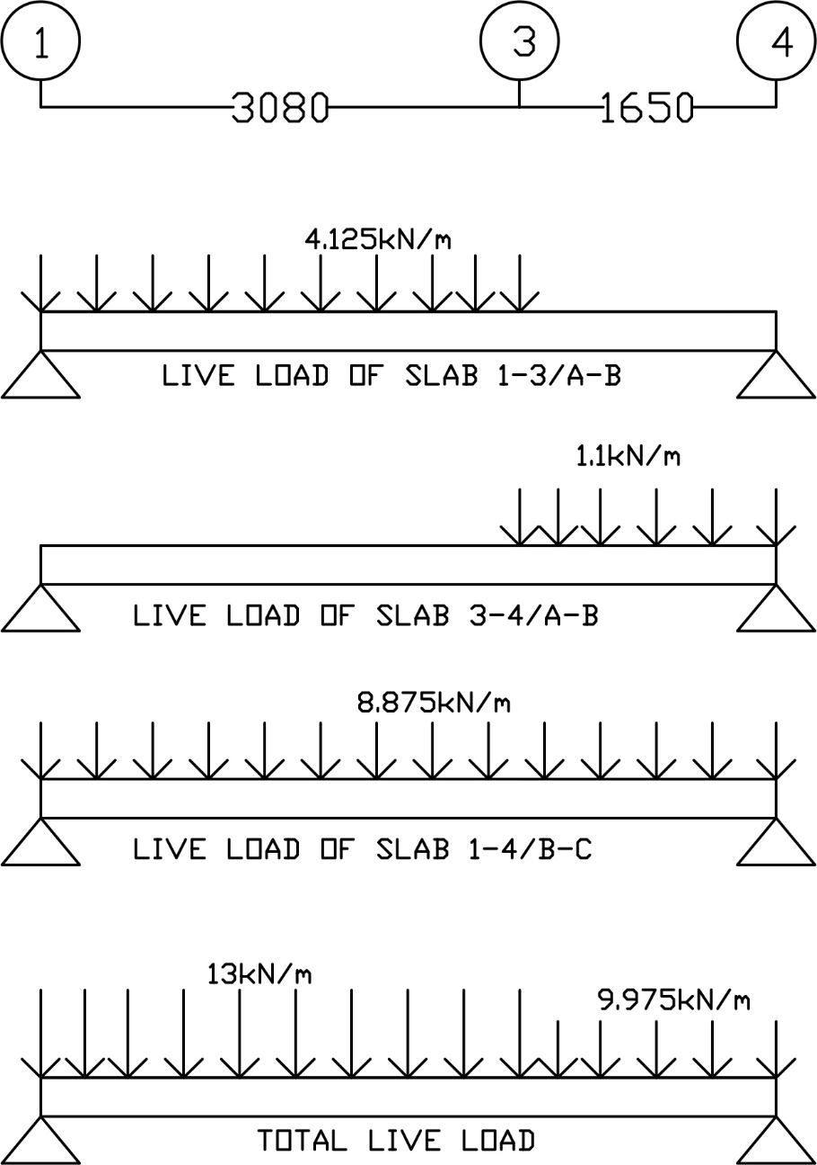

ULTIMATE LOAD
Apply factor 1.4 and 1.6 to dead load and live load respectively.

Total dead load 1 – 3 = 10.26 x 1.4 = 14.364kN/m
Total dead load 3 – 4 = 18.585 x 1.4 = 26.019kN/m

Total live load 1 – 3 = 4.125 + 8.875 = 13 x 1.6 = 20.8kN/m
Total live load 3 – 4 = 1.1 + 8.875 = 9.975 x 1.6 = 15.96kN/m

Ultimate load 1 – 3 = 28.329 + 20.8 = 35.164kN/m
Ultimate load 3 – 4 = 26.019 + 15.96 = 41.979kN/m

ULTIMATE LOAD DIAGRAM
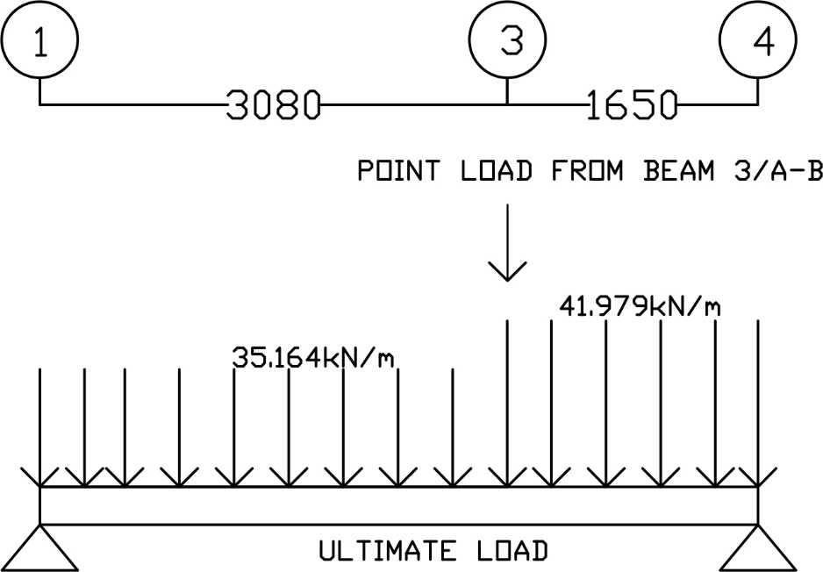
REACTIONS

∑M₁ = 0
(35.164)(3.08)(1.54)+(24.4)(3.08)+(41.979)(1.65)(3.905)-R_{4Y}(4.73)=0
4.73R_{4Y} = 166.79 + 75.152 + 270.48
R_{4Y} = 108.33kN/m

∑F_{Y} = 0
R_{1Y} + R_{4Y} + (-35.164)(3.08) + (-24.4)+(-41.979)(1.65) = 0
R_{1Y} = 93.64kN/m

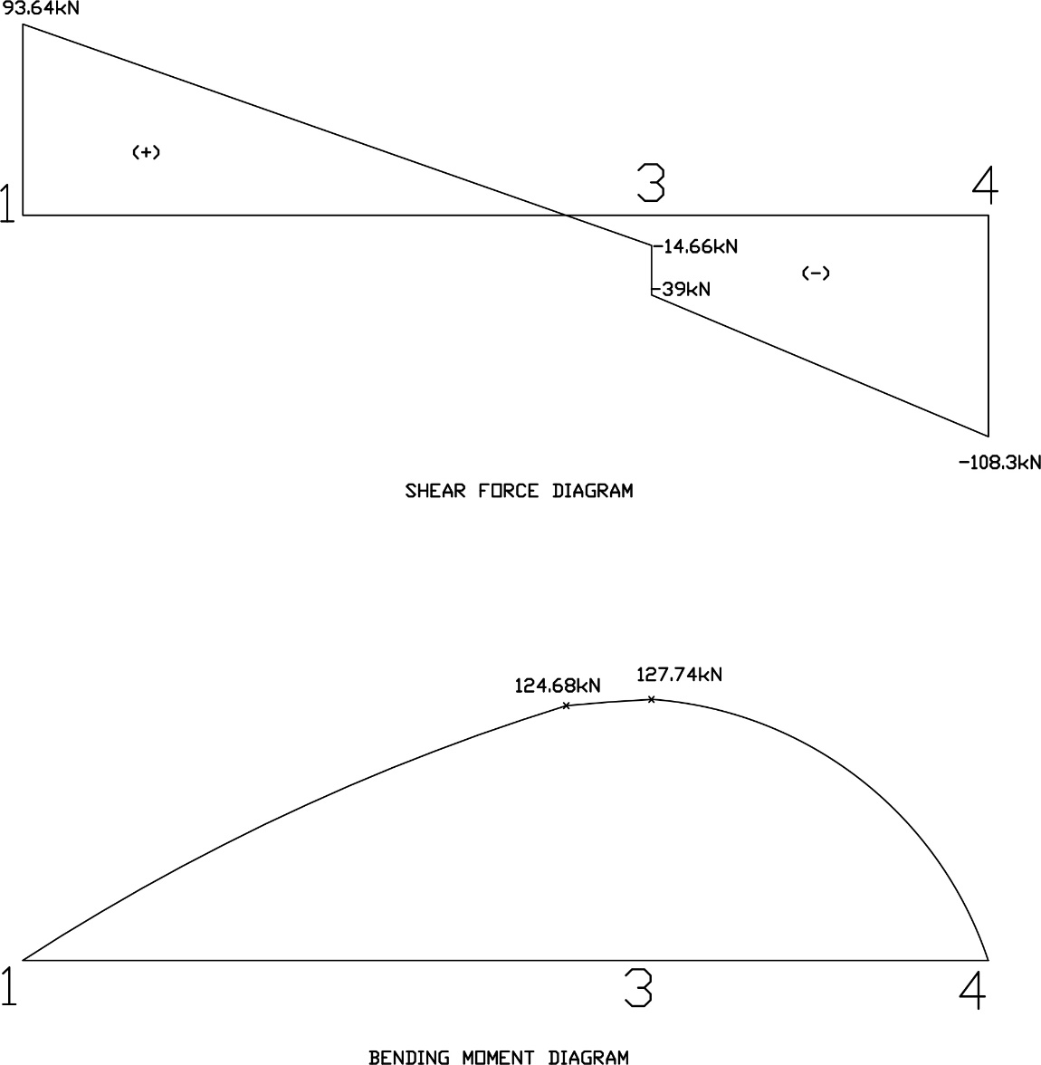

GROUND FLOOR BEAM, 1 / A - C
- Self weight = Beam size x Density
= 0.25m x 0.15m x 24kN/m³
= 0.9 kN/m

- Weight of brick wall = Height x Width x Density
= 3.5m x 0.15m x 19kN/m³
= 9.975kN/m

- Point load from beam 1 – 4 / B

- Slab’s dead load & live load : Slab 1 – 3 / A – B , Slab 1 – 4 / B – C

From previous calculation,

Dead load of slab 1 – 3 / A - B (2 way slab)
= 2.97kN/m

Dead load of slab 1 – 4 / B - C
= 6.39kN/m

Total dead load A – B = 0.9 + 9.975 + 2.97 = 13.845kN/m
Total dead load B – C = 0.9 + 9.975 + 6.39 = 17.265kN/m

DEAD LOAD DIAGRAM
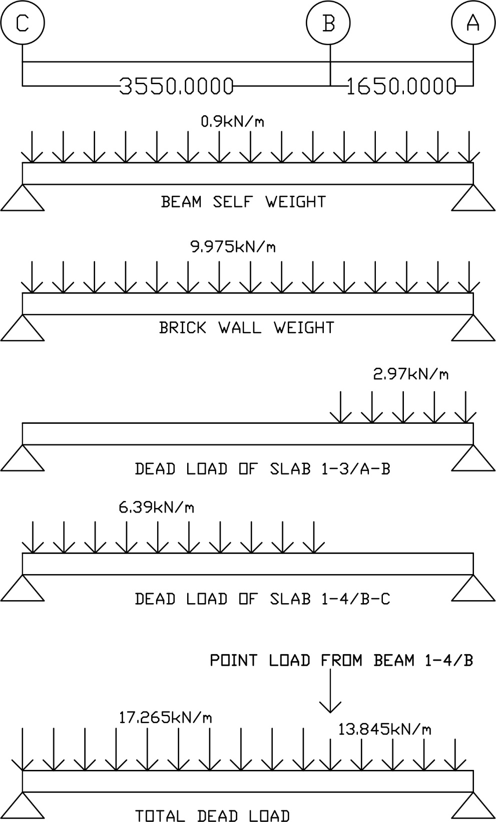

LIVE LOAD

From previous calculation,

Live load of slab 1 – 3 / A - B
= 4.125kN/m

Live load of slab 1 – 4 / B – C
= 8.875kN/m

Total live load A – B = 4.125kN/m
Total live load B – C = 8.875kN/m
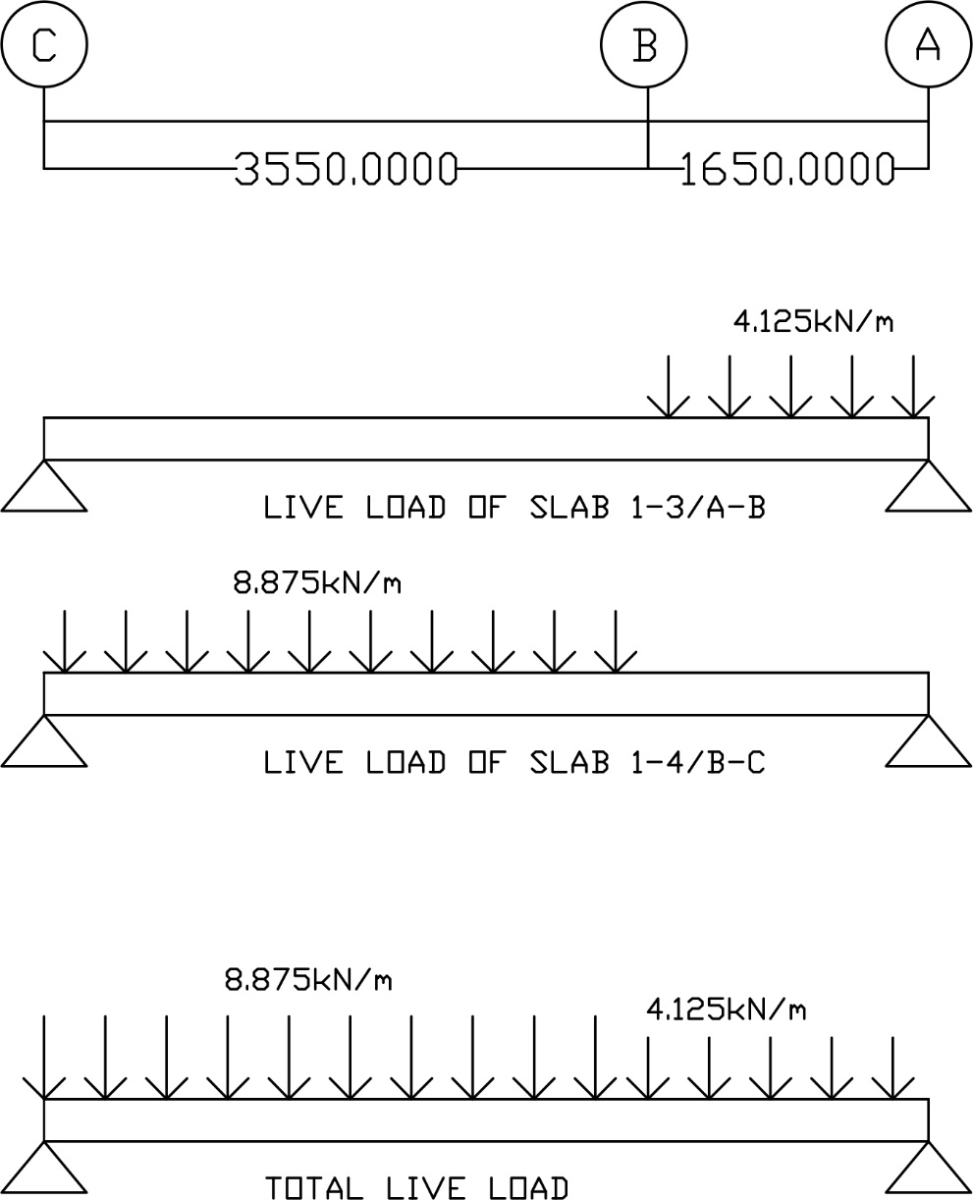

ULTIMATE LOAD
Apply factor 1.4 and 1.6 to dead load and live load respectively.

Total dead load A – B = 13.845 x 1.4 = 19.383kN/m
Total dead load B – C = 17.265 x 1.4 = 24.171kN/m

Total live load A – B = 4.125 x 1.6 = 6.6kN/m
Total live load B – C = 8.875 x 1.6 = 14.2kN/m

Ultimate load A – B = 25.983kN/m
Ultimate load B – C = 38.371kN/m

ULTIMATE LOAD DIAGRAM
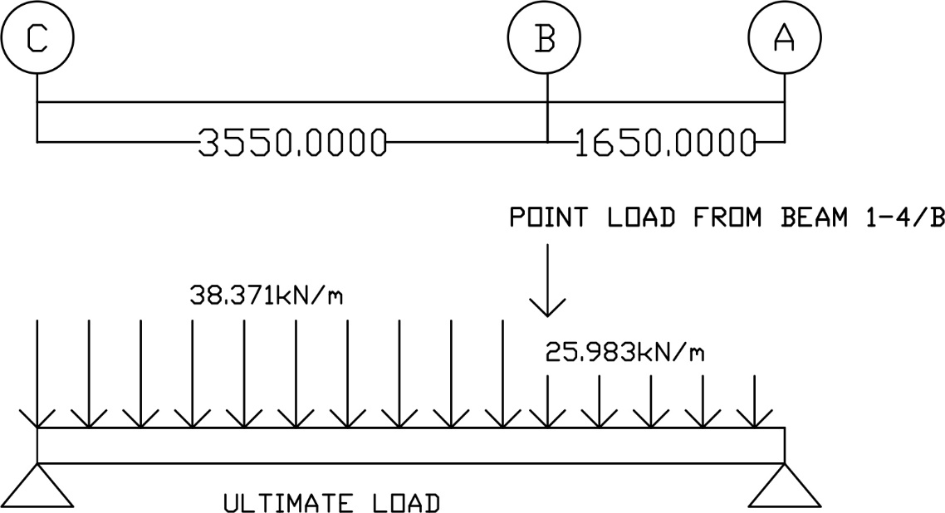

REACTIONS

∑M_{CY} = 0
(38.371)(3.55)(1.775)+(93.64)(3.55)+(25.983)(1.65)(4.375)-R_{AY}(5.2)=0
5.2R_{AY} = 241.79 + 332.422 + 187.56
R_{AY} = 146.5kN/m

∑F_{Y} = 0
R_{AY} + R_{CY} + (-38.371)(3.55) +(- 93.64) + (-25.983)(1.65) = 0
R_{CY} = 126.229kN/m

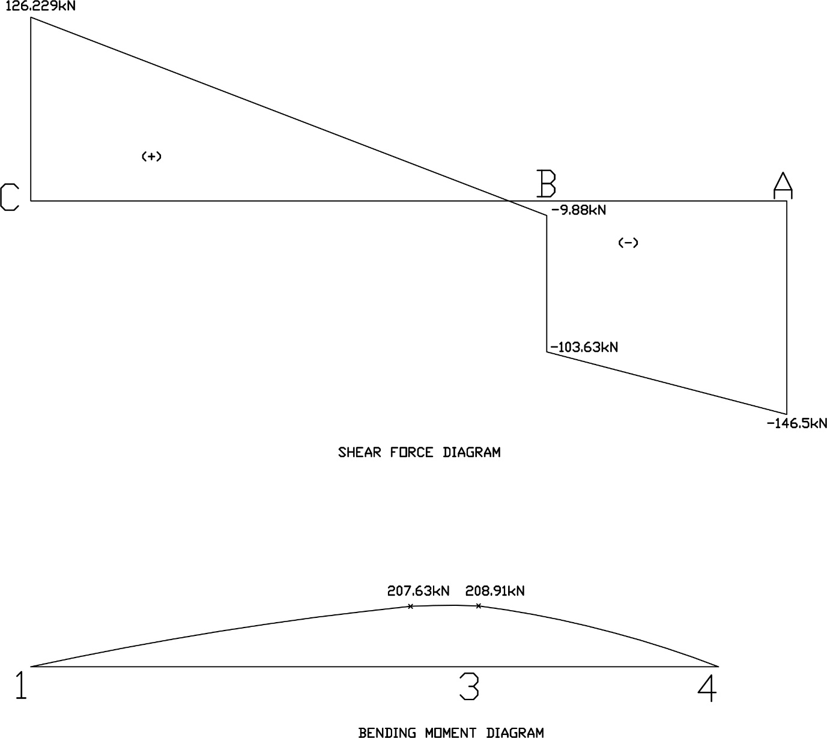

GROUND FLOOR BEAM, 5 / C - D
- Self weight = Beam size x Density
= 0.25m x 0.15m x 24kN/m³
= 0.9 kN/m

- Weight of brick wall = Height x Width x Density
= 3.5m x 0.15m x 19kN/m³
= 9.975kN/m

- Slab’s dead load & live load : Slab 4 - 5 / C – D

Dead load of slab 4 – 5 / C – D = Dead load on slab x (L_{x}/2)m
= 3.6kN/m² x (1.5/2)m
= 2.7kN/m
Total dead load on C – D = 0.9 + 9.975 + 2.7 = 13.575kN/m

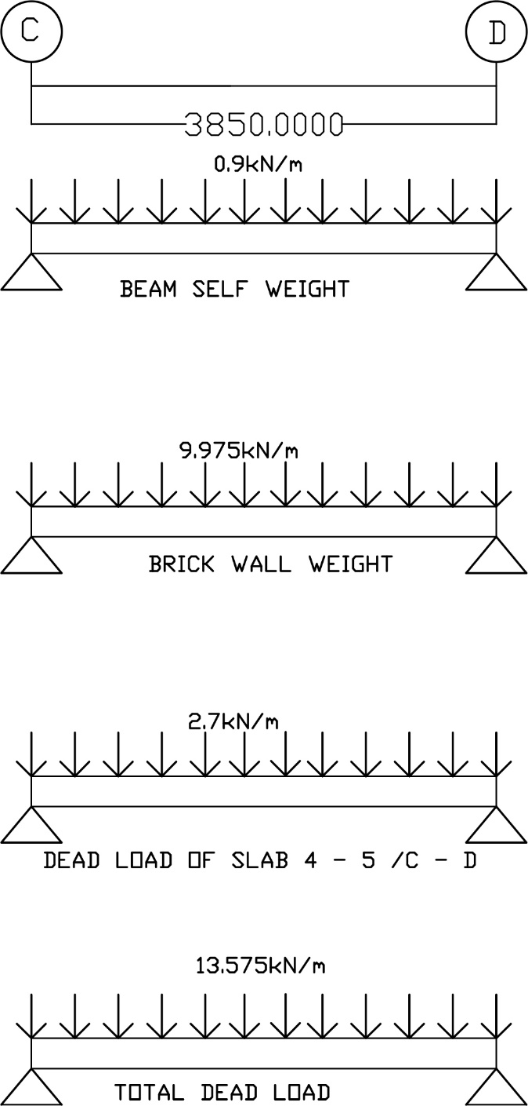
DEAD LOAD DIAGRAM
LIVE LOAD
Live load of slab 4 – 5 / C - D
Live load = Live load on slab x (L_{x}/2)m
= 2kN/m² x (1.5/2)m
= 1.5kN/m

ULTIMATE LOAD

Apply factor 1.4 and 1.6 to dead load and live load respectively.

Total dead load = 13.575 x 1.4 = 19.005kN/m
Total live load = 1.5 x 1.6 = 2.4kN/m
Ultimate load = 21.405kN/m

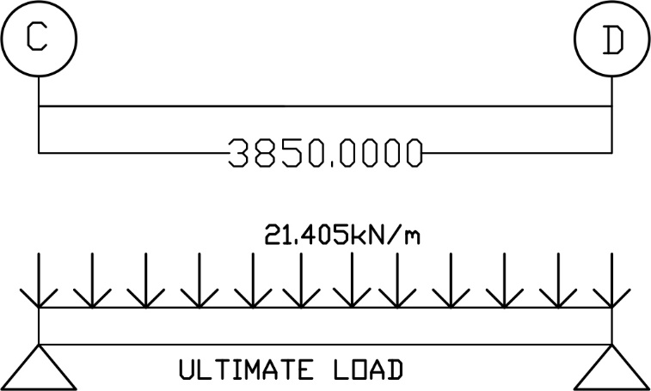
ULTIMATE LOAD DIAGRAM

∑M_{CY} = 0
(21.405)(3.85)(1.925)-R_{DY}(3.85) = 0
R_{DY} = 41.20kN/m
∑F_{Y} = 0
R_{DY} + R_{CY} + (-21.405)(3.85) = 0
R_{CY} =41.2kN/m
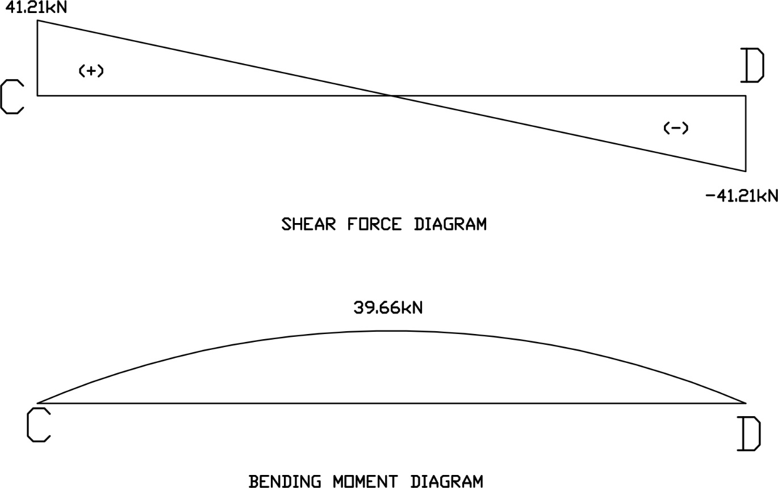

GROUND FLOOR BEAM, 2 / C - D
- Self weight = Beam size x Density
= 0.25m x 0.15m x 24kN/m³
= 0.9 kN/m

- Weight of brick wall = Height x Width x Density
= 3.5m x 0.15m x 19kN/m³
= 9.975kN/m

- Slab’s dead load & live load : Slab 2 - 4 / C – D

Dead load of slab 2 – 4 / C – D = Dead load on slab x (L_{x}/2)m
= 3.6kN/m² x (3.41/2)m
= 6.138kN/m
Total dead load on C – D = 0.9 + 9.975 + 6.138 = 17.013kN/m

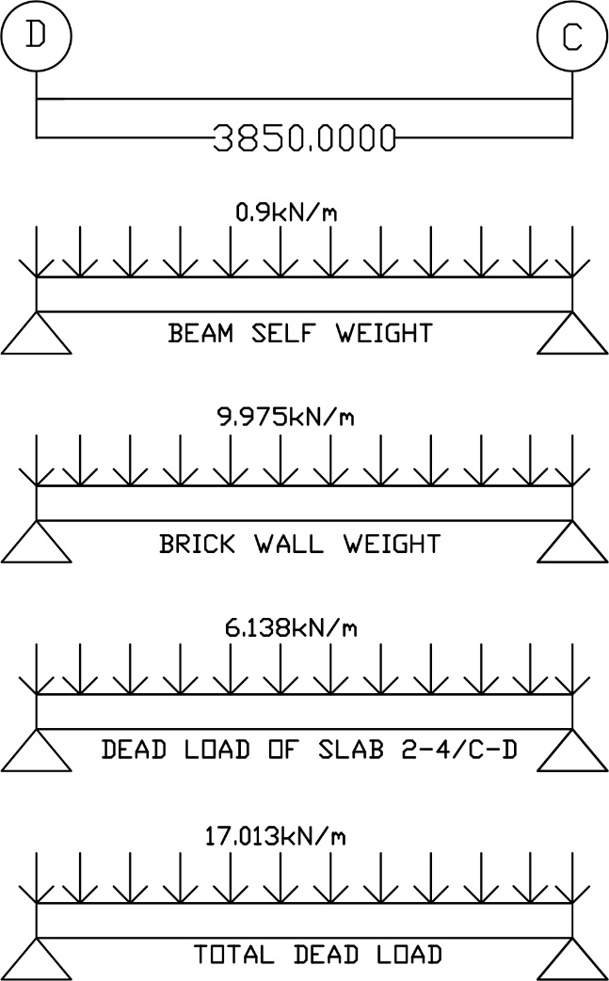
DEAD LOAD DIAGRAM
LIVE LOAD
Live load of slab 2 – 4 / C - D
Live load = Live load on slab x (L_{x}/2)m
= 1.5kN/m² x (3.41/2)m
= 2.5575kN/m

ULTIMATE LOAD
Apply factor 1.4 and 1.6 to dead load and live load respectively.

Total dead load = 17.013 x 1.4 = 23.82kN/m
Total live load = 2.5575 x 1.6 = 4.092kN/m
Ultimate load = 27.912kN/m

ULTIMATE LOAD DIAGRAM
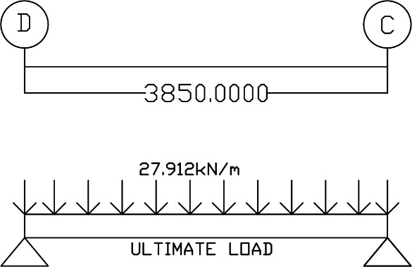

REACTIONS
∑M_{DY} = 0
(27.912)(3.85)(1.925)-R_{CY}(3.85) = 0
R_{CY} = 53.73kN/m
∑F_{Y} = 0
R_{DY} + R_{CY} + (-27.912)(3.85) = 0
R_{CY} =53.73kN/m

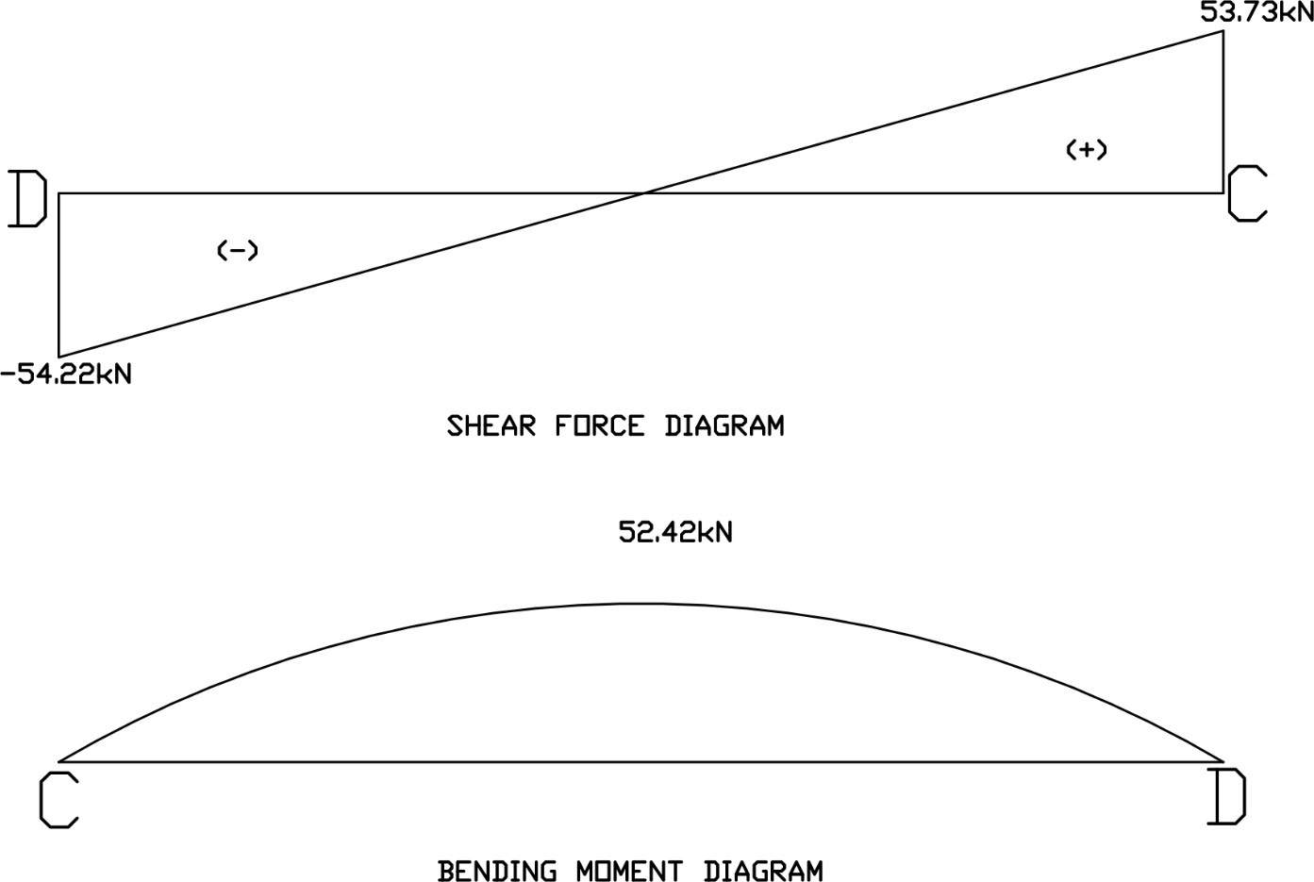
2.1.7 COLUMN ANALYSIS CALCULATION
LOAD DISTRIBUTION DIAGRAM
Indicating the distribution of load from slab to column by using the tributary area method.
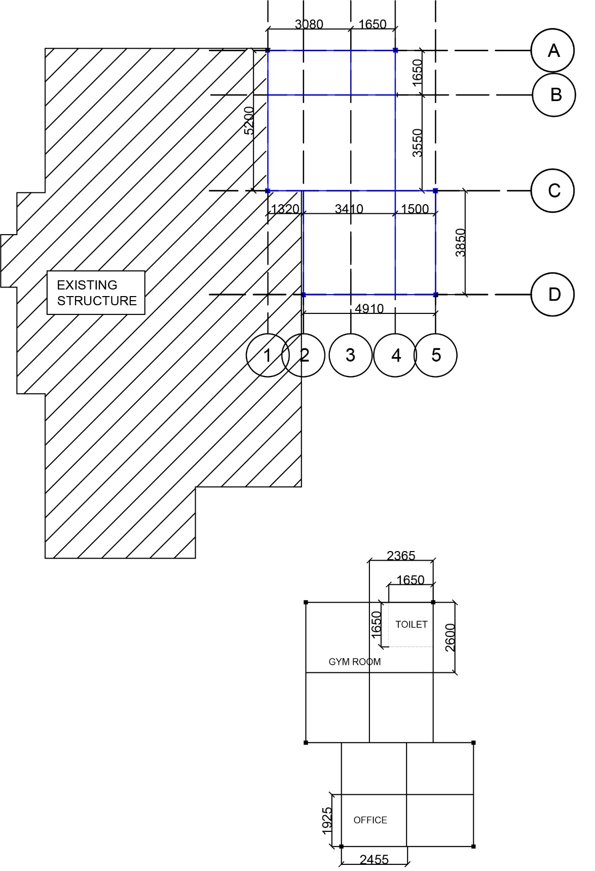

Ground floor plan showing distribution of load from slabs to columns.
LOAD DISTRIBUTION DIAGRAM
Indicating the distribution of load from slab to column by using the tributary area method.
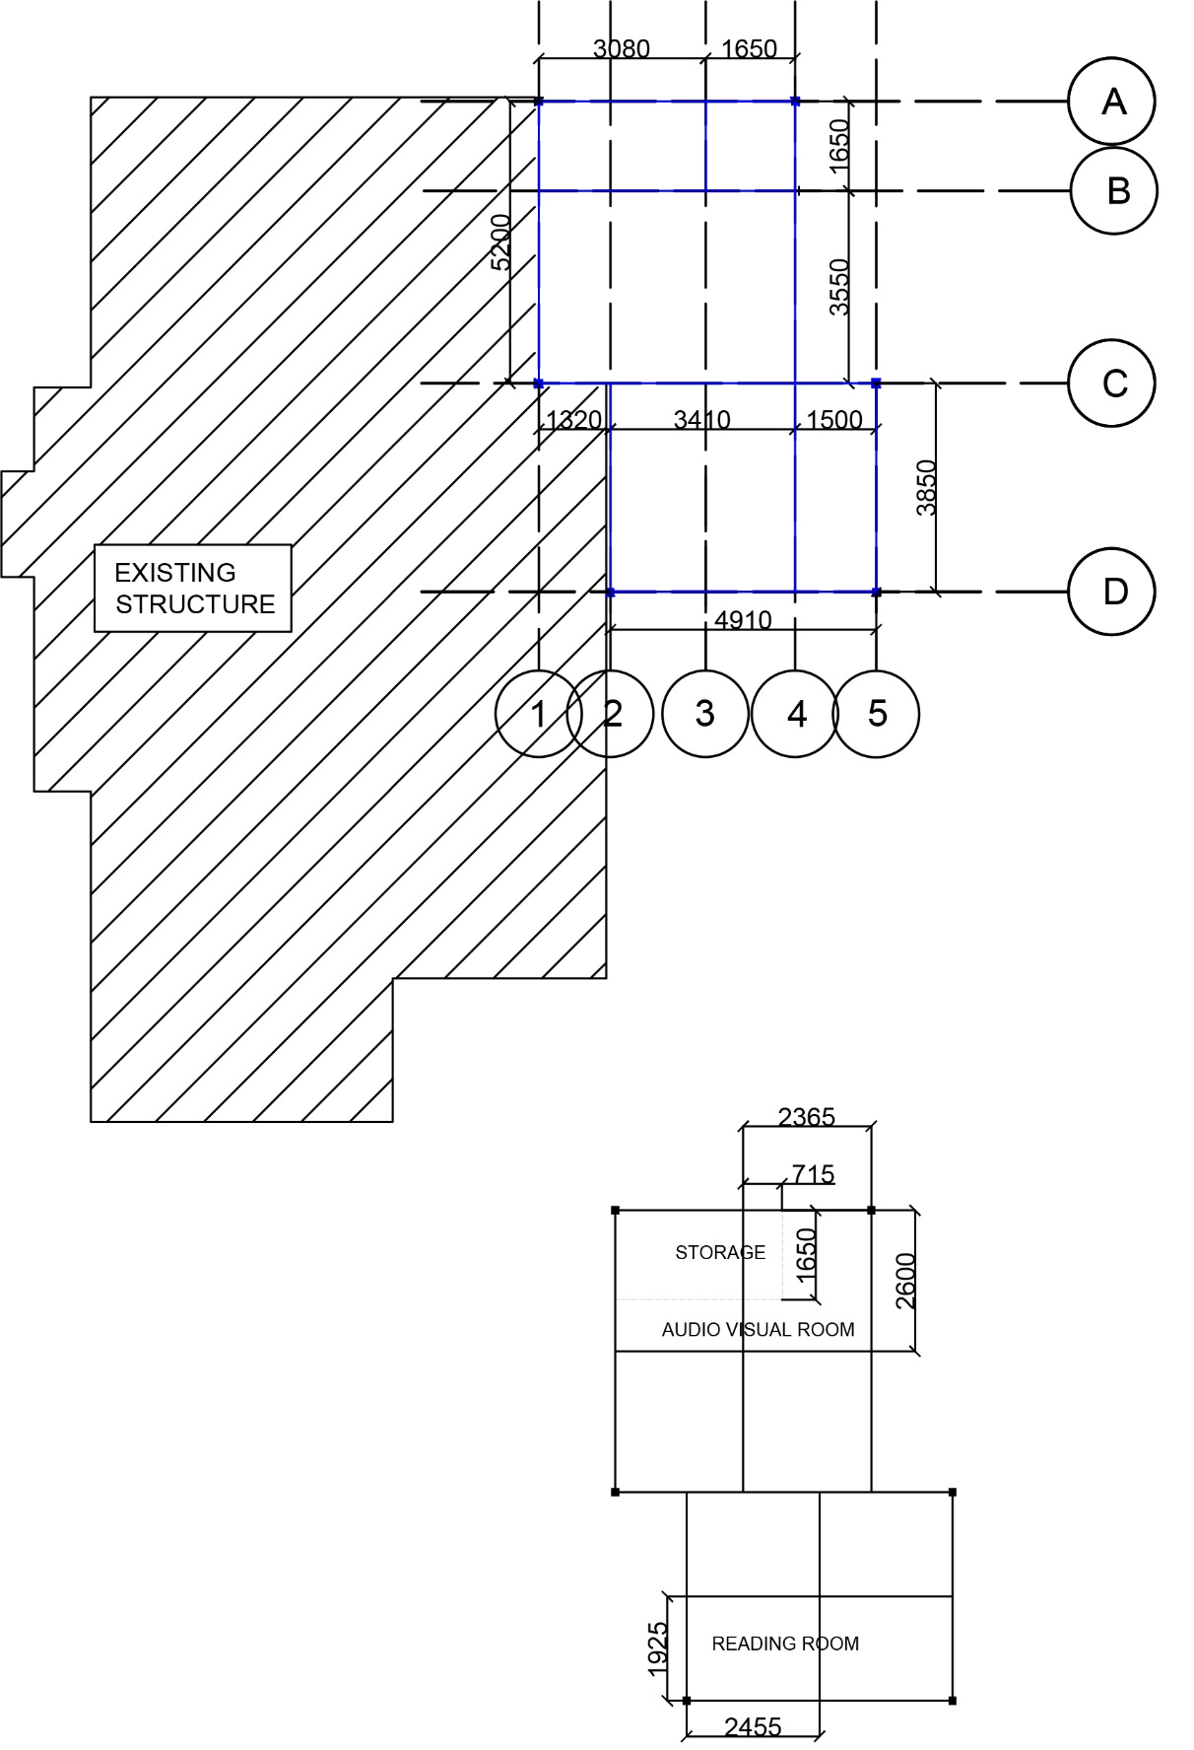

First floor plan showing distribution of load from slabs to columns.

LOAD DISTRIBUTION DIAGRAM
Indicating the distribution of load from slab to column by using the tributary area method.

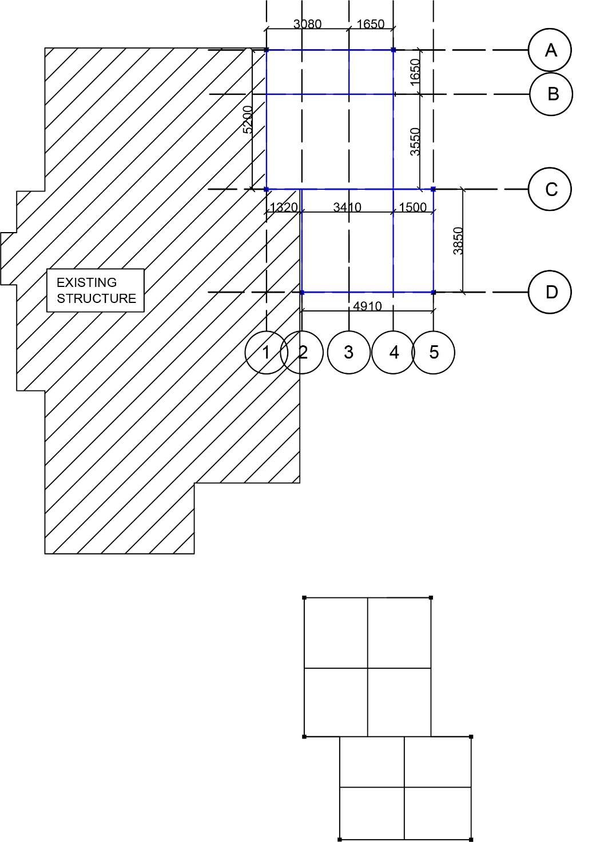

Roof structure plan showing distribution of load from slabs to columns.

COLUMN A / 4
Slabs involved : Ground floor toilet , Ground floor gym room , First floor storage , First floor audio visual room , Roof slab

DEAD LOAD
Ground floor :
Beams : (2.365)(0.9) + (2.6)(0.9) = 4.4685kN
Outer brick walls : (2.365)(9.975) + ( 2.6)(9.975) = 49.5259kN
Brick wall for toilet : (1.65)(9.975)(2) = 32.9175kN
Slab for ground floor toilet : (1.65)(1.65)(2.4) = 6.534kN
Slab involved for ground floor gym room = (Area of the entire slab involved – Area of toilet)(3.6) = 3.4265kN

First floor :
Beams : (2.365)(0.9) + (2.6)(0.9) = 4.4685kN
Outer brick walls : (2.365)(9.975) + ( 2.6)(9.975) = 49.5259kN
Brick wall for storage : (0.715)(9.975) + (1.65)(9.975) = 23.59kN
Slab involved for first floor storage : (0.715)(1.65)(3.6) = 4.247kN
Slab involved for first floor audio visual room = (Area of the entire slab involved – Area of storage involved)(3.6) = 17.9kN

Roof :
Roof beams : (2.365)(0.9) + (2.6)(0.9) = 4.4685kN
Roof slab : (2.365)(2.6)(1.0) = 6.15kN

Column self-weight :
Density x Height = (0.9)(7) = 6.3kN

LIVE LOAD
Ground floor :
Slab for ground floor toilet : (1.65)(1.65)(2.0) = 5.445kN
Slab involved for ground floor gym room = (Area of the entire slab involved – Area of toilet)(5.0) = 17.0935kN

First floor :
Slab involved for first floor storage : (0.715)(1.65)(2.0) = 2.3595kN
Slab involved for first floor audio visual room = (Area of the entire slab involved – Area of storage involved)(2.0) = 9.9385kN

Roof :
Area x Live load = (2.365)(2.6)(0.5) = 3.0745kN

COLUMN A / 1
Slabs involved : Ground floor gym room , First floor storage , First floor audio visual room , Roof slab

DEAD LOAD
Ground floor :
Beams : (2.365)(0.9) + (2.6)(0.9) = 4.4685kN
Outer brick walls : (2.365)(9.975) + ( 2.6)(9.975) = 49.5259kN
Slab for ground floor gym room involved : (2.365)(2.6)(3.6) = 22.14kN

First floor :
Beams : (2.365)(0.9) + (2.6)(0.9) = 4.4685kN
Outer brick walls : (2.365)(9.975) + ( 2.6)(9.975) = 49.5259kN
Brick wall for storage : (2.365)(9.975) = 23.59kN
Slab involved for first floor storage : (2.365)(1.65)(3.6) = 14.0481kN
Slab involved for first floor audio visual room = (Area of the entire slab involved – Area of storage involved)(3.6) = 8.0883kN

Roof :
Roof beams : (2.365)(0.9) + (2.6)(0.9) = 4.4685kN
Roof slab : (2.365)(2.6)(1.0) = 6.15kN

Column self-weight :
Density x Height = (0.9)(7) = 6.3kN

LIVE LOAD
Ground floor :
Slab for ground floor gym room: (2.365)(2.6)(5.0) = 30.745kN

First floor :
Slab involved for first floor storage : (2.365)(1.65)(2.0) = 7.8045kN
Slab involved for first floor audio visual room = (Area of the entire slab involved – Area of storage involved)(2.0) = 4.4935kN

Roof :
Area x Live load = (2.365)(2.6)(0.5) = 3.0745kN

COLUMN D / 2
Slabs involved : Ground floor office , First floor reading room , Roof slab

DEAD LOAD
Ground floor :
Beams : (2.455) (0.9) + (1.925)(0.9) = 3.942kN
Outer brick walls : (2.455)(9.975) + ( 1.925)(9.975) = 4.36905kN
Slab for ground floor office: (2.455)(1.925)(3.6) = 17.01kN

First floor :
Beams : (2.455) (0.9) + (1.925)(0.9) = 3.942kN
Outer brick walls : (2.455)(9.975) + ( 1.925)(9.975) = 4.36905kN
Slab for first floor reading room =(2.455)(1.925)(3.6) = 17.01kN

Roof :
Roof beams : (2.455)(0.9) + (1.925)(0.9) = 3.942kN
Roof slab : (2.455)(1.925) (1.0) = 4.725kN

Column self-weight :
Density x Height = (0.9)(7) = 6.3kN

LIVE LOAD

Ground floor :
Slab for ground floor office: (2.455)(1.925)(1.5) = 7.09kN

First floor :
Slab for first floor reading room =(2.455)(1.925)(2.0) = 9.45kN

Roof :
Area x Live load = (2.365)(2.6)(0.5) = 3.0745kN

